# HTML & JS

**_________________________________**

**NAME : Rutuja Chavan**

**COLLEGE : N.K. ORCHID COLLEGE ENGG. & TECH; SOLAPUR.**

**____________________________________________________**

* **AIM :-** Create college web pages for displaying college information using CSS.
* DESCRIPTION:-

CSS Table Properties

|  |  |
| --- | --- |
| **Property** | **Description** |
| [border](https://www.w3schools.com/cssref/pr_border.asp) | Sets all the border properties in one declaration |
| [border-collapse](https://www.w3schools.com/cssref/pr_border-collapse.asp) | Specifies whether or not table borders should be collapsed |
| [border-spacing](https://www.w3schools.com/cssref/pr_border-spacing.asp) | Specifies the distance between the borders of adjacent cells |
| [caption-side](https://www.w3schools.com/cssref/pr_tab_caption-side.asp) | Specifies the placement of a table caption |
| [empty-cells](https://www.w3schools.com/cssref/pr_tab_empty-cells.asp) | Specifies whether or not to display borders and background on empty cells in a table |
| [table-layout](https://www.w3schools.com/cssref/pr_tab_table-layout.asp) | Sets the layout algorithm to be used for a table |

**TAGS & ATTRIBUTE USED IN CODING :-**

*Text colour:-*

<h1 style = “colour:blue”>this is heading</h> <p style= “colour:red;”>this is a paragraph.</p> eg:darkcyan,cornsilk,cyan,darkgrey,crimson,etc.

*Text size:-*

<h1 style= “font-size:300%;”>this is heading.</h1>

<p style = “font-size:160%;”>this is a para</p>

*Text alignment:-*

<h1 style= “text-align:center;”>Centered heading </h>

<html>

<head>

<title>Align Attribute Example</title>

</head>

<body>

<p align = "left">This is left aligned</p>

<p align = "center">This is center aligned</p>

<p align = "right">This is right aligned</p>

</body>

</html>

*The src Attribute :-*

<img src = “img_girl.jpg”>

(img-embed in an HTML page)

(src-specifies the path to img)

The width & height Attributes

<img src= “img_girl.jpg” width = “500” height = “600”>

**TAGS:-**

|  |  |
| --- | --- |
| <address> | Defines contact information for the author/owner of a document |
| <area> | Defines an area inside an image map |
| <article>  <aside> | Defines an article  Defines content aside from the page content |
| <audio> | Defines embedded sound content |
| <b> | Defines bold text |
| <base> | Specifies the base URL/target for all relative URLs in a document |
| <bdi> | Isolates a part of text that might be formatted in a different direction from other text outside it |
| <bdo> | Overrides the current text direction |
| <blockquote> | Defines a section that is quoted from another source |
| <body> | Defines the document's body |
| <br> | Defines a single line break |
| <button> | Defines a clickable button |
| <canvas> | Used to draw graphics, on the fly, via scripting (usually JavaScript) |
| <caption> | Defines a table caption |
| <cite> | Defines the title of a work |
| <code> | Defines a piece of computer code |
| <col> | Specifies column properties for each column within a <colgroup> element |
| <colgroup> | Specifies a group of one or more columns in a table for formatting |
| <data> | Adds a machine-readable translation of a given content |
| <datalist> | Specifies a list of pre-defined options for input controls |

FOR IMAGE __

Tag Description

<img> Defines an image

<map> Defines a client-side image map

<area> Defines an area inside an image map

<canvas> Used to draw graphics, on the fly, via scripting (usually JavaScript)

LINKS__

Tag Description

<a> Defines a hyperlink

Defines the relationship between a document and an external resource (most used to link to

<link>

style sheets)

*CODING:-*

<html>

<head>

<center>

<a href="https://www.orchidengg.ac.in/" title="N. K. Orchid College Of Engineering &amp;

Technology, Solapur - " rel="home" class="no-sticky-logo">

<img src="https://www.orchidengg.ac.in/wp-content/uploads/2019/05/college_header.png"

alt="N. K. Orchid College Of Engineering &amp; Technology,

Solapur"" width="1200"></a>

</center>

<body>

</b></font></h1>

&nbsp;&nbsp;&nbsp;&nbsp;&nbsp;

</b></font></h1>

<html>

<head>

<style>

th {

white-space: nowrap;

}

table {

width: 100%;

}

th {

height: 50px;

}

a {

color: #FFFFFF;

}

a {

text-decoration: none;

}

</style>

<table style="width:100%" cellspacing="4" cellpadding="5" border="1"bgcolor="#8B0000">

<th> <A HREF="HOME.html"> HOME </A></th>

<th> <A HREF = "ABOUT US.html" > ABOUT US</A></th>

<th> <A HREF ="CONTACT US.HTML" > CONTACT US </A></th>

<th> <A HREF ="DEPARTMENT.HTML" > DEPARETMENT </A></th>

<th> <A HREF ="SPORTS.HTML" > SPORTS </A></th>

<th> <A HREF ="COURSES.HTML" > COURSES </A></th>

</table>

<style>

<meta name="viewport" content="width=device-width, initial-scale=1">

<style>

* {box-sizing: border-box;}

body {font-family: Verdana, sans-serif;}

.mySlides {display: none;}

img {vertical-align: middle;}

.slideshow-container {

max-width: 2000px;

max-height:100px;

position: relative;

margin: auto;

}

.text {

color: #f2f2f2;

font-size: 15px;

padding: 8px 12px;

position: absolute;

bottom: 8px;

width: 100%;

text-align: center;

}

.numbertext {

color: #f2f2f2;

font-size: 12px;

padding: 8px 12px;

position: absolute;

top: 0;

}

.dot {

height: 15px;

width: 15px;

margin: 0 2px;

background-color: #bbb;

border-radius: 50%;

display: inline-block;

transition: background-color 0.6s ease;

}

.active {

background-color: #717171;

}

.fade {

-webkit-animation-name: fade;

-webkit-animation-duration: 1.5s;

animation-name: fade;

animation-duration: 1.5s;

}

@-webkit-keyframes fade {

from {opacity: .4}

to {opacity: 1}

}

@keyframes fade {

from {opacity: .4}

to {opacity: 1}

}

@media only screen and (max-width: 300px) {

.text {font-size: 11px}

}

</style>

</head>

<body>

<div class="slideshow-container">

<div class="mySlides fade">

<div class="numbertext">1 / 4</div>

<img src="C:/Users/hp/Pictures/Desktop/image5.jpg" style="width:100%">

<div class="text">Caption Text</div>

</div>

<div class="mySlides fade">

<div class="numbertext">2 / 4</div>

<img src="C:/Users/hp/Pictures/Desktop/image4.jpg" style="width:100%">

<div class="text">Caption Two</div>

</div>

<div class="mySlides fade">

<div class="numbertext">3 / 4</div>

<img src="C:/Users/hp/Pictures/Desktop/image3.jpg" style="width:100%">

<div class="text">Caption Three</div>

</div>

<div class="mySlides fade">

<div class="numbertext">4 / 4</div>

<img src="C:/Users/hp/Pictures/Desktop/image2.jpg" style="width:100%">

<div class="text">Caption four</div>

</div>

<br>

<div style="text-align:center">

<span class="dot"></span>

<span class="dot"></span>

<span class="dot"></span>

</div>

<script>

var slideIndex = 0;

showSlides();

function showSlides() {

var i;

var slides = document.getElementsByClassName("mySlides");

var dots = document.getElementsByClassName("dot");

for (i = 0; i < slides.length; i++) {

slides[i].style.display = "none";

}

slideIndex++;

if (slideIndex > slides.length) {slideIndex = 1}

for (i = 0; i < dots.length; i++) {

dots[i].className = dots[i].className.replace(" active", "");

}

slides[slideIndex-1].style.display = "block";

dots[slideIndex-1].className += "active";

setTimeout(showSlides, 2000);

}

</script>

</head>

</html>

<h1 align="center"><font size="+20"><b>Addmision 2020-21<br>

<hr size="3px" color="black">

&nbsp;&nbsp;&nbsp;&nbsp;&nbsp;

</b></font></h1>

<table cellpadding="3" width="100%" height="100%">

<h1 align="center"><b>DEPARTMENT </h1>

<br>

<hr size="3px" color="black">

<table cellspacing="12">

<tr>

<th><H1>CIVIL ENGINNERING</H1></th>

<th><H1>COMPUTER ENGINEERING<H1></th>

<th><h1>E&TC ENGINNERING</h1></th>

</tr>

<td><A href="civil.html">

<IMG SRC="C:/Users/hp/Pictures/Desktop/civil.jpg"alt="civil image... align="left"

"width="100%" height="400" border="1">

<img as a link></A>

</td>

<td>

<A href="computer.html">

<IMG SRC="C:/Users/hp/Pictures/Desktop/Computer-Engineering.jpg"

alt="Computer-Engineering image... align="middle"

"width="100%" height="400" border="1">

<img as a link></A>

</td>

<td>

<A href="Entc.html">

<IMG SRC="C:/Users/hp/Pictures/Desktop/entc-engineering (1).jpg"

alt"... align="bottom right"

"width="100%" height="400" border="1">

<img as a link></A>

</td>

<table cellspacing="4">

<tr>

<th><h1>ELECTRONIC ENGINNERING</h1></th>

<th><h1>MECHANICAL ENGINNERING</h1></th>

<th><h1>GENERAL ENGINNERING</h1></th>

</tr>

<td>

<A href="electrical.html">

<IMG SRC="C:/Users/hp/Pictures/Desktop/electronics-.jpg"

alt="electronics image...align="left"

"width="100%" height="400" border="1">

<img as a link></A>

</td>

<td>

<A href="mechanical.html">

<IMG SRC="C:/Users/hp/Pictures/Desktop/mechanical.jpg"

alt="mechanical image... align="bottom center"

"width="100%" height="400" border="1">

<img as a link></A>

</td>

<td>

<A href="general.html">

<IMG SRC="C:/Users/hp/Pictures/Desktop/general.jpg"

alt="general image... align="bottomright"

"width="100%" height="400" border="1">

<img as a link></A>

</td>

&nbsp;&nbsp;&nbsp;&nbsp;&nbsp;&nbsp;&nbsp;&nbsp;&nbsp;&nbsp

</Table>

</tr>

<style>

h1 { font-size: 28px; }

p { font-size: 12px; }

</style>

<hr size="3px" color="black">

<h2 align="left"><font size="+3"><A HREF="AboutUs.html" >About Us</A></h2>

<p>With the Vision of “Locally Rooted, Globally Competent Education”,

N. K. Orchid College of Engineering & Technology, Solapur (NKOCET)

started from the academic year 2008-09. NKOCET is approved by AICTE,

New Delhi, recognized by Government of Maharashtra with its SE, TE, BE and ME

classes are affiliated to Solapur University.

From this academic year 2017-18 first year of the UG course is affiliated

to the newly formed state technological university of Maharashtra;

Dr. Babasaheb Ambedkar Technological University, Lonere.

The NKOCET has spread over picturesque, sprawling land of 10.6 acres

in the vicinity of Hipparga Lake in Tale-Hipparaga, Solapur.

It has emerged as a preferred knowledge destination for aspiring Engineering students.

NKOCET provides excellent engineering education and creates

globally competent technocrats. The trust, Pradnya Niketan Education Society,

Pune has been founded by 14 highly educated eminent Technocrats, Bureaucrats

and Entrepreneurs who have envisioned transformation of society

through education and to serve for welfare of the people.</p>

<p>NKOCET has added many feathers in its cap through its journey.

In recognition of its academic excellence, the institute was conferred 36th rank in

“Top 50 Private Engineering Colleges in India” in 2012 by Bhaskar-Lakshya Magazine.

NKOCET is known for its strong teaching-learning process where lot of precedence

is given on practical and real knowledge acquisition.</p>

<p>The Institute has been a leader in academics with effective teaching-learning

pedagogy which has produced many University Rankers.

The institute is renowned for its academic excellence as every year

almost 50 percent university rankers are from NKOCET.

The institute has not only made its mark in the affiliated university

through excellent academic results but also left its footprints in the

top-notch MNCs by placing Competent Engineers.</p>

<p>Considering varied backgrounds and different learning abilities,

lot of emphasis is given on strengthening theoretical as well as practical

knowledge by providing student-centric teaching learning pedagogies.

With the effective use of ICT, the teaching learning process has been

transformed, wherein students are made to learn through NPTEL

MOOCs courses, spoken tutorials, video recorded faculty lectures,

animations, simulation software. </p>

<p>The well-organized Library consist leading National and International

periodicals and Research Journals along with a huge collection of books

which is accessible 24x7 for the students.

NKOCET has highly qualifiedand experienced faculty members who are committed

to create a congenial student friendly environment.

The Institute encourages students not only for placements in MNCs but also

for higher education abroad and in renowned educational

institutes through GATE.</p>

<p> NKOCET conducts special classes during vacations for students

who prepare for GATE examination. The focused and systematic training

has brought exceptional results as many students have been qualified

GATE exam till date.

Also, to encourage students to pursue higher education

abroad the Institute’s Study Abroad Cell (SAC) guides and arranges trainings.

NKOCET has become a destination through which they can get admitted

in the best of the Universities in India and abroad.</p>

<p>

NKOCET has been a major source for renowned industries through which

quality Engineers are recruited through the Training & Placement Cell

of the institute. The Institute has a strong Industry-Institute connect

which gives prominence to bridge the gap between industry and the Institute.

To establish strong industry-connect, the institute has signed MoUs with

industries for training the students on advanced technologies and mentoring

for final year projects.

The institute also encourages the student’s innovation and creativity

by arranging technical competitions and national level

events like Orchitech every year.

<p>The Institute has initiated a novel concept of Soft Skills for future

engineers for their personal and professional advancements.

The Soft Skills Training conducted by NKOCET focuses on elements of Training &

Development that require changes in Communication, behavior, adaptability &

Critical thinking.

Every class goes through two hours of rigorous Soft Skills training wherein

specialized full time Trainers are appointed to prepare the students

for their future challenges. It has brought significant change in students’

attitude and resulted into increased placement of the Institute.

</p>

<A HREF="Home.html" >back</A>

</BODY>

<hr size="3px" color="black">

<IMG SRC="C:/Users/hp/Pictures/Desktop/clg.jpg"alt"college image...

"width="2000%" height="80%" border="2">

<hr size="2px" color="black">

<html>

<head>

<title>Civil Engginering</title>

</head>

<style>

th, td {

padding: 15px;

}

</style>

<body>

<center>

<a href="https://www.orchidengg.ac.in/" title="N. K. Orchid College Of Engineering &amp;

Technology, Solapur - " rel="home" class="no-sticky-logo">

<img src="https://www.orchidengg.ac.in/wp-content/uploads/2019/05/college_header.png"

alt="N. K. Orchid College Of Engineering &amp; Technology,

Solapur"" width="1200"></a>

</center>

<body>

</b></font></h1>

&nbsp;&nbsp;&nbsp;&nbsp;&nbsp;

</b></font></h1>

<hr size="2px" color="black">

<html>

<head>

<style>

th {

white-space: nowrap;

}

table {

width: 100%;

}

th {

height: 50px;

}

a {

color: #FFFFFF;

}

a {

text-decoration: none;

}

</style>

<table style="width:100%" cellspacing="4" cellpadding="5" border="1"bgcolor="#8B0000">

<th> <A HREF="HOME.html"> HOME </A></th>

<th> <A HREF = "ABOUT US.html" > ABOUT US</A></th>

<th> <A HREF ="ADMISSIONS.HTML" > ADMISSIONS </A></th>

<th> <A HREF ="DEPARTMENTS.HTML" > DEPARETMENTS </A></th>

<th> <A HREF ="RESEARCH.HTML" > RESEARCH </A></th>

<th> <A HREF ="CONTACT US.HTML" > CONTACT US </A></th>

</table>

<h1 align="center"><font size="+3"><b> Civil Engineering Department<br>

&nbsp;&nbsp;&nbsp;&nbsp;&nbsp;

</b></font></h1>

<hr size="2px" color="black">

<p align="center">CIVIL ENGINNERING</P>

<font size="+1" face="Arial"><p><h2><b>Department Vision:</b></h2>

&nbsp;&nbsp;&nbsp;&nbsp;Locally rooted globally competent education in Civil

Engineering.<br>

<h2><b>Department Mission:</b></h2>

<b>M1:</b>To strive for excellence in our teaching-learning process, encouraging

creativity and critical thinking leading to

development of higher order cognitive skills.<br>

<b>M2:</b>Strengthening Industry-Institute interaction to enhance skills

and experiential learning<br>

<b>M3:</b> Providing holistic education for the students’ personality development.<br>

<b>M4:</b>To nurture life skills, motivate to work in multidisciplinary fields

and encourage entrepreneurship.<br>

<b>M5:</b>Provide employable education to make the students Industry Ready Engineers.<br>

<b>M6:</b>Promote research based projects and activities in the emerging

areas of technology convergence<br>

<h2><b>About Department:</b></h2>

&nbsp;&nbsp;&nbsp;&nbsp;Profession of civil engineering retains it ancient era

even in the current era of electronics and computer revolution.

This branch of engineering touches to entire need of society, civilians that includes

shelter and water, roads and bridges, dam and tunnels, environmental pollution and similar

construction activities directly related to welfare and human beings.

As long as civilization extracts and grows civil engineering profession will persist.

<br>

The department of civil Engineering is established form the inception of college with the intake of 120.

The department is having highly qualified faculties with average experience of 12 years.

The department is well-established laboratories of modern equipment

in the surveying, strength of material, concrete technology, fluid mechanics,

geology, applied mechanics etc..

&nbsp;&nbsp;&nbsp;&nbsp;The department of civil Engineering is established form

the inception of college with the intake of 120.

The department is having highly qualified faculties

with average experience of 12 years.

The department is well-established laboratories of modern equipment

in the surveying, strength of material, concrete technology, fluid mechanics,

geology, applied mechanics etc..

</font>

<div class="th,td">

<center>

<table border="3px" color="black" style="border-collapse:

collapse;width:800px;height:500px;padding:3px;font-size:25px;" >

<tr>

<th><b>Deaprtment Location</b></th>

<th><b>E-Building (civil wing)</b></th>

</tr>

<tr>

<td>Year of Established</td>

<td>2008</td>

</tr>

<tr>

<td>Head Of Department</td>

<td>Dr.V.K.Patil</td>

</tr>

<tr>

<td>Contaxct No.</td>

<td>9552529235</td>

</tr>

<tr>

<td>Email ID</td>

<td>vinayakpatki@orchidengg.ac.in</td>

</tr>

<tr>

<td>Total No.of Classrooms</td>

<td>06</td>

</tr>

<tr>

<td>Total No. of Laborataries</td>

<td>11</td>

</tr>

<tr>

<td>Faculty Student ratio</td>

<td>1:15</td>

</tr>

<tr>

<td>No. of Professor</td>

<td>03</td>

</tr>

<tr>

<td>No. of Associate Professor</td>

<td>02</td>

</tr>

<tr>

<td>No. of Assistant Professor</td>

<td>16</td>

</tr>

<tr>

<td>Total No. of Faculty</td>

<td>27</td>

</tr>

<tr>

<td>No. of Supporting Non- teaching Faculty</td>

<td>04</td>

</tr>

<tr>

<td>Menial Staff</td>

<td>06</td>

</tr>

</table>

</center>

</div>

<p><font size="+1" face="Arial">The department is equipped with

latest Dell Computers, installed with latest softwares. Our computer

laboratories

are well equipped with latest terminals, scanners, printers, Online

Ups with Battery backup, CD writers, multimedia peripherals and legal copies

of

latest softwares like windows 2003 server, ,Linux, MS-office, Oracle 10i,

Visual Studio, Dot Net Framework and C++. These laboratories support an

environment for

Networking, Multimedia, Databases, Programming and advanced technologies.

</p><br>

<p>CESA (Civil Engineering Students Association) is a department level club working

for arranging various activities and guest lectures for the students.

The aim of CESA is to encourage the student’s participation in the curriculum activities,

to make aware of social and technical issues,

to guide them & to broaden their view.

Our departmentis continuously arranging Expert lectures for the subjects

which are there in Syllabusand over and above the syllabus.

We have arranged workshops for the students and faculty such as Adobe Flex,

Use of animation in Teaching, Recent trends in Electronics and

Computer Engineering etc.

</font></p><br>

</body>

</html>

<hr size="2px" color="black">

<html>

<head>

<title>Computer Science & Engineering</title>

</head>

<style>

th, td {

padding: 15px;

}

</style>

<body>

<center>

<a href="https://www.orchidengg.ac.in/" title="N. K. Orchid College Of Engineering &amp;

Technology, Solapur - " rel="home" class="no-sticky-logo">

<img src="https://www.orchidengg.ac.in/wp-content/uploads/2019/05/college_header.png"

alt="N. K. Orchid College Of Engineering &amp; Technology,

Solapur"" width="1200"></a>

</center>

<body>

</b></font></h1>

&nbsp;&nbsp;&nbsp;&nbsp;&nbsp;

</b></font></h1>

<hr size="2px" color="black">

<html>

<head>

<style>

th {

white-space: nowrap;

}

table {

width: 100%;

}

th {

height: 50px;

}

a {

color: #FFFFFF;

}

a {

text-decoration: none;

}

</style>

<table style="width:100%" cellspacing="4" cellpadding="5" border="1"bgcolor="#8B0000">

<th> <A HREF="HOME.html"> HOME </A></th>

<th> <A HREF = "ABOUT US.html" > ABOUT US</A></th>

<th> <A HREF ="ADMISSIONS.HTML" > ADMISSIONS </A></th>

<th> <A HREF ="DEPARTMENTS.HTML" > DEPARETMENTS </A></th>

<th> <A HREF ="RESEARCH.HTML" > RESEARCH </A></th>

<th> <A HREF ="CONTACT US.HTML" > CONTACT US </A></th>

</table>

<h1 align="center"><font size="+3"><b> COMPUTER Engineering Department<br>

&nbsp;&nbsp;&nbsp;&nbsp;&nbsp;

</b></font></h1>

<hr size="2px" color="black">

<p align="center">COMPUTER ENGINNERING</P>

<font size="+1" face="Arial"><p><h2><b>Department Vision:</b></h2>

&nbsp;&nbsp;&nbsp;&nbsp;Locally rooted globally competent education in Computer

Science and Engineering.<br>

<h2><b>Department Mission:</b></h2>

<b>M1:</b>To strive for excellence in our teaching-learning process, encouraging

creativity and critical thinking leading to

development of higher order cognitive skills.<br>

<b>M2:</b>Strengthening Industry-Institute interaction to enhance skills

and experiential learning<br>

<b>M3:</b> Providing holistic education for the students’ personality development.<br>

<b>M4:</b>To nurture life skills, motivate to work in multidisciplinary fields

and encourage entrepreneurship.<br>

<b>M5:</b>Provide employable education to make the students Industry Ready Engineers.<br>

<b>M6:</b>Promote research based projects and activities in the emerging

areas of technology convergence<br>

<h2><b>About Department:</b></h2>

&nbsp;&nbsp;&nbsp;&nbsp;The Computer Science & Engineering

Departmentis well equipped to impart the latest knowledge demanded by the industries.

The department has all the latest software and hardware to keep the students

abreast with the emerging technologies.

All computers are with latest configuration and with uninterruptable power back up.

Institute-Industry interaction is maintained by simulating software

industry

work environment, arranging study tours, undertaking sponsored projects,

arranging seminars by experts from industries on recent topics.

<br>

&nbsp;&nbsp;&nbsp;&nbsp;Department constantly monitors the

academic performance of students, identifying weaker students and counseling

them for their improvements. The department also conducts co-curricular

courses on latest software and programming languages as per industry demands.

Department continuously encourages the students to present and publish papers

in National and International conferences and journals.

Computer Science and Engineering Student's Association (CSESA) is

formed for co-curricular and extracurricular development of students.</font>

<div class="th,td">

<center>

<table border="3px" color="black" style="border-collapse:

collapse;width:800px;height:500px;padding:3px;font-size:25px;" >

<tr>

<th><b>Deaprtment Location</b></th>

<th><b>Second Floor Main Building</b></th>

</tr>

<tr>

<td>Year of Established</td>

<td>2008</td>

</tr>

<tr>

<td>Head Of Department</td>

<td>Dr.S.D.Raut</td>

</tr>

<tr>

<td>Contaxct No.</td>

<td>9730464071</td>

</tr>

<tr>

<td>Email ID</td>

<td>suhasraut@orchidengg.ac.in</td>

</tr>

<tr>

<td>Total No.of Classrooms</td>

<td>05</td>

</tr>

<tr>

<td>Total No. of Laborataries</td>

<td>10</td>

</tr>

<tr>

<td>Faculty Student ratio</td>

<td>1:15</td>

</tr>

<tr>

<td>No. of Professor</td>

<td>02</td>

</tr>

<tr>

<td>No. of Associate Professor</td>

<td>01</td>

</tr>

<tr>

<td>No. of Assistant Professor</td>

<td>16</td>

</tr>

<tr>

<td>Total No. of Faculty</td>

<td>19</td>

</tr>

<tr>

<td>No. of Supporting Non- teaching Faculty</td>

<td>03</td>

</tr>

<tr>

<td>Menial Staff</td>

<td>04</td>

</tr>

</table>

</center>

</div>

<p><font size="+1" face="Arial">The department is equipped with

latest Dell Computers, installed with latest softwares. Our computer

laboratories

are well equipped with latest terminals, scanners, printers, Online

Ups with Battery backup, CD writers, multimedia peripherals and legal copies

of

latest softwares like windows 2003 server, ,Linux, MS-office, Oracle 10i,

Visual Studio, Dot Net Framework and C++. These laboratories support an

environment for

Networking, Multimedia, Databases, Programming and advanced technologies.

</p><br>

<p>We have two Ph.D and another two faculty pursuing Ph.D, remaining all faculty

are post graduates from reputed institutes.

Department of Computer Science and Engineering has been consistently maintaining

remarkable results in University.

Our departmentis continuously arranging Expert lectures for the subjects

which are there in Syllabusand over and above the syllabus.

We have arranged workshops for the students and faculty such as Adobe Flex,

Use of animation in Teaching, Recent trends in Electronics and

Computer Engineering etc.

</font></p><br>

</body>

</html>

<hr size="2px" color="black">

<html>

<head>

<title>Electronics & Telecommunication Engineering</title>

</head>

<style>

th, td {

padding: 15px;

}

</style>

<body>

<center>

<a href="https://www.orchidengg.ac.in/" title="N. K. Orchid College Of Engineering &amp;

Technology, Solapur - " rel="home" class="no-sticky-logo">

<img src="https://www.orchidengg.ac.in/wp-content/uploads/2019/05/college_header.png"

alt="N. K. Orchid College Of Engineering &amp; Technology,

Solapur"" width="1200"></a>

</center>

<body>

</b></font></h1>

&nbsp;&nbsp;&nbsp;&nbsp;&nbsp;

</b></font></h1>

<html>

<head>

<style>

th {

white-space: nowrap;

}

table {

width: 100%;

}

th {

height: 50px;

}

a {

color: #FFFFFF;

}

a {

text-decoration: none;

}

</style>

<table style="width:100%" cellspacing="4" cellpadding="5" border="1"bgcolor="#8B0000">

<th> <A HREF="HOME.html"> HOME </A></th>

<th> <A HREF = "ABOUT US.html" > ABOUT US</A></th>

<th> <A HREF ="ADMISSIONS.HTML" > ADMISSIONS </A></th>

<th> <A HREF ="DEPARTMENTS.HTML" > DEPARETMENTS </A></th>

<th> <A HREF ="RESEARCH.HTML" > RESEARCH </A></th>

<th> <A HREF ="CONTACT US.HTML" > CONTACT US </A></th>

</table>

<h1 align="center"><font size="+3"><b> Electronic & Telecommunication

Engineering Department<br>

&nbsp;&nbsp;&nbsp;&nbsp;&nbsp;

</b></font></h1>

<hr size="2px" color="black">

<p align="center">ELECTRICAL & TELECOMMUNICATION ENGINNERING</P>

<font size="+1" face="Arial"><p><h2><b>Department Vision:</b></h2>

&nbsp;&nbsp;&nbsp;&nbsp;Locally rooted globally competent education in Computer

Science and Engineering.<br>

<h2><b>Department Mission:</b></h2>

<b>M1:</b>To strive for excellence in our teaching-learning process, encouraging

creativity and critical thinking leading to

development of higher order cognitive skills.<br>

<b>M2:</b>Strengthening Industry-Institute interaction to enhance skills

and experiential learning<br>

<b>M3:</b> Providing holistic education for the students’ personality development.<br>

<b>M4:</b>To nurture life skills, motivate to work in multidisciplinary fields

and encourage entrepreneurship.<br>

<b>M5:</b>Provide employable education to make the students Industry Ready Engineers.<br>

<b>M6:</b>Promote research based projects and activities in the emerging

areas of technology convergence<br>

<h2><b>About Department:</b></h2>

&nbsp;&nbsp;&nbsp;&nbsp;Department of Electronics & Telecommunication Engineering

at NKOCET has taken development as a continuous process and has assured this through

upgrading the academic programs, research infrastructure and laboratories.

In order to ensure high standards of education, the

department is constantly upgrading itself by adding well equipped laboratories

to supplement the theory courses. We have a team of highly qualified, experienced,

dedicated and self-motivated faculty members.

Students are provided with a solid foundation to formulate, solve

and analyse engineering problems.

<br>

The department has strong industry-institute interface, which helps in bridging the gap between college education and industry needs. Various initiatives are regularly taken to give the students a clear and decisive edge in employability through modular and supplementary courses based on industry needs. These include soft skill training and employment oriented co-curricular and extracurricular courses. The Department trains students to be team players to work on multi-disciplinary projects and extend their abilities to co-relate engineering issues to the broader social context.

&nbsp;&nbsp;&nbsp;&nbsp;The department has strong industry-institute interface,

which helps in bridging the gap between college education and industry needs.

Various initiatives are regularly taken to give the students a clear and

decisive edge in employability through modular and supplementary

courses based on industry needs.

These include soft skill training and employment oriented co-curricular

and extracurricular courses.

The Department trains students to be team players to work on multi-disciplinary

projects and extend their abilities to co-relate engineering issues to the

broader social context.

</font>

<div class="th,td">

<center>

<table border="3px" color="black" style="border-collapse:

collapse;width:800px;height:500px;padding:3px;font-size:25px;" >

<tr>

<th><b>Deaprtment Location</b></th>

<th><b>C Building 3rd Floor</b></th>

</tr>

<tr>

<td>Year of Established</td>

<td>2008</td>

</tr>

<tr>

<td>Head Of Department</td>

<td>Dr.S.S.Dhotre</td>

</tr>

<tr>

<td>Contaxct No.</td>

<td>8380051120</td>

</tr>

<tr>

<td>Email ID</td>

<td>sudhirkumardhotre@orchidengg.ac.in</td>

</tr>

<tr>

<td>Total No.of Classrooms</td>

<td>05</td>

</tr>

<tr>

<td>Total No. of Laborataries</td>

<td>10</td>

</tr>

<tr>

<td>Faculty Student ratio</td>

<td>1:15</td>

</tr>

<tr>

<td>No. of Professor</td>

<td>0</td>

</tr>

<tr>

<td>No. of Associate Professor</td>

<td>04</td>

</tr>

<tr>

<td>No. of Assistant Professor</td>

<td>11</td>

</tr>

<tr>

<td>Total No. of Faculty</td>

<td>18</td>

</tr>

<tr>

<td>No. of Supporting Non- teaching Faculty</td>

<td>03</td>

</tr>

<tr>

<td>Menial Staff</td>

<td>03</td>

</tr>

</table>

</center>

</div>

<p><font size="+1" face="Arial">The department is equipped with

latest Dell Computers, installed with latest softwares. Our computer

laboratories

are well equipped with latest terminals, scanners, printers, Online

Ups with Battery backup, CD writers, multimedia peripherals and legal copies

of

latest softwares like windows 2003 server, ,Linux, MS-office, Oracle 10i,

Visual Studio, Dot Net Framework and C++. These laboratories support an

environment for

Networking, Multimedia, Databases, Programming and advanced technologies.

</p><br>

<p>Association of Electronics and telecommunication students (AEXS)

provides platform for students to arrange student focused extracurricular

activities so that they can develop leadership, volunteerism, cultural participation,

educational involvement and life management.

</font></p><br>

</body>

</html>

<hr size="2px" color="black">

</head>

<style>

th, td {

padding: 15px;

}

</style>

<body>

<center>

<a href="https://www.orchidengg.ac.in/" title="N. K. Orchid College Of Engineering &amp;

Technology, Solapur - " rel="home" class="no-sticky-logo">

<img src="https://www.orchidengg.ac.in/wp-content/uploads/2019/05/college_header.png"

alt="N. K. Orchid College Of Engineering &amp; Technology,

Solapur"" width="1200"></a>

</center>

<body>

</b></font></h1>

&nbsp;&nbsp;&nbsp;&nbsp;&nbsp;

</b></font></h1>

<html>

<head>

<style>

th {

white-space: nowrap;

}

table {

width: 100%;

}

th {

height: 50px;

}

a {

color: #FFFFFF;

}

a {

text-decoration: none;

}

</style>

<table style="width:100%" cellspacing="4" cellpadding="5" border="1"bgcolor="#8B0000">

<th> <A HREF="HOME.html"> HOME </A></th>

<th> <A HREF = "ABOUT US.html" > ABOUT US</A></th>

<th> <A HREF ="ADMISSIONS.HTML" > ADMISSIONS </A></th>

<th> <A HREF ="DEPARTMENTS.HTML" > DEPARETMENTS </A></th>

<th> <A HREF ="RESEARCH.HTML" > RESEARCH </A></th>

<th> <A HREF ="CONTACT US.HTML" > CONTACT US </A></th>

</table>

<h1 align="center"><font size="+3"><b> Electrical Engineering Department<br>

&nbsp;&nbsp;&nbsp;&nbsp;&nbsp;

</b></font></h1>

<hr size="2px" color="black">

<h2><b>About Department:</b></h2>

&nbsp;&nbsp;&nbsp;&nbsp;There is continuous accelerated growing demand

of electricity in our country due to growing industrialization

and changing life style of our people. Therefore presently

and in near future there are plenty of opportunities available

for placement in various sector/ organization to electrical engineers.

A quite large expansion of power sector is currently taking place.

And in near future also the same is planned in phased manner by

our government in state & at centre.

There is tremendous scope in the field of Planning, design,

construction/erection of power plants (stations),Electricity

transmission system, Power distribution system their testing,

commissioning, operation & maintenance & trouble attending,

ritro fitting etc.

<br>

&nbsp;&nbsp;&nbsp;&nbsp;In almost all types of industries (other than electrical)

medium, large size invariably & even small size also there

is scope for placement to electrical engineers.

Because every industry manufacturing & process require electricpower

supply for running electric machines (motors) ,transformer

for lighting, water pump, street light etc.

So depending on size of industry, there are placement opportunities

to electrical engineers ranging from one for small size to

hundreds & above for large size.

Organizations where ample opportunities are available for

electrical engineers</font>

<p><h3>1.Manufacturing electrical products</p></h3>

General Electrical Company

<p>&#8226 ALSTHOM</p>

<p>&#8226 ABB</p>

<p>&#8226 SIEMENS</p>

<p>&#8226 BHEL</p>

<p>&#8226 AREVA</p>

<p>&#8226 CROMTUN</p>

<p>&#8226 Philips</p>

<p>&#8226 Bajaj, Jyoti, Tata</p>

<p><h3>NGF, Bharat Bijali, EMCO, Telk, Automatic Electric<p></h3>

<p><h3>& manyother large industries, manufacturing electrical goods.</p></h3>

<p><h3>2. Medium & small size electrical goods manufacturing industry.<p></h3>

<p><h3>3. A great (infinite) number of large & medium size engineering,

automobile, chemical, pharmaceutical etc.</p></h3>

<p><h3>4.Power Sector</p></h3>

<p></h2>I) Power Generation companies</p></h2>

<p>State owned power plants/ station, thermal,

hydro, Gas, Wind mills etc<p>

<p>1.Power stations owned by private / public Ltd. Cos.

M/S Tata electric Dhabol, Power Reliance, Adani, Jindal &

many other large industries who have captive power plants, co-generation plants

Centre Govt.

(Public Sector undertaking) owned power generation companies</p>

<p>&#8226 NTPC</p>

<p>&#8226 NHPC</p>

<p>&#8226 NPCL</p>

<p><h2>II) Power transmission companies</p></h2>

<p>1.State Govt. owned transmission co. viz. for Maharashtra</p>

<p>(Maharashtra State Electricity Transmission Co. Ltd.)</p>

<p>2.Tata Power Co.</p>

<p>3.Reliance power</p>

<p>4.Central government owned public sector transmission cos.

<p>&#8226 PGCIL (Power Grid Corporation of India Ltd)</p>

<p><h2>III) Power distribution Companies</h2></p>

<p>1.State owned power distribution Co.</p>

<p>&#8226 Maharashtra State Electricity Distribution Co. Ltd.</p>

<p>&#8226 M/S Reliance power.</p>

<p>&#8226 Mula Prawara Co. operation Electric Society.</p>

<p>Transformer manufacturing & repair industries in

the state require Electrical engineer.</p>

<p>This is just the list of known organizations.</p>

<span>

<p><h2>Prof.V.S.Shirwal</p></h2>

<p><h2>Head of Electrical Engineering Dept.</p></h2>

<div class="th,td">

<center>

<table border="3px" color="black" style="border-collapse:

collapse;width:800px;height:500px;padding:3px;font-size:25px;" >

<tr>

<th><b>Deaprtment Location</b></th>

<th><b>C Building 1st Floor</b></th>

</tr>

<tr>

<td>Year of Established</td>

<td>2011-12</td>

</tr>

<tr>

<td>Head Of Department</td>

<td>Prof.V.S.Shriwal</td>

</tr>

<tr>

<td>Contaxct No.</td>

<td>9552529258</td>

</tr>

<tr>

<td>Email ID</td>

<td>vijaykumarshirwal@orchidengg.ac.in</td>

</tr>

<tr>

<td>Total No.of Classrooms</td>

<td>03</td>

</tr>

<tr>

<td>Total No. of Laborataries</td>

<td>06</td>

</tr>

<tr>

<td>Faculty Student ratio</td>

<td>1:15</td>

</tr>

<tr>

<td>No. of Professor</td>

<td>02</td>

</tr>

<tr>

<td>No. of Associate Professor</td>

<td>01</td>

</tr>

<tr>

<td>No. of Assistant Professor</td>

<td>10</td>

</tr>

<tr>

<td>Total No. of Faculty</td>

<td>11</td>

</tr>

<tr>

<td>No. of Supporting Non- teaching Faculty</td>

<td>02</td>

</tr>

<tr>

<td>Menial Staff</td>

<td>02</td>

</tr>

</table>

</center>

</div>

<p><font size="+1" face="Arial">The department is equipped with

latest Dell Computers, installed with latest software.

</p><br>

<p>Therefore there is equally ample scope for electrical engineers

in electrical production industries for design,

manufacture (production), testing commissioning of various

electrical equipments, apparatus, electrical devices, goods.

These include small, medium & large size industries engaged

in manufacture of electrical items.

</font></p><br>

</body>

</html>

<hr size="2px" color="black">

<html>

<head>

<title>Mechanical Engineering</title>

</head>

<style>

th, td {

padding: 15px;

}

</style>

<body>

<center>

<a href="https://www.orchidengg.ac.in/" title="N. K. Orchid College Of Engineering &amp;

Technology, Solapur - " rel="home" class="no-sticky-logo">

<img src="https://www.orchidengg.ac.in/wp-content/uploads/2019/05/college_header.png"

alt="N. K. Orchid College Of Engineering &amp; Technology,

Solapur"" width="1200"></a>

</center>

<body>

</b></font></h1>

&nbsp;&nbsp;&nbsp;&nbsp;&nbsp;

</b></font></h1>

<html>

<head>

<style>

th {

white-space: nowrap;

}

table {

width: 100%;

}

th {

height: 50px;

}

a {

color: #FFFFFF;

}

a {

text-decoration: none;

}

</style>

<table style="width:100%" cellspacing="4" cellpadding="5" border="1"bgcolor="#8B0000">

<th> <A HREF="HOME.html"> HOME </A></th>

<th> <A HREF = "ABOUT US.html" > ABOUT US</A></th>

<th> <A HREF ="ADMISSIONS.HTML" > ADMISSIONS </A></th>

<th> <A HREF ="DEPARTMENTS.HTML" > DEPARETMENTS </A></th>

<th> <A HREF ="RESEARCH.HTML" > RESEARCH </A></th>

<th> <A HREF ="CONTACT US.HTML" > CONTACT US </A></th>

</table>

<h1 align="center"><font size="+3"><b> Mechanical Engineering Department<br>

&nbsp;&nbsp;&nbsp;&nbsp;&nbsp;

</b></font></h1>

<hr size="2px" color="black">

<p align="center">MECHANICAL ENGINNERING</P>

<font size="+1" face="Arial"><p><h2><b>Department Vision:</b></h2>

&nbsp;&nbsp;&nbsp;&nbsp;Locally rooted globally competent education in Mechanical

Engineering.<br>

<h2><b>Department Mission:</b></h2>

<b>M1:</b>To strive for excellence in our teaching-learning process, encouraging

creativity and critical thinking leading to

development of higher order cognitive skills.<br>

<b>M2:</b>Strengthening Industry-Institute interaction to enhance skills

and experiential learning<br>

<b>M3:</b> Providing holistic education for the students’

personality development.<br>

<b>M4:</b>To nurture life skills, motivate to work in multidisciplinary fields

and encourage entrepreneurship.<br>

<b>M5:</b>Provide employable education to make the students

Industry Ready Engineers.<br>

<b>M6:</b>Promote research based projects and activities in the emerging

areas of technology convergence<br>

<h2><b>About Department:</b></h2>

&nbsp;&nbsp;&nbsp;&nbsp;Mechanical Engineering Department at N.K.

Orchid College of Engineering & Technology, Solapur is one of the oldest

department in the institute and in this region.

The Mechanical Engineering Department is continuously striving to

achieve excellence in Academics &Technical Education as well as in

Projects in service to the society.

Our Department has got the perfect blend of intellectual as well

as practical experience faculty members

that helps our students to work as an Engineer in society to fulfill the

societal needs and become industry ready before leaving the campus.

</br>

&nbsp;&nbsp;&nbsp;&nbsp;The Mechanical Engineering Department is

continuously striving to achieve excellence in Academics &Technical

Education as well as in Projects in service to the society.

Our Department has got the perfect blend of intellectual as well

as practical experience faculty members that helps our students to

work as an Engineer in society to fulfill the societal needs and

become industry ready before leaving the campus.

More than a decade the Mechanical Engineering Department’s

connect with the industry is getting stronger year by year through

various activities such as Industry Expert Session, Industrial visits,

vocational in-plant tracings, Sponsored Projects also having Department

Advisory Boardconsisting of Industry Experts etc.

<br>

</font>

<div class="th,td">

<center>

<table border="3px" color="black" style="border-collapse:

collapse;width:800px;height:500px;padding:3px;font-size:25px;" >

<tr>

<th><b>Deaprtment Location</b></th>

<th><b>'D' Building Mechanical Wing</b></th>

<p>Workshop Building I & II</p>

</tr>

<tr>

<td>Year of Established</td>

<td>2008</td>

</tr>

<tr>

<td>Head Of Department</td>

<td>Dr.S.S Metan</td>

</tr>

<tr>

<td>Contaxct No.</td>

<td>9552529283</td>

</tr>

<tr>

<td>Email ID</td>

<td>shrinivasmetan@orchidengg.ac.in</td>

</tr>

<tr>

<td>Total No.of Classrooms</td>

<td>06</td>

</tr>

<tr>

<td>Total No. of Laborataries</td>

<td>17</td>

</tr>

<tr>

<td>Faculty Student ratio</td>

<td>1:15</td>

</tr>

<tr>

<td>No. of Professor</td>

<td>02</td>

</tr>

<tr>

<td>No. of Associate Professor</td>

<td>18</td>

</tr>

<tr>

<td>No. of Assistant Professor</td>

<td>18</td>

</tr>

<tr>

<td>Total No. of Faculty</td>

<td>22</td>

</tr>

<tr>

<td>No. of Supporting Non- teaching Faculty</td>

<td>07</td>

</tr>

<tr>

<td>Menial Staff</td>

<td>07</td>

</tr>

</table>

</center>

</div>

<p><font size="+1" face="Arial">Mechanical Department is

well equipped with professional laboratories

in specialized domains such as Thermal engineering,

Design Engineering, Production Engineering, CAD/CAM and with

Interdisciplinary subjects also.

In addition to that we have

innovation centers such as Thermal, Automobile & Solar Innovation

center developed in association with Industry.

</p><br>

<p> Mechanical Engineering Department is amongst the top 7 Engineering

Colleges in India for AICTE- CII Best Industry Institute Survey.

More focus is given on the enhancement of the placement aspects

of the students in the Department, which paid off from last four years.

Our Department is focusing on the Research and Development aspects as

well as Funding.

Faculty Members and Students are continuously exposed to different

National-International Competitions, Conferences, Seminars &Training

programs to update their knowledge about recent industrial and

technological advancements.

With academic growth, students can achieve

overall development through activities such as Cultural,

Debates, Extempore Speeches, Quizzes etc.

which are regularly conducted by Mechanical Engineering

Student Association (MESA).

</font></p><br>

</body>

</html>

<hr size="2px" color="black">

<html>

<head>

<title>General Engineering</title>

</head>

<style>

th, td {

padding: 15px;

}

</style>

<body>

<center>

<a href="https://www.orchidengg.ac.in/" title="N. K. Orchid College Of Engineering &amp;

Technology, Solapur - " rel="home" class="no-sticky-logo">

<img src="https://www.orchidengg.ac.in/wp-content/uploads/2019/05/college_header.png"

alt="N. K. Orchid College Of Engineering &amp; Technology,

Solapur"" width="1200"></a>

</center>

<body>

</b></font></h1>

&nbsp;&nbsp;&nbsp;&nbsp;&nbsp;

</b></font></h1>

<html>

<head>

<style>

th {

white-space: nowrap;

}

table {

width: 100%;

}

th {

height: 50px;

}

a {

color: #FFFFFF;

}

a {

text-decoration: none;

}

</style>

<table style="width:100%" cellspacing="4" cellpadding="5" border="1"bgcolor="#8B0000">

<th> <A HREF="HOME.html"> HOME </A></th>

<th> <A HREF = "ABOUT US.html" > ABOUT US</A></th>

<th> <A HREF ="ADMISSIONS.HTML" > ADMISSIONS </A></th>

<th> <A HREF ="DEPARTMENTS.HTML" > DEPARETMENTS </A></th>

<th> <A HREF ="RESEARCH.HTML" > RESEARCH </A></th>

<th> <A HREF ="CONTACT US.HTML" > CONTACT US </A></th>

</table>

<h1 align="center"><font size="+3"><b> General Engineering Department<br>

&nbsp;&nbsp;&nbsp;&nbsp;&nbsp;

</b></font></h1>

<hr size="2px" color="black">

<h2><b>About Department:</b></h2>

<p> &nbsp;&nbsp;&nbsp;&nbsp;Department is committed to serving the needs

of various branches of Engineering by imparting an effective teaching

and learning environment.</p>

<p>Our department faculty members provides an encouraging environment to

develop the intellectual capacity, critical thinking, creativity and

problem solving ability in students so that they can contribute in the area

of Science and Engineering</p>

<p> &nbsp;&nbsp;&nbsp;&nbsp;Under this department the Laboratories are of

Basic Engineering subjects such

as Basic Mechanical Engineering, Basic Civil Engineering, Basic Electrical

Engineering and Basic Electronics Engineering along with Engineering

Physics and Engineering Chemistry.</p>

</font>

<div class="th,td">

<center>

<table border="3px" color="black" style="border-collapse:

collapse;width:800px;height:500px;padding:3px;font-size:25px;" >

<tr>

<th><b>Deaprtment Location</b></th>

<th><b> 3rd Floor Mechanical and Civil Wing</b></th>

</tr>

<tr>

<td>Year of Established</td>

<td>2008</td>

</tr>

<tr>

<td>Head Of Department</td>

<td>Prof S D Jadhav</td>

</tr>

<tr>

<td>Contaxct No.</td>

<td>+91-9552529255</td>

</tr>

<tr>

<td>Email ID</td>

<td>santoshjadhav@orchidengg.ac.in</td>

</tr>

<tr>

<td>Under Graduate Programee</td>

<td>First Year Engineering</td>

</tr>

<tr>

<td>Intak</td>

<td>540+25(TFWS) (AY :2020-21)</td>

</tr>

<tr>

<td>Total No.of Classrooms</td>

<td>06</td>

</tr>

<tr>

<td>Total No. of Laborataries</td>

<td>09</td>

</tr>

<tr>

<td>Faculty Student ratio</td>

<td>1:15</td>

</tr>

<tr>

<td>No. of Professor</td>

<td>01</td>

</tr>

<tr>

<td>No. of Associate Professor</td>

<td>01</td>

</tr>

<tr>

<td>No. of Assistant Professor</td>

<td>13</td>

</tr>

<tr>

<td>Total No. of Faculty</td>

<td>15</td>

</tr>

<tr>

<td>No. of Supporting Non- teaching Faculty</td>

<td>01</td>

</tr>

<tr>

<td>Menial Staff</td>

<td>01</td>

</tr>

</table>

</center>

</div>

<p><font size="+1" face="Arial">The department is equipped with

latest Dell Computers, installed with latest softwares.

<p>We are treating the first year as a separate department which has strong

administration, infrastructure and dedicated team of faculty.

</font></p><br>

</body>

</html>

<hr size="2px" color="black">

<html>

<head>

<center>

<a href="https://www.orchidengg.ac.in/" title="N. K. Orchid College Of Engineering &amp;

Technology, Solapur - " rel="home" class="no-sticky-logo">

<img src="https://www.orchidengg.ac.in/wp-content/uploads/2019/05/college_header.png"

alt="N. K. Orchid College Of Engineering &amp; Technology,

Solapur"" width="1200"></a>

</center>

<h1><font color="blue">CONTACT US:-</font></h1>

</head>

<style type="text/css">

body

{background-color:"ADD8E6"}

</style>

</head>

</tr>

<tr>

<p>Pradnya Niketan Education Society Pune's Nagesh Karajagi Orchid College Of Engginering &Technology,Solapur</P>

<P>Gat No.16.Solapur-Tulajapur Road,Near Mashroom Ganapati Temple</p>

<p>Tel:-Hipparaga, Solapur-413002</p>

<p>Tel:-0217-2500020,2500021,6452834</p>

<p>E-mail. contactus@orchidengg.ac.in</p>

<p>E-mailfor Admission Enquiry:admission@orchidengg.ac.in</p>

<p>Register:- Mr.Shelke S.S.</p>

<a href="mailto:contactus@orchidengg.ac.in@gmail.com">Mail us to </a><br>

</html>

<html>

<head>

<center>

<a href="https://www.orchidengg.ac.in/" title="N. K. Orchid College Of Engineering &amp;

Technology, Solapur - " rel="home" class="no-sticky-logo">

<img src="https://www.orchidengg.ac.in/wp-content/uploads/2019/05/college_header.png"

alt="N. K. Orchid College Of Engineering &amp; Technology,

Solapur"" width="1200"></a>

</center>

<body>

</b></font></h1>

&nbsp;&nbsp;&nbsp;&nbsp;&nbsp;

</b></font></h1>

<html>

<head>

<style>

th {

white-space: nowrap;

}

table {

width: 100%;

}

th {

height: 50px;

}

a {

color: #FFFFFF;

}

a {

text-decoration: none;

}

</style>

<table style="width:100%" cellspacing="4" cellpadding="5" border="1"bgcolor="#8B0000">

<th> <A HREF="HOME.html"> HOME </A></th>

<th> <A HREF = "ABOUT US.html" > ABOUT US</A></th>

<th> <A HREF ="CONTACT US.HTML" > CONTACT US </A></th>

<th> <A HREF ="DEPARTMENT.HTML" > DEPARETMENT </A></th>

<th> <A HREF ="SPORTS.HTML" > SPORTS </A></th>

<th> <A HREF ="COURSES.HTML" > COURSES </A></th>

</table>

<style>

<meta name="viewport" content="width=device-width, initial-scale=1">

<style>

* {box-sizing: border-box;}

body {font-family: Verdana, sans-serif;}

.mySlides {display: none;}

img {vertical-align: middle;}

.slideshow-container {

max-width: 2000px;

max-height:100px;

position: relative;

margin: auto;

}

.text {

color: #f2f2f2;

font-size: 15px;

padding: 8px 12px;

position: absolute;

bottom: 8px;

width: 100%;

text-align: center;

}

.numbertext {

color: #f2f2f2;

font-size: 12px;

padding: 8px 12px;

position: absolute;

top: 0;

}

.dot {

height: 15px;

width: 15px;

margin: 0 2px;

background-color: #bbb;

border-radius: 50%;

display: inline-block;

transition: background-color 0.6s ease;

}

.active {

background-color: #717171;

}

.fade {

-webkit-animation-name: fade;

-webkit-animation-duration: 1.5s;

animation-name: fade;

animation-duration: 1.5s;

}

@-webkit-keyframes fade {

from {opacity: .4}

to {opacity: 1}

}

@keyframes fade {

from {opacity: .4}

to {opacity: 1}

}

@media only screen and (max-width: 300px) {

.text {font-size: 11px}

}

</style>

</head>

<body>

<div class="slideshow-container">

<div class="mySlides fade">

<div class="numbertext">1 / 4</div>

<img src="C:/Users/hp/Pictures/Desktop/image5.jpg" style="width:100%">

<div class="text">Caption Text</div>

</div>

<div class="mySlides fade">

<div class="numbertext">2 / 4</div>

<img src="C:/Users/hp/Pictures/Desktop/image4.jpg" style="width:100%">

<div class="text">Caption Two</div>

</div>

<div class="mySlides fade">

<div class="numbertext">3 / 4</div>

<img src="C:/Users/hp/Pictures/Desktop/image3.jpg" style="width:100%">

<div class="text">Caption Three</div>

</div>

<div class="mySlides fade">

<div class="numbertext">4 / 4</div>

<img src="C:/Users/hp/Pictures/Desktop/image2.jpg" style="width:100%">

<div class="text">Caption four</div>

</div>

<br>

<div style="text-align:center">

<span class="dot"></span>

<span class="dot"></span>

<span class="dot"></span>

</div>

<script>

var slideIndex = 0;

showSlides();

function showSlides() {

var i;

var slides = document.getElementsByClassName("mySlides");

var dots = document.getElementsByClassName("dot");

for (i = 0; i < slides.length; i++) {

slides[i].style.display = "none";

}

slideIndex++;

if (slideIndex > slides.length) {slideIndex = 1}

for (i = 0; i < dots.length; i++) {

dots[i].className = dots[i].className.replace(" active", "");

}

slides[slideIndex-1].style.display = "block";

dots[slideIndex-1].className += "active";

setTimeout(showSlides, 2000);

}

</script>

</head>

</html>

<h1 align="center"><font size="+20"><b>Addmision 2020-21<br>

<hr size="3px" color="black">

&nbsp;&nbsp;&nbsp;&nbsp;&nbsp;

</b></font></h1>

<table cellpadding="3" width="100%" height="100%">

<h1 align="center"><b>DEPARTMENT </h1>

<br>

<hr size="3px" color="black">

<table cellspacing="12">

<tr>

<th><H1>CIVIL ENGINNERING</H1></th>

<th><H1>COMPUTER ENGINEERING<H1></th>

<th><h1>E&TC ENGINNERING</h1></th>

</tr>

<td><A href="civil.html">

<IMG SRC="C:/Users/hp/Pictures/Desktop/civil.jpg"alt="civil image... align="left"

"width="100%" height="400" border="1">

<img as a link></A>

</td>

<td>

<A href="computer.html">

<IMG SRC="C:/Users/hp/Pictures/Desktop/Computer-Engineering.jpg"

alt="Computer-Engineering image... align="middle"

"width="100%" height="400" border="1">

<img as a link></A>

</td>

<td>

<A href="Entc.html">

<IMG SRC="C:/Users/hp/Pictures/Desktop/entc-engineering (1).jpg"

alt"... align="bottom right"

"width="100%" height="400" border="1">

<img as a link></A>

</td>

<table cellspacing="4">

<tr>

<th><h1>ELECTRONIC ENGINNERING</h1></th>

<th><h1>MECHANICAL ENGINNERING</h1></th>

<th><h1>GENERAL ENGINNERING</h1></th>

</tr>

<td>

<A href="electrical.html">

<IMG SRC="C:/Users/hp/Pictures/Desktop/electronics-.jpg"

alt="electronics image...align="left"

"width="100%" height="400" border="1">

<img as a link></A>

</td>

<td>

<A href="mechanical.html">

<IMG SRC="C:/Users/hp/Pictures/Desktop/mechanical.jpg"

alt="mechanical image... align="bottom center"

"width="100%" height="400" border="1">

<img as a link></A>

</td>

<td>

<A href="general.html">

<IMG SRC="C:/Users/hp/Pictures/Desktop/general.jpg"

alt="general image... align="bottomright"

"width="100%" height="400" border="1">

<img as a link></A>

</td>

&nbsp;&nbsp;&nbsp;&nbsp;&nbsp;&nbsp;&nbsp;&nbsp;&nbsp;&nbsp

</Table>

</tr>

<style>

h1 { font-size: 28px; }

p { font-size: 12px; }

</style>

<hr size="3px" color="black">

<h2 align="left"><font size="+3"><A HREF="AboutUs.html" >About Us</A></h2>

<p>With the Vision of “Locally Rooted, Globally Competent Education”,

N. K. Orchid College of Engineering & Technology, Solapur (NKOCET)

started from the academic year 2008-09. NKOCET is approved by AICTE,

New Delhi, recognized by Government of Maharashtra with its SE, TE, BE and ME

classes are affiliated to Solapur University.

From this academic year 2017-18 first year of the UG course is affiliated

to the newly formed state technological university of Maharashtra;

Dr. Babasaheb Ambedkar Technological University, Lonere.

The NKOCET has spread over picturesque, sprawling land of 10.6 acres

in the vicinity of Hipparga Lake in Tale-Hipparaga, Solapur.

It has emerged as a preferred knowledge destination for aspiring Engineering students.

NKOCET provides excellent engineering education and creates

globally competent technocrats. The trust, Pradnya Niketan Education Society,

Pune has been founded by 14 highly educated eminent Technocrats, Bureaucrats

and Entrepreneurs who have envisioned transformation of society

through education and to serve for welfare of the people.</p>

<p>NKOCET has added many feathers in its cap through its journey.

In recognition of its academic excellence, the institute was conferred 36th rank in

“Top 50 Private Engineering Colleges in India” in 2012 by Bhaskar-Lakshya Magazine.

NKOCET is known for its strong teaching-learning process where lot of precedence

is given on practical and real knowledge acquisition.</p>

<p>The Institute has been a leader in academics with effective teaching-learning

pedagogy which has produced many University Rankers.

The institute is renowned for its academic excellence as every year

almost 50 percent university rankers are from NKOCET.

The institute has not only made its mark in the affiliated university

through excellent academic results but also left its footprints in the

top-notch MNCs by placing Competent Engineers.</p>

<p>Considering varied backgrounds and different learning abilities,

lot of emphasis is given on strengthening theoretical as well as practical

knowledge by providing student-centric teaching learning pedagogies.

With the effective use of ICT, the teaching learning process has been

transformed, wherein students are made to learn through NPTEL

MOOCs courses, spoken tutorials, video recorded faculty lectures,

animations, simulation software. </p>

<p>The well-organized Library consist leading National and International

periodicals and Research Journals along with a huge collection of books

which is accessible 24x7 for the students.

NKOCET has highly qualifiedand experienced faculty members who are committed

to create a congenial student friendly environment.

The Institute encourages students not only for placements in MNCs but also

for higher education abroad and in renowned educational

institutes through GATE.</p>

<p> NKOCET conducts special classes during vacations for students

who prepare for GATE examination. The focused and systematic training

has brought exceptional results as many students have been qualified

GATE exam till date.

Also, to encourage students to pursue higher education

abroad the Institute’s Study Abroad Cell (SAC) guides and arranges trainings.

NKOCET has become a destination through which they can get admitted

in the best of the Universities in India and abroad.</p>

<p>

NKOCET has been a major source for renowned industries through which

quality Engineers are recruited through the Training & Placement Cell

of the institute. The Institute has a strong Industry-Institute connect

which gives prominence to bridge the gap between industry and the Institute.

To establish strong industry-connect, the institute has signed MoUs with

industries for training the students on advanced technologies and mentoring

for final year projects.

The institute also encourages the student’s innovation and creativity

by arranging technical competitions and national level

events like Orchitech every year.

<p>The Institute has initiated a novel concept of Soft Skills for future

engineers for their personal and professional advancements.

The Soft Skills Training conducted by NKOCET focuses on elements of Training &

Development that require changes in Communication, behavior, adaptability &

Critical thinking.

Every class goes through two hours of rigorous Soft Skills training wherein

specialized full time Trainers are appointed to prepare the students

for their future challenges. It has brought significant change in students’

attitude and resulted into increased placement of the Institute.

</p>

<A HREF="Home.html" >back</A>

</BODY>

<hr size="3px" color="black">

<IMG SRC="C:/Users/hp/Pictures/Desktop/clg.jpg"alt"college image...

"width="2000%" height="80%" border="2">

<hr size="2px" color="black">

<html>

<head>

<title>Civil Engginering</title>

</head>

<style>

th, td {

padding: 15px;

}

</style>

<body>

<center>

<a href="https://www.orchidengg.ac.in/" title="N. K. Orchid College Of Engineering &amp;

Technology, Solapur - " rel="home" class="no-sticky-logo">

<img src="https://www.orchidengg.ac.in/wp-content/uploads/2019/05/college_header.png"

alt="N. K. Orchid College Of Engineering &amp; Technology,

Solapur"" width="1200"></a>

</center>

<body>

</b></font></h1>

&nbsp;&nbsp;&nbsp;&nbsp;&nbsp;

</b></font></h1>

<hr size="2px" color="black">

<html>

<head>

<style>

th {

white-space: nowrap;

}

table {

width: 100%;

}

th {

height: 50px;

}

a {

color: #FFFFFF;

}

a {

text-decoration: none;

}

</style>

<table style="width:100%" cellspacing="4" cellpadding="5" border="1"bgcolor="#8B0000">

<th> <A HREF="HOME.html"> HOME </A></th>

<th> <A HREF = "ABOUT US.html" > ABOUT US</A></th>

<th> <A HREF ="ADMISSIONS.HTML" > ADMISSIONS </A></th>

<th> <A HREF ="DEPARTMENTS.HTML" > DEPARETMENTS </A></th>

<th> <A HREF ="RESEARCH.HTML" > RESEARCH </A></th>

<th> <A HREF ="CONTACT US.HTML" > CONTACT US </A></th>

</table>

<h1 align="center"><font size="+3"><b> Civil Engineering Department<br>

&nbsp;&nbsp;&nbsp;&nbsp;&nbsp;

</b></font></h1>

<hr size="2px" color="black">

<p align="center">CIVIL ENGINNERING</P>

<font size="+1" face="Arial"><p><h2><b>Department Vision:</b></h2>

&nbsp;&nbsp;&nbsp;&nbsp;Locally rooted globally competent education in Civil

Engineering.<br>

<h2><b>Department Mission:</b></h2>

<b>M1:</b>To strive for excellence in our teaching-learning process, encouraging

creativity and critical thinking leading to

development of higher order cognitive skills.<br>

<b>M2:</b>Strengthening Industry-Institute interaction to enhance skills

and experiential learning<br>

<b>M3:</b> Providing holistic education for the students’ personality development.<br>

<b>M4:</b>To nurture life skills, motivate to work in multidisciplinary fields

and encourage entrepreneurship.<br>

<b>M5:</b>Provide employable education to make the students Industry Ready Engineers.<br>

<b>M6:</b>Promote research based projects and activities in the emerging

areas of technology convergence<br>

<h2><b>About Department:</b></h2>

&nbsp;&nbsp;&nbsp;&nbsp;Profession of civil engineering retains it ancient era

even in the current era of electronics and computer revolution.

This branch of engineering touches to entire need of society, civilians that includes

shelter and water, roads and bridges, dam and tunnels, environmental pollution and similar

construction activities directly related to welfare and human beings.

As long as civilization extracts and grows civil engineering profession will persist.

<br>

The department of civil Engineering is established form the inception of college with the intake of 120.

The department is having highly qualified faculties with average experience of 12 years.

The department is well-established laboratories of modern equipment

in the surveying, strength of material, concrete technology, fluid mechanics,

geology, applied mechanics etc..

&nbsp;&nbsp;&nbsp;&nbsp;The department of civil Engineering is established form

the inception of college with the intake of 120.

The department is having highly qualified faculties

with average experience of 12 years.

The department is well-established laboratories of modern equipment

in the surveying, strength of material, concrete technology, fluid mechanics,

geology, applied mechanics etc..

</font>

<div class="th,td">

<center>

<table border="3px" color="black" style="border-collapse:

collapse;width:800px;height:500px;padding:3px;font-size:25px;" >

<tr>

<th><b>Deaprtment Location</b></th>

<th><b>E-Building (civil wing)</b></th>

</tr>

<tr>

<td>Year of Established</td>

<td>2008</td>

</tr>

<tr>

<td>Head Of Department</td>

<td>Dr.V.K.Patil</td>

</tr>

<tr>

<td>Contaxct No.</td>

<td>9552529235</td>

</tr>

<tr>

<td>Email ID</td>

<td>vinayakpatki@orchidengg.ac.in</td>

</tr>

<tr>

<td>Total No.of Classrooms</td>

<td>06</td>

</tr>

<tr>

<td>Total No. of Laborataries</td>

<td>11</td>

</tr>

<tr>

<td>Faculty Student ratio</td>

<td>1:15</td>

</tr>

<tr>

<td>No. of Professor</td>

<td>03</td>

</tr>

<tr>

<td>No. of Associate Professor</td>

<td>02</td>

</tr>

<tr>

<td>No. of Assistant Professor</td>

<td>16</td>

</tr>

<tr>

<td>Total No. of Faculty</td>

<td>27</td>

</tr>

<tr>

<td>No. of Supporting Non- teaching Faculty</td>

<td>04</td>

</tr>

<tr>

<td>Menial Staff</td>

<td>06</td>

</tr>

</table>

</center>

</div>

<p><font size="+1" face="Arial">The department is equipped with

latest Dell Computers, installed with latest softwares. Our computer

laboratories

are well equipped with latest terminals, scanners, printers, Online

Ups with Battery backup, CD writers, multimedia peripherals and legal copies

of

latest softwares like windows 2003 server, ,Linux, MS-office, Oracle 10i,

Visual Studio, Dot Net Framework and C++. These laboratories support an

environment for

Networking, Multimedia, Databases, Programming and advanced technologies.

</p><br>

<p>CESA (Civil Engineering Students Association) is a department level club working

for arranging various activities and guest lectures for the students.

The aim of CESA is to encourage the student’s participation in the curriculum activities,

to make aware of social and technical issues,

to guide them & to broaden their view.

Our departmentis continuously arranging Expert lectures for the subjects

which are there in Syllabusand over and above the syllabus.

We have arranged workshops for the students and faculty such as Adobe Flex,

Use of animation in Teaching, Recent trends in Electronics and

Computer Engineering etc.

</font></p><br>

</body>

</html>

<hr size="2px" color="black">

<html>

<head>

<title>Computer Science & Engineering</title>

</head>

<style>

th, td {

padding: 15px;

}

</style>

<body>

<center>

<a href="https://www.orchidengg.ac.in/" title="N. K. Orchid College Of Engineering &amp;

Technology, Solapur - " rel="home" class="no-sticky-logo">

<img src="https://www.orchidengg.ac.in/wp-content/uploads/2019/05/college_header.png"

alt="N. K. Orchid College Of Engineering &amp; Technology,

Solapur"" width="1200"></a>

</center>

<body>

</b></font></h1>

&nbsp;&nbsp;&nbsp;&nbsp;&nbsp;

</b></font></h1>

<hr size="2px" color="black">

<html>

<head>

<style>

th {

white-space: nowrap;

}

table {

width: 100%;

}

th {

height: 50px;

}

a {

color: #FFFFFF;

}

a {

text-decoration: none;

}

</style>

<table style="width:100%" cellspacing="4" cellpadding="5" border="1"bgcolor="#8B0000">

<th> <A HREF="HOME.html"> HOME </A></th>

<th> <A HREF = "ABOUT US.html" > ABOUT US</A></th>

<th> <A HREF ="ADMISSIONS.HTML" > ADMISSIONS </A></th>

<th> <A HREF ="DEPARTMENTS.HTML" > DEPARETMENTS </A></th>

<th> <A HREF ="RESEARCH.HTML" > RESEARCH </A></th>

<th> <A HREF ="CONTACT US.HTML" > CONTACT US </A></th>

</table>

<h1 align="center"><font size="+3"><b> COMPUTER Engineering Department<br>

&nbsp;&nbsp;&nbsp;&nbsp;&nbsp;

</b></font></h1>

<hr size="2px" color="black">

<p align="center">COMPUTER ENGINNERING</P>

<font size="+1" face="Arial"><p><h2><b>Department Vision:</b></h2>

&nbsp;&nbsp;&nbsp;&nbsp;Locally rooted globally competent education in Computer

Science and Engineering.<br>

<h2><b>Department Mission:</b></h2>

<b>M1:</b>To strive for excellence in our teaching-learning process, encouraging

creativity and critical thinking leading to

development of higher order cognitive skills.<br>

<b>M2:</b>Strengthening Industry-Institute interaction to enhance skills

and experiential learning<br>

<b>M3:</b> Providing holistic education for the students’ personality development.<br>

<b>M4:</b>To nurture life skills, motivate to work in multidisciplinary fields

and encourage entrepreneurship.<br>

<b>M5:</b>Provide employable education to make the students Industry Ready Engineers.<br>

<b>M6:</b>Promote research based projects and activities in the emerging

areas of technology convergence<br>

<h2><b>About Department:</b></h2>

&nbsp;&nbsp;&nbsp;&nbsp;The Computer Science & Engineering

Departmentis well equipped to impart the latest knowledge demanded by the industries.

The department has all the latest software and hardware to keep the students

abreast with the emerging technologies.

All computers are with latest configuration and with uninterruptable power back up.

Institute-Industry interaction is maintained by simulating software

industry

work environment, arranging study tours, undertaking sponsored projects,

arranging seminars by experts from industries on recent topics.

<br>

&nbsp;&nbsp;&nbsp;&nbsp;Department constantly monitors the

academic performance of students, identifying weaker students and counseling

them for their improvements. The department also conducts co-curricular

courses on latest software and programming languages as per industry demands.

Department continuously encourages the students to present and publish papers

in National and International conferences and journals.

Computer Science and Engineering Student's Association (CSESA) is

formed for co-curricular and extracurricular development of students.</font>

<div class="th,td">

<center>

<table border="3px" color="black" style="border-collapse:

collapse;width:800px;height:500px;padding:3px;font-size:25px;" >

<tr>

<th><b>Deaprtment Location</b></th>

<th><b>Second Floor Main Building</b></th>

</tr>

<tr>

<td>Year of Established</td>

<td>2008</td>

</tr>

<tr>

<td>Head Of Department</td>

<td>Dr.S.D.Raut</td>

</tr>

<tr>

<td>Contaxct No.</td>

<td>9730464071</td>

</tr>

<tr>

<td>Email ID</td>

<td>suhasraut@orchidengg.ac.in</td>

</tr>

<tr>

<td>Total No.of Classrooms</td>

<td>05</td>

</tr>

<tr>

<td>Total No. of Laborataries</td>

<td>10</td>

</tr>

<tr>

<td>Faculty Student ratio</td>

<td>1:15</td>

</tr>

<tr>

<td>No. of Professor</td>

<td>02</td>

</tr>

<tr>

<td>No. of Associate Professor</td>

<td>01</td>

</tr>

<tr>

<td>No. of Assistant Professor</td>

<td>16</td>

</tr>

<tr>

<td>Total No. of Faculty</td>

<td>19</td>

</tr>

<tr>

<td>No. of Supporting Non- teaching Faculty</td>

<td>03</td>

</tr>

<tr>

<td>Menial Staff</td>

<td>04</td>

</tr>

</table>

</center>

</div>

<p><font size="+1" face="Arial">The department is equipped with

latest Dell Computers, installed with latest softwares. Our computer

laboratories

are well equipped with latest terminals, scanners, printers, Online

Ups with Battery backup, CD writers, multimedia peripherals and legal copies

of

latest softwares like windows 2003 server, ,Linux, MS-office, Oracle 10i,

Visual Studio, Dot Net Framework and C++. These laboratories support an

environment for

Networking, Multimedia, Databases, Programming and advanced technologies.

</p><br>

<p>We have two Ph.D and another two faculty pursuing Ph.D, remaining all faculty

are post graduates from reputed institutes.

Department of Computer Science and Engineering has been consistently maintaining

remarkable results in University.

Our departmentis continuously arranging Expert lectures for the subjects

which are there in Syllabusand over and above the syllabus.

We have arranged workshops for the students and faculty such as Adobe Flex,

Use of animation in Teaching, Recent trends in Electronics and

Computer Engineering etc.

</font></p><br>

</body>

</html>

<hr size="2px" color="black">

<html>

<head>

<title>Electronics & Telecommunication Engineering</title>

</head>

<style>

th, td {

padding: 15px;

}

</style>

<body>

<center>

<a href="https://www.orchidengg.ac.in/" title="N. K. Orchid College Of Engineering &amp;

Technology, Solapur - " rel="home" class="no-sticky-logo">

<img src="https://www.orchidengg.ac.in/wp-content/uploads/2019/05/college_header.png"

alt="N. K. Orchid College Of Engineering &amp; Technology,

Solapur"" width="1200"></a>

</center>

<body>

</b></font></h1>

&nbsp;&nbsp;&nbsp;&nbsp;&nbsp;

</b></font></h1>

<html>

<head>

<style>

th {

white-space: nowrap;

}

table {

width: 100%;

}

th {

height: 50px;

}

a {

color: #FFFFFF;

}

a {

text-decoration: none;

}

</style>

<table style="width:100%" cellspacing="4" cellpadding="5" border="1"bgcolor="#8B0000">

<th> <A HREF="HOME.html"> HOME </A></th>

<th> <A HREF = "ABOUT US.html" > ABOUT US</A></th>

<th> <A HREF ="ADMISSIONS.HTML" > ADMISSIONS </A></th>

<th> <A HREF ="DEPARTMENTS.HTML" > DEPARETMENTS </A></th>

<th> <A HREF ="RESEARCH.HTML" > RESEARCH </A></th>

<th> <A HREF ="CONTACT US.HTML" > CONTACT US </A></th>

</table>

<h1 align="center"><font size="+3"><b> Electronic & Telecommunication

Engineering Department<br>

&nbsp;&nbsp;&nbsp;&nbsp;&nbsp;

</b></font></h1>

<hr size="2px" color="black">

<p align="center">ELECTRICAL & TELECOMMUNICATION ENGINNERING</P>

<font size="+1" face="Arial"><p><h2><b>Department Vision:</b></h2>

&nbsp;&nbsp;&nbsp;&nbsp;Locally rooted globally competent education in Computer

Science and Engineering.<br>

<h2><b>Department Mission:</b></h2>

<b>M1:</b>To strive for excellence in our teaching-learning process, encouraging

creativity and critical thinking leading to

development of higher order cognitive skills.<br>

<b>M2:</b>Strengthening Industry-Institute interaction to enhance skills

and experiential learning<br>

<b>M3:</b> Providing holistic education for the students’ personality development.<br>

<b>M4:</b>To nurture life skills, motivate to work in multidisciplinary fields

and encourage entrepreneurship.<br>

<b>M5:</b>Provide employable education to make the students Industry Ready Engineers.<br>

<b>M6:</b>Promote research based projects and activities in the emerging

areas of technology convergence<br>

<h2><b>About Department:</b></h2>

&nbsp;&nbsp;&nbsp;&nbsp;Department of Electronics & Telecommunication Engineering

at NKOCET has taken development as a continuous process and has assured this through

upgrading the academic programs, research infrastructure and laboratories.

In order to ensure high standards of education, the

department is constantly upgrading itself by adding well equipped laboratories

to supplement the theory courses. We have a team of highly qualified, experienced,

dedicated and self-motivated faculty members.

Students are provided with a solid foundation to formulate, solve

and analyse engineering problems.

<br>

The department has strong industry-institute interface, which helps in bridging the gap between college education and industry needs. Various initiatives are regularly taken to give the students a clear and decisive edge in employability through modular and supplementary courses based on industry needs. These include soft skill training and employment oriented co-curricular and extracurricular courses. The Department trains students to be team players to work on multi-disciplinary projects and extend their abilities to co-relate engineering issues to the broader social context.

&nbsp;&nbsp;&nbsp;&nbsp;The department has strong industry-institute interface,

which helps in bridging the gap between college education and industry needs.

Various initiatives are regularly taken to give the students a clear and

decisive edge in employability through modular and supplementary

courses based on industry needs.

These include soft skill training and employment oriented co-curricular

and extracurricular courses.

The Department trains students to be team players to work on multi-disciplinary

projects and extend their abilities to co-relate engineering issues to the

broader social context.

</font>

<div class="th,td">

<center>

<table border="3px" color="black" style="border-collapse:

collapse;width:800px;height:500px;padding:3px;font-size:25px;" >

<tr>

<th><b>Deaprtment Location</b></th>

<th><b>C Building 3rd Floor</b></th>

</tr>

<tr>

<td>Year of Established</td>

<td>2008</td>

</tr>

<tr>

<td>Head Of Department</td>

<td>Dr.S.S.Dhotre</td>

</tr>

<tr>

<td>Contaxct No.</td>

<td>8380051120</td>

</tr>

<tr>

<td>Email ID</td>

<td>sudhirkumardhotre@orchidengg.ac.in</td>

</tr>

<tr>

<td>Total No.of Classrooms</td>

<td>05</td>

</tr>

<tr>

<td>Total No. of Laborataries</td>

<td>10</td>

</tr>

<tr>

<td>Faculty Student ratio</td>

<td>1:15</td>

</tr>

<tr>

<td>No. of Professor</td>

<td>0</td>

</tr>

<tr>

<td>No. of Associate Professor</td>

<td>04</td>

</tr>

<tr>

<td>No. of Assistant Professor</td>

<td>11</td>

</tr>

<tr>

<td>Total No. of Faculty</td>

<td>18</td>

</tr>

<tr>

<td>No. of Supporting Non- teaching Faculty</td>

<td>03</td>

</tr>

<tr>

<td>Menial Staff</td>

<td>03</td>

</tr>

</table>

</center>

</div>

<p><font size="+1" face="Arial">The department is equipped with

latest Dell Computers, installed with latest softwares. Our computer

laboratories

are well equipped with latest terminals, scanners, printers, Online

Ups with Battery backup, CD writers, multimedia peripherals and legal copies

of

latest softwares like windows 2003 server, ,Linux, MS-office, Oracle 10i,

Visual Studio, Dot Net Framework and C++. These laboratories support an

environment for

Networking, Multimedia, Databases, Programming and advanced technologies.

</p><br>

<p>Association of Electronics and telecommunication students (AEXS)

provides platform for students to arrange student focused extracurricular

activities so that they can develop leadership, volunteerism, cultural participation,

educational involvement and life management.

</font></p><br>

</body>

</html>

<hr size="2px" color="black">

</head>

<style>

th, td {

padding: 15px;

}

</style>

<body>

<center>

<a href="https://www.orchidengg.ac.in/" title="N. K. Orchid College Of Engineering &amp;

Technology, Solapur - " rel="home" class="no-sticky-logo">

<img src="https://www.orchidengg.ac.in/wp-content/uploads/2019/05/college_header.png"

alt="N. K. Orchid College Of Engineering &amp; Technology,

Solapur"" width="1200"></a>

</center>

<body>

</b></font></h1>

&nbsp;&nbsp;&nbsp;&nbsp;&nbsp;

</b></font></h1>

<html>

<head>

<style>

th {

white-space: nowrap;

}

table {

width: 100%;

}

th {

height: 50px;

}

a {

color: #FFFFFF;

}

a {

text-decoration: none;

}

</style>

<table style="width:100%" cellspacing="4" cellpadding="5" border="1"bgcolor="#8B0000">

<th> <A HREF="HOME.html"> HOME </A></th>

<th> <A HREF = "ABOUT US.html" > ABOUT US</A></th>

<th> <A HREF ="ADMISSIONS.HTML" > ADMISSIONS </A></th>

<th> <A HREF ="DEPARTMENTS.HTML" > DEPARETMENTS </A></th>

<th> <A HREF ="RESEARCH.HTML" > RESEARCH </A></th>

<th> <A HREF ="CONTACT US.HTML" > CONTACT US </A></th>

</table>

<h1 align="center"><font size="+3"><b> Electrical Engineering Department<br>

&nbsp;&nbsp;&nbsp;&nbsp;&nbsp;

</b></font></h1>

<hr size="2px" color="black">

<h2><b>About Department:</b></h2>

&nbsp;&nbsp;&nbsp;&nbsp;There is continuous accelerated growing demand

of electricity in our country due to growing industrialization

and changing life style of our people. Therefore presently

and in near future there are plenty of opportunities available

for placement in various sector/ organization to electrical engineers.

A quite large expansion of power sector is currently taking place.

And in near future also the same is planned in phased manner by

our government in state & at centre.

There is tremendous scope in the field of Planning, design,

construction/erection of power plants (stations),Electricity

transmission system, Power distribution system their testing,

commissioning, operation & maintenance & trouble attending,

ritro fitting etc.

<br>

&nbsp;&nbsp;&nbsp;&nbsp;In almost all types of industries (other than electrical)

medium, large size invariably & even small size also there

is scope for placement to electrical engineers.

Because every industry manufacturing & process require electricpower

supply for running electric machines (motors) ,transformer

for lighting, water pump, street light etc.

So depending on size of industry, there are placement opportunities

to electrical engineers ranging from one for small size to

hundreds & above for large size.

Organizations where ample opportunities are available for

electrical engineers</font>

<p><h3>1.Manufacturing electrical products</p></h3>

General Electrical Company

<p>&#8226 ALSTHOM</p>

<p>&#8226 ABB</p>

<p>&#8226 SIEMENS</p>

<p>&#8226 BHEL</p>

<p>&#8226 AREVA</p>

<p>&#8226 CROMTUN</p>

<p>&#8226 Philips</p>

<p>&#8226 Bajaj, Jyoti, Tata</p>

<p><h3>NGF, Bharat Bijali, EMCO, Telk, Automatic Electric<p></h3>

<p><h3>& manyother large industries, manufacturing electrical goods.</p></h3>

<p><h3>2. Medium & small size electrical goods manufacturing industry.<p></h3>

<p><h3>3. A great (infinite) number of large & medium size engineering,

automobile, chemical, pharmaceutical etc.</p></h3>

<p><h3>4.Power Sector</p></h3>

<p></h2>I) Power Generation companies</p></h2>

<p>State owned power plants/ station, thermal,

hydro, Gas, Wind mills etc<p>

<p>1.Power stations owned by private / public Ltd. Cos.

M/S Tata electric Dhabol, Power Reliance, Adani, Jindal &

many other large industries who have captive power plants, co-generation plants

Centre Govt.

(Public Sector undertaking) owned power generation companies</p>

<p>&#8226 NTPC</p>

<p>&#8226 NHPC</p>

<p>&#8226 NPCL</p>

<p><h2>II) Power transmission companies</p></h2>

<p>1.State Govt. owned transmission co. viz. for Maharashtra</p>

<p>(Maharashtra State Electricity Transmission Co. Ltd.)</p>

<p>2.Tata Power Co.</p>

<p>3.Reliance power</p>

<p>4.Central government owned public sector transmission cos.

<p>&#8226 PGCIL (Power Grid Corporation of India Ltd)</p>

<p><h2>III) Power distribution Companies</h2></p>

<p>1.State owned power distribution Co.</p>

<p>&#8226 Maharashtra State Electricity Distribution Co. Ltd.</p>

<p>&#8226 M/S Reliance power.</p>

<p>&#8226 Mula Prawara Co. operation Electric Society.</p>

<p>Transformer manufacturing & repair industries in

the state require Electrical engineer.</p>

<p>This is just the list of known organizations.</p>

<span>

<p><h2>Prof.V.S.Shirwal</p></h2>

<p><h2>Head of Electrical Engineering Dept.</p></h2>

<div class="th,td">

<center>

<table border="3px" color="black" style="border-collapse:

collapse;width:800px;height:500px;padding:3px;font-size:25px;" >

<tr>

<th><b>Deaprtment Location</b></th>

<th><b>C Building 1st Floor</b></th>

</tr>

<tr>

<td>Year of Established</td>

<td>2011-12</td>

</tr>

<tr>

<td>Head Of Department</td>

<td>Prof.V.S.Shriwal</td>

</tr>

<tr>

<td>Contaxct No.</td>

<td>9552529258</td>

</tr>

<tr>

<td>Email ID</td>

<td>vijaykumarshirwal@orchidengg.ac.in</td>

</tr>

<tr>

<td>Total No.of Classrooms</td>

<td>03</td>

</tr>

<tr>

<td>Total No. of Laborataries</td>

<td>06</td>

</tr>

<tr>

<td>Faculty Student ratio</td>

<td>1:15</td>

</tr>

<tr>

<td>No. of Professor</td>

<td>02</td>

</tr>

<tr>

<td>No. of Associate Professor</td>

<td>01</td>

</tr>

<tr>

<td>No. of Assistant Professor</td>

<td>10</td>

</tr>

<tr>

<td>Total No. of Faculty</td>

<td>11</td>

</tr>

<tr>

<td>No. of Supporting Non- teaching Faculty</td>

<td>02</td>

</tr>

<tr>

<td>Menial Staff</td>

<td>02</td>

</tr>

</table>

</center>

</div>

<p><font size="+1" face="Arial">The department is equipped with

latest Dell Computers, installed with latest software.

</p><br>

<p>Therefore there is equally ample scope for electrical engineers

in electrical production industries for design,

manufacture (production), testing commissioning of various

electrical equipments, apparatus, electrical devices, goods.

These include small, medium & large size industries engaged

in manufacture of electrical items.

</font></p><br>

</body>

</html>

<hr size="2px" color="black">

<html>

<head>

<title>Mechanical Engineering</title>

</head>

<style>

th, td {

padding: 15px;

}

</style>

<body>

<center>

<a href="https://www.orchidengg.ac.in/" title="N. K. Orchid College Of Engineering &amp;

Technology, Solapur - " rel="home" class="no-sticky-logo">

<img src="https://www.orchidengg.ac.in/wp-content/uploads/2019/05/college_header.png"

alt="N. K. Orchid College Of Engineering &amp; Technology,

Solapur"" width="1200"></a>

</center>

<body>

</b></font></h1>

&nbsp;&nbsp;&nbsp;&nbsp;&nbsp;

</b></font></h1>

<html>

<head>

<style>

th {

white-space: nowrap;

}

table {

width: 100%;

}

th {

height: 50px;

}

a {

color: #FFFFFF;

}

a {

text-decoration: none;

}

</style>

<table style="width:100%" cellspacing="4" cellpadding="5" border="1"bgcolor="#8B0000">

<th> <A HREF="HOME.html"> HOME </A></th>

<th> <A HREF = "ABOUT US.html" > ABOUT US</A></th>

<th> <A HREF ="ADMISSIONS.HTML" > ADMISSIONS </A></th>

<th> <A HREF ="DEPARTMENTS.HTML" > DEPARETMENTS </A></th>

<th> <A HREF ="RESEARCH.HTML" > RESEARCH </A></th>

<th> <A HREF ="CONTACT US.HTML" > CONTACT US </A></th>

</table>

<h1 align="center"><font size="+3"><b> Mechanical Engineering Department<br>

&nbsp;&nbsp;&nbsp;&nbsp;&nbsp;

</b></font></h1>

<hr size="2px" color="black">

<p align="center">MECHANICAL ENGINNERING</P>

<font size="+1" face="Arial"><p><h2><b>Department Vision:</b></h2>

&nbsp;&nbsp;&nbsp;&nbsp;Locally rooted globally competent education in Mechanical

Engineering.<br>

<h2><b>Department Mission:</b></h2>

<b>M1:</b>To strive for excellence in our teaching-learning process, encouraging

creativity and critical thinking leading to

development of higher order cognitive skills.<br>

<b>M2:</b>Strengthening Industry-Institute interaction to enhance skills

and experiential learning<br>

<b>M3:</b> Providing holistic education for the students’

personality development.<br>

<b>M4:</b>To nurture life skills, motivate to work in multidisciplinary fields

and encourage entrepreneurship.<br>

<b>M5:</b>Provide employable education to make the students

Industry Ready Engineers.<br>

<b>M6:</b>Promote research based projects and activities in the emerging

areas of technology convergence<br>

<h2><b>About Department:</b></h2>

&nbsp;&nbsp;&nbsp;&nbsp;Mechanical Engineering Department at N.K.

Orchid College of Engineering & Technology, Solapur is one of the oldest

department in the institute and in this region.

The Mechanical Engineering Department is continuously striving to

achieve excellence in Academics &Technical Education as well as in

Projects in service to the society.

Our Department has got the perfect blend of intellectual as well

as practical experience faculty members

that helps our students to work as an Engineer in society to fulfill the

societal needs and become industry ready before leaving the campus.

</br>

&nbsp;&nbsp;&nbsp;&nbsp;The Mechanical Engineering Department is

continuously striving to achieve excellence in Academics &Technical

Education as well as in Projects in service to the society.

Our Department has got the perfect blend of intellectual as well

as practical experience faculty members that helps our students to

work as an Engineer in society to fulfill the societal needs and

become industry ready before leaving the campus.

More than a decade the Mechanical Engineering Department’s

connect with the industry is getting stronger year by year through

various activities such as Industry Expert Session, Industrial visits,

vocational in-plant tracings, Sponsored Projects also having Department

Advisory Boardconsisting of Industry Experts etc.

<br>

</font>

<div class="th,td">

<center>

<table border="3px" color="black" style="border-collapse:

collapse;width:800px;height:500px;padding:3px;font-size:25px;" >

<tr>

<th><b>Deaprtment Location</b></th>

<th><b>'D' Building Mechanical Wing</b></th>

<p>Workshop Building I & II</p>

</tr>

<tr>

<td>Year of Established</td>

<td>2008</td>

</tr>

<tr>

<td>Head Of Department</td>

<td>Dr.S.S Metan</td>

</tr>

<tr>

<td>Contaxct No.</td>

<td>9552529283</td>

</tr>

<tr>

<td>Email ID</td>

<td>shrinivasmetan@orchidengg.ac.in</td>

</tr>

<tr>

<td>Total No.of Classrooms</td>

<td>06</td>

</tr>

<tr>

<td>Total No. of Laborataries</td>

<td>17</td>

</tr>

<tr>

<td>Faculty Student ratio</td>

<td>1:15</td>

</tr>

<tr>

<td>No. of Professor</td>

<td>02</td>

</tr>

<tr>

<td>No. of Associate Professor</td>

<td>18</td>

</tr>

<tr>

<td>No. of Assistant Professor</td>

<td>18</td>

</tr>

<tr>

<td>Total No. of Faculty</td>

<td>22</td>

</tr>

<tr>

<td>No. of Supporting Non- teaching Faculty</td>

<td>07</td>

</tr>

<tr>

<td>Menial Staff</td>

<td>07</td>

</tr>

</table>

</center>

</div>

<p><font size="+1" face="Arial">Mechanical Department is

well equipped with professional laboratories

in specialized domains such as Thermal engineering,

Design Engineering, Production Engineering, CAD/CAM and with

Interdisciplinary subjects also.

In addition to that we have

innovation centers such as Thermal, Automobile & Solar Innovation

center developed in association with Industry.

</p><br>

<p> Mechanical Engineering Department is amongst the top 7 Engineering

Colleges in India for AICTE- CII Best Industry Institute Survey.

More focus is given on the enhancement of the placement aspects

of the students in the Department, which paid off from last four years.

Our Department is focusing on the Research and Development aspects as

well as Funding.

Faculty Members and Students are continuously exposed to different

National-International Competitions, Conferences, Seminars &Training

programs to update their knowledge about recent industrial and

technological advancements.

With academic growth, students can achieve

overall development through activities such as Cultural,

Debates, Extempore Speeches, Quizzes etc.

which are regularly conducted by Mechanical Engineering

Student Association (MESA).

</font></p><br>

</body>

</html>

<hr size="2px" color="black">

<html>

<head>

<title>General Engineering</title>

</head>

<style>

th, td {

padding: 15px;

}

</style>

<body>

<center>

<a href="https://www.orchidengg.ac.in/" title="N. K. Orchid College Of Engineering &amp;

Technology, Solapur - " rel="home" class="no-sticky-logo">

<img src="https://www.orchidengg.ac.in/wp-content/uploads/2019/05/college_header.png"

alt="N. K. Orchid College Of Engineering &amp; Technology,

Solapur"" width="1200"></a>

</center>

<body>

</b></font></h1>

&nbsp;&nbsp;&nbsp;&nbsp;&nbsp;

</b></font></h1>

<html>

<head>

<style>

th {

white-space: nowrap;

}

table {

width: 100%;

}

th {

height: 50px;

}

a {

color: #FFFFFF;

}

a {

text-decoration: none;

}

</style>

<table style="width:100%" cellspacing="4" cellpadding="5" border="1"bgcolor="#8B0000">

<th> <A HREF="HOME.html"> HOME </A></th>

<th> <A HREF = "ABOUT US.html" > ABOUT US</A></th>

<th> <A HREF ="ADMISSIONS.HTML" > ADMISSIONS </A></th>

<th> <A HREF ="DEPARTMENTS.HTML" > DEPARETMENTS </A></th>

<th> <A HREF ="RESEARCH.HTML" > RESEARCH </A></th>

<th> <A HREF ="CONTACT US.HTML" > CONTACT US </A></th>

</table>

<h1 align="center"><font size="+3"><b> General Engineering Department<br>

&nbsp;&nbsp;&nbsp;&nbsp;&nbsp;

</b></font></h1>

<hr size="2px" color="black">

<h2><b>About Department:</b></h2>

<p> &nbsp;&nbsp;&nbsp;&nbsp;Department is committed to serving the needs

of various branches of Engineering by imparting an effective teaching

and learning environment.</p>

<p>Our department faculty members provides an encouraging environment to

develop the intellectual capacity, critical thinking, creativity and

problem solving ability in students so that they can contribute in the area

of Science and Engineering</p>

<p> &nbsp;&nbsp;&nbsp;&nbsp;Under this department the Laboratories are of

Basic Engineering subjects such

as Basic Mechanical Engineering, Basic Civil Engineering, Basic Electrical

Engineering and Basic Electronics Engineering along with Engineering

Physics and Engineering Chemistry.</p>

</font>

<div class="th,td">

<center>

<table border="3px" color="black" style="border-collapse:

collapse;width:800px;height:500px;padding:3px;font-size:25px;" >

<tr>

<th><b>Deaprtment Location</b></th>

<th><b> 3rd Floor Mechanical and Civil Wing</b></th>

</tr>

<tr>

<td>Year of Established</td>

<td>2008</td>

</tr>

<tr>

<td>Head Of Department</td>

<td>Prof S D Jadhav</td>

</tr>

<tr>

<td>Contaxct No.</td>

<td>+91-9552529255</td>

</tr>

<tr>

<td>Email ID</td>

<td>santoshjadhav@orchidengg.ac.in</td>

</tr>

<tr>

<td>Under Graduate Programee</td>

<td>First Year Engineering</td>

</tr>

<tr>

<td>Intak</td>

<td>540+25(TFWS) (AY :2020-21)</td>

</tr>

<tr>

<td>Total No.of Classrooms</td>

<td>06</td>

</tr>

<tr>

<td>Total No. of Laborataries</td>

<td>09</td>

</tr>

<tr>

<td>Faculty Student ratio</td>

<td>1:15</td>

</tr>

<tr>

<td>No. of Professor</td>

<td>01</td>

</tr>

<tr>

<td>No. of Associate Professor</td>

<td>01</td>

</tr>

<tr>

<td>No. of Assistant Professor</td>

<td>13</td>

</tr>

<tr>

<td>Total No. of Faculty</td>

<td>15</td>

</tr>

<tr>

<td>No. of Supporting Non- teaching Faculty</td>

<td>01</td>

</tr>

<tr>

<td>Menial Staff</td>

<td>01</td>

</tr>

</table>

</center>

</div>

<p><font size="+1" face="Arial">The department is equipped with

latest Dell Computers, installed with latest softwares.

<p>We are treating the first year as a separate department which has strong

administration, infrastructure and dedicated team of faculty.

</font></p><br>

</body>

</html>

<hr size="2px" color="black">

<html>

<head>

<center>

<a href="https://www.orchidengg.ac.in/" title="N. K. Orchid College Of Engineering &amp;

Technology, Solapur - " rel="home" class="no-sticky-logo">

<img src="https://www.orchidengg.ac.in/wp-content/uploads/2019/05/college_header.png"

alt="N. K. Orchid College Of Engineering &amp; Technology,

Solapur"" width="1200"></a>

</center>

<h1><font color="blue">CONTACT US:-</font></h1>

</head>

<style type="text/css">

body

{background-color:"ADD8E6"}

</style>

</head>

</tr>

<tr>

<p>Pradnya Niketan Education Society Pune's Nagesh Karajagi Orchid College Of Engginering &Technology,Solapur</P>

<P>Gat No.16.Solapur-Tulajapur Road,Near Mashroom Ganapati Temple</p>

<p>Tel:-Hipparaga, Solapur-413002</p>

<p>Tel:-0217-2500020,2500021,6452834</p>

<p>E-mail. contactus@orchidengg.ac.in</p>

<p>E-mailfor Admission Enquiry:admission@orchidengg.ac.in</p>

<p>Register:- Mr.Shelke S.S.</p>

<a href="mailto:contactus@orchidengg.ac.in@gmail.com">Mail us to </a><br>

</html>

<html>

<head>

<center>

<a href="https://www.orchidengg.ac.in/" title="N. K. Orchid College Of Engineering &amp;

Technology, Solapur - " rel="home" class="no-sticky-logo">

<img src="https://www.orchidengg.ac.in/wp-content/uploads/2019/05/college_header.png"

alt="N. K. Orchid College Of Engineering &amp; Technology,

Solapur"" width="1200"></a>

</center>

<body>

</b></font></h1>

&nbsp;&nbsp;&nbsp;&nbsp;&nbsp;

</b></font></h1>

<html>

<head>

<style>

th {

white-space: nowrap;

}

table {

width: 100%;

}

th {

height: 50px;

}

a {

color: #FFFFFF;

}

a {

text-decoration: none;

}

</style>

<table style="width:100%" cellspacing="4" cellpadding="5" border="1"bgcolor="#8B0000">

<th> <A HREF="HOME.html"> HOME </A></th>

<th> <A HREF = "ABOUT US.html" > ABOUT US</A></th>

<th> <A HREF ="CONTACT US.HTML" > CONTACT US </A></th>

<th> <A HREF ="DEPARTMENT.HTML" > DEPARETMENT </A></th>

<th> <A HREF ="SPORTS.HTML" > SPORTS </A></th>

<th> <A HREF ="COURSES.HTML" > COURSES </A></th>

</table>

<style>

<meta name="viewport" content="width=device-width, initial-scale=1">

<style>

* {box-sizing: border-box;}

body {font-family: Verdana, sans-serif;}

.mySlides {display: none;}

img {vertical-align: middle;}

.slideshow-container {

max-width: 2000px;

max-height:100px;

position: relative;

margin: auto;

}

.text {

color: #f2f2f2;

font-size: 15px;

padding: 8px 12px;

position: absolute;

bottom: 8px;

width: 100%;

text-align: center;

}

.numbertext {

color: #f2f2f2;

font-size: 12px;

padding: 8px 12px;

position: absolute;

top: 0;

}

.dot {

height: 15px;

width: 15px;

margin: 0 2px;

background-color: #bbb;

border-radius: 50%;

display: inline-block;

transition: background-color 0.6s ease;

}

.active {

background-color: #717171;

}

.fade {

-webkit-animation-name: fade;

-webkit-animation-duration: 1.5s;

animation-name: fade;

animation-duration: 1.5s;

}

@-webkit-keyframes fade {

from {opacity: .4}

to {opacity: 1}

}

@keyframes fade {

from {opacity: .4}

to {opacity: 1}

}

@media only screen and (max-width: 300px) {

.text {font-size: 11px}

}

</style>

</head>

<body>

<div class="slideshow-container">

<div class="mySlides fade">

<div class="numbertext">1 / 4</div>

<img src="C:/Users/hp/Pictures/Desktop/image5.jpg" style="width:100%">

<div class="text">Caption Text</div>

</div>

<div class="mySlides fade">

<div class="numbertext">2 / 4</div>

<img src="C:/Users/hp/Pictures/Desktop/image4.jpg" style="width:100%">

<div class="text">Caption Two</div>

</div>

<div class="mySlides fade">

<div class="numbertext">3 / 4</div>

<img src="C:/Users/hp/Pictures/Desktop/image3.jpg" style="width:100%">

<div class="text">Caption Three</div>

</div>

<div class="mySlides fade">

<div class="numbertext">4 / 4</div>

<img src="C:/Users/hp/Pictures/Desktop/image2.jpg" style="width:100%">

<div class="text">Caption four</div>

</div>

<br>

<div style="text-align:center">

<span class="dot"></span>

<span class="dot"></span>

<span class="dot"></span>

</div>

<script>

var slideIndex = 0;

showSlides();

function showSlides() {

var i;

var slides = document.getElementsByClassName("mySlides");

var dots = document.getElementsByClassName("dot");

for (i = 0; i < slides.length; i++) {

slides[i].style.display = "none";

}

slideIndex++;

if (slideIndex > slides.length) {slideIndex = 1}

for (i = 0; i < dots.length; i++) {

dots[i].className = dots[i].className.replace(" active", "");

}

slides[slideIndex-1].style.display = "block";

dots[slideIndex-1].className += "active";

setTimeout(showSlides, 2000);

}

</script>

</head>

</html>

<h1 align="center"><font size="+20"><b>Addmision 2020-21<br>

<hr size="3px" color="black">

&nbsp;&nbsp;&nbsp;&nbsp;&nbsp;

</b></font></h1>

<table cellpadding="3" width="100%" height="100%">

<h1 align="center"><b>DEPARTMENT </h1>

<br>

<hr size="3px" color="black">

<table cellspacing="12">

<tr>

<th><H1>CIVIL ENGINNERING</H1></th>

<th><H1>COMPUTER ENGINEERING<H1></th>

<th><h1>E&TC ENGINNERING</h1></th>

</tr>

<td><A href="civil.html">

<IMG SRC="C:/Users/hp/Pictures/Desktop/civil.jpg"alt="civil image... align="left"

"width="100%" height="400" border="1">

<img as a link></A>

</td>

<td>

<A href="computer.html">

<IMG SRC="C:/Users/hp/Pictures/Desktop/Computer-Engineering.jpg"

alt="Computer-Engineering image... align="middle"

"width="100%" height="400" border="1">

<img as a link></A>

</td>

<td>

<A href="Entc.html">

<IMG SRC="C:/Users/hp/Pictures/Desktop/entc-engineering (1).jpg"

alt"... align="bottom right"

"width="100%" height="400" border="1">

<img as a link></A>

</td>

<table cellspacing="4">

<tr>

<th><h1>ELECTRONIC ENGINNERING</h1></th>

<th><h1>MECHANICAL ENGINNERING</h1></th>

<th><h1>GENERAL ENGINNERING</h1></th>

</tr>

<td>

<A href="electrical.html">

<IMG SRC="C:/Users/hp/Pictures/Desktop/electronics-.jpg"

alt="electronics image...align="left"

"width="100%" height="400" border="1">

<img as a link></A>

</td>

<td>

<A href="mechanical.html">

<IMG SRC="C:/Users/hp/Pictures/Desktop/mechanical.jpg"

alt="mechanical image... align="bottom center"

"width="100%" height="400" border="1">

<img as a link></A>

</td>

<td>

<A href="general.html">

<IMG SRC="C:/Users/hp/Pictures/Desktop/general.jpg"

alt="general image... align="bottomright"

"width="100%" height="400" border="1">

<img as a link></A>

</td>

&nbsp;&nbsp;&nbsp;&nbsp;&nbsp;&nbsp;&nbsp;&nbsp;&nbsp;&nbsp

</Table>

</tr>

<style>

h1 { font-size: 28px; }

p { font-size: 12px; }

</style>

<hr size="3px" color="black">

<h2 align="left"><font size="+3"><A HREF="AboutUs.html" >About Us</A></h2>

<p>With the Vision of “Locally Rooted, Globally Competent Education”,

N. K. Orchid College of Engineering & Technology, Solapur (NKOCET)

started from the academic year 2008-09. NKOCET is approved by AICTE,

New Delhi, recognized by Government of Maharashtra with its SE, TE, BE and ME

classes are affiliated to Solapur University.

From this academic year 2017-18 first year of the UG course is affiliated

to the newly formed state technological university of Maharashtra;

Dr. Babasaheb Ambedkar Technological University, Lonere.

The NKOCET has spread over picturesque, sprawling land of 10.6 acres

in the vicinity of Hipparga Lake in Tale-Hipparaga, Solapur.

It has emerged as a preferred knowledge destination for aspiring Engineering students.

NKOCET provides excellent engineering education and creates

globally competent technocrats. The trust, Pradnya Niketan Education Society,

Pune has been founded by 14 highly educated eminent Technocrats, Bureaucrats

and Entrepreneurs who have envisioned transformation of society

through education and to serve for welfare of the people.</p>

<p>NKOCET has added many feathers in its cap through its journey.

In recognition of its academic excellence, the institute was conferred 36th rank in

“Top 50 Private Engineering Colleges in India” in 2012 by Bhaskar-Lakshya Magazine.

NKOCET is known for its strong teaching-learning process where lot of precedence

is given on practical and real knowledge acquisition.</p>

<p>The Institute has been a leader in academics with effective teaching-learning

pedagogy which has produced many University Rankers.

The institute is renowned for its academic excellence as every year

almost 50 percent university rankers are from NKOCET.

The institute has not only made its mark in the affiliated university

through excellent academic results but also left its footprints in the

top-notch MNCs by placing Competent Engineers.</p>

<p>Considering varied backgrounds and different learning abilities,

lot of emphasis is given on strengthening theoretical as well as practical

knowledge by providing student-centric teaching learning pedagogies.

With the effective use of ICT, the teaching learning process has been

transformed, wherein students are made to learn through NPTEL

MOOCs courses, spoken tutorials, video recorded faculty lectures,

animations, simulation software. </p>

<p>The well-organized Library consist leading National and International

periodicals and Research Journals along with a huge collection of books

which is accessible 24x7 for the students.

NKOCET has highly qualifiedand experienced faculty members who are committed

to create a congenial student friendly environment.

The Institute encourages students not only for placements in MNCs but also

for higher education abroad and in renowned educational

institutes through GATE.</p>

<p> NKOCET conducts special classes during vacations for students

who prepare for GATE examination. The focused and systematic training

has brought exceptional results as many students have been qualified

GATE exam till date.

Also, to encourage students to pursue higher education

abroad the Institute’s Study Abroad Cell (SAC) guides and arranges trainings.

NKOCET has become a destination through which they can get admitted

in the best of the Universities in India and abroad.</p>

<p>

NKOCET has been a major source for renowned industries through which

quality Engineers are recruited through the Training & Placement Cell

of the institute. The Institute has a strong Industry-Institute connect

which gives prominence to bridge the gap between industry and the Institute.

To establish strong industry-connect, the institute has signed MoUs with

industries for training the students on advanced technologies and mentoring

for final year projects.

The institute also encourages the student’s innovation and creativity

by arranging technical competitions and national level

events like Orchitech every year.

<p>The Institute has initiated a novel concept of Soft Skills for future

engineers for their personal and professional advancements.

The Soft Skills Training conducted by NKOCET focuses on elements of Training &

Development that require changes in Communication, behavior, adaptability &

Critical thinking.

Every class goes through two hours of rigorous Soft Skills training wherein

specialized full time Trainers are appointed to prepare the students

for their future challenges. It has brought significant change in students’

attitude and resulted into increased placement of the Institute.

</p>

<A HREF="Home.html" >back</A>

</BODY>

<hr size="3px" color="black">

<IMG SRC="C:/Users/hp/Pictures/Desktop/clg.jpg"alt"college image...

"width="2000%" height="80%" border="2">

<hr size="2px" color="black">

<html>

<head>

<title>Civil Engginering</title>

</head>

<style>

th, td {

padding: 15px;

}

</style>

<body>

<center>

<a href="https://www.orchidengg.ac.in/" title="N. K. Orchid College Of Engineering &amp;

Technology, Solapur - " rel="home" class="no-sticky-logo">

<img src="https://www.orchidengg.ac.in/wp-content/uploads/2019/05/college_header.png"

alt="N. K. Orchid College Of Engineering &amp; Technology,

Solapur"" width="1200"></a>

</center>

<body>

</b></font></h1>

&nbsp;&nbsp;&nbsp;&nbsp;&nbsp;

</b></font></h1>

<hr size="2px" color="black">

<html>

<head>

<style>

th {

white-space: nowrap;

}

table {

width: 100%;

}

th {

height: 50px;

}

a {

color: #FFFFFF;

}

a {

text-decoration: none;

}

</style>

<table style="width:100%" cellspacing="4" cellpadding="5" border="1"bgcolor="#8B0000">

<th> <A HREF="HOME.html"> HOME </A></th>

<th> <A HREF = "ABOUT US.html" > ABOUT US</A></th>

<th> <A HREF ="ADMISSIONS.HTML" > ADMISSIONS </A></th>

<th> <A HREF ="DEPARTMENTS.HTML" > DEPARETMENTS </A></th>

<th> <A HREF ="RESEARCH.HTML" > RESEARCH </A></th>

<th> <A HREF ="CONTACT US.HTML" > CONTACT US </A></th>

</table>

<h1 align="center"><font size="+3"><b> Civil Engineering Department<br>

&nbsp;&nbsp;&nbsp;&nbsp;&nbsp;

</b></font></h1>

<hr size="2px" color="black">

<p align="center">CIVIL ENGINNERING</P>

<font size="+1" face="Arial"><p><h2><b>Department Vision:</b></h2>

&nbsp;&nbsp;&nbsp;&nbsp;Locally rooted globally competent education in Civil

Engineering.<br>

<h2><b>Department Mission:</b></h2>

<b>M1:</b>To strive for excellence in our teaching-learning process, encouraging

creativity and critical thinking leading to

development of higher order cognitive skills.<br>

<b>M2:</b>Strengthening Industry-Institute interaction to enhance skills

and experiential learning<br>

<b>M3:</b> Providing holistic education for the students’ personality development.<br>

<b>M4:</b>To nurture life skills, motivate to work in multidisciplinary fields

and encourage entrepreneurship.<br>

<b>M5:</b>Provide employable education to make the students Industry Ready Engineers.<br>

<b>M6:</b>Promote research based projects and activities in the emerging

areas of technology convergence<br>

<h2><b>About Department:</b></h2>

&nbsp;&nbsp;&nbsp;&nbsp;Profession of civil engineering retains it ancient era

even in the current era of electronics and computer revolution.

This branch of engineering touches to entire need of society, civilians that includes

shelter and water, roads and bridges, dam and tunnels, environmental pollution and similar

construction activities directly related to welfare and human beings.

As long as civilization extracts and grows civil engineering profession will persist.

<br>

The department of civil Engineering is established form the inception of college with the intake of 120.

The department is having highly qualified faculties with average experience of 12 years.

The department is well-established laboratories of modern equipment

in the surveying, strength of material, concrete technology, fluid mechanics,

geology, applied mechanics etc..

&nbsp;&nbsp;&nbsp;&nbsp;The department of civil Engineering is established form

the inception of college with the intake of 120.

The department is having highly qualified faculties

with average experience of 12 years.

The department is well-established laboratories of modern equipment

in the surveying, strength of material, concrete technology, fluid mechanics,

geology, applied mechanics etc..

</font>

<div class="th,td">

<center>

<table border="3px" color="black" style="border-collapse:

collapse;width:800px;height:500px;padding:3px;font-size:25px;" >

<tr>

<th><b>Deaprtment Location</b></th>

<th><b>E-Building (civil wing)</b></th>

</tr>

<tr>

<td>Year of Established</td>

<td>2008</td>

</tr>

<tr>

<td>Head Of Department</td>

<td>Dr.V.K.Patil</td>

</tr>

<tr>

<td>Contaxct No.</td>

<td>9552529235</td>

</tr>

<tr>

<td>Email ID</td>

<td>vinayakpatki@orchidengg.ac.in</td>

</tr>

<tr>

<td>Total No.of Classrooms</td>

<td>06</td>

</tr>

<tr>

<td>Total No. of Laborataries</td>

<td>11</td>

</tr>

<tr>

<td>Faculty Student ratio</td>

<td>1:15</td>

</tr>

<tr>

<td>No. of Professor</td>

<td>03</td>

</tr>

<tr>

<td>No. of Associate Professor</td>

<td>02</td>

</tr>

<tr>

<td>No. of Assistant Professor</td>

<td>16</td>

</tr>

<tr>

<td>Total No. of Faculty</td>

<td>27</td>

</tr>

<tr>

<td>No. of Supporting Non- teaching Faculty</td>

<td>04</td>

</tr>

<tr>

<td>Menial Staff</td>

<td>06</td>

</tr>

</table>

</center>

</div>

<p><font size="+1" face="Arial">The department is equipped with

latest Dell Computers, installed with latest softwares. Our computer

laboratories

are well equipped with latest terminals, scanners, printers, Online

Ups with Battery backup, CD writers, multimedia peripherals and legal copies

of

latest softwares like windows 2003 server, ,Linux, MS-office, Oracle 10i,

Visual Studio, Dot Net Framework and C++. These laboratories support an

environment for

Networking, Multimedia, Databases, Programming and advanced technologies.

</p><br>

<p>CESA (Civil Engineering Students Association) is a department level club working

for arranging various activities and guest lectures for the students.

The aim of CESA is to encourage the student’s participation in the curriculum activities,

to make aware of social and technical issues,

to guide them & to broaden their view.

Our departmentis continuously arranging Expert lectures for the subjects

which are there in Syllabusand over and above the syllabus.

We have arranged workshops for the students and faculty such as Adobe Flex,

Use of animation in Teaching, Recent trends in Electronics and

Computer Engineering etc.

</font></p><br>

</body>

</html>

<hr size="2px" color="black">

<html>

<head>

<title>Computer Science & Engineering</title>

</head>

<style>

th, td {

padding: 15px;

}

</style>

<body>

<center>

<a href="https://www.orchidengg.ac.in/" title="N. K. Orchid College Of Engineering &amp;

Technology, Solapur - " rel="home" class="no-sticky-logo">

<img src="https://www.orchidengg.ac.in/wp-content/uploads/2019/05/college_header.png"

alt="N. K. Orchid College Of Engineering &amp; Technology,

Solapur"" width="1200"></a>

</center>

<body>

</b></font></h1>

&nbsp;&nbsp;&nbsp;&nbsp;&nbsp;

</b></font></h1>

<hr size="2px" color="black">

<html>

<head>

<style>

th {

white-space: nowrap;

}

table {

width: 100%;

}

th {

height: 50px;

}

a {

color: #FFFFFF;

}

a {

text-decoration: none;

}

</style>

<table style="width:100%" cellspacing="4" cellpadding="5" border="1"bgcolor="#8B0000">

<th> <A HREF="HOME.html"> HOME </A></th>

<th> <A HREF = "ABOUT US.html" > ABOUT US</A></th>

<th> <A HREF ="ADMISSIONS.HTML" > ADMISSIONS </A></th>

<th> <A HREF ="DEPARTMENTS.HTML" > DEPARETMENTS </A></th>

<th> <A HREF ="RESEARCH.HTML" > RESEARCH </A></th>

<th> <A HREF ="CONTACT US.HTML" > CONTACT US </A></th>

</table>

<h1 align="center"><font size="+3"><b> COMPUTER Engineering Department<br>

&nbsp;&nbsp;&nbsp;&nbsp;&nbsp;

</b></font></h1>

<hr size="2px" color="black">

<p align="center">COMPUTER ENGINNERING</P>

<font size="+1" face="Arial"><p><h2><b>Department Vision:</b></h2>

&nbsp;&nbsp;&nbsp;&nbsp;Locally rooted globally competent education in Computer

Science and Engineering.<br>

<h2><b>Department Mission:</b></h2>

<b>M1:</b>To strive for excellence in our teaching-learning process, encouraging

creativity and critical thinking leading to

development of higher order cognitive skills.<br>

<b>M2:</b>Strengthening Industry-Institute interaction to enhance skills

and experiential learning<br>

<b>M3:</b> Providing holistic education for the students’ personality development.<br>

<b>M4:</b>To nurture life skills, motivate to work in multidisciplinary fields

and encourage entrepreneurship.<br>

<b>M5:</b>Provide employable education to make the students Industry Ready Engineers.<br>

<b>M6:</b>Promote research based projects and activities in the emerging

areas of technology convergence<br>

<h2><b>About Department:</b></h2>

&nbsp;&nbsp;&nbsp;&nbsp;The Computer Science & Engineering

Departmentis well equipped to impart the latest knowledge demanded by the industries.

The department has all the latest software and hardware to keep the students

abreast with the emerging technologies.

All computers are with latest configuration and with uninterruptable power back up.

Institute-Industry interaction is maintained by simulating software

industry

work environment, arranging study tours, undertaking sponsored projects,

arranging seminars by experts from industries on recent topics.

<br>

&nbsp;&nbsp;&nbsp;&nbsp;Department constantly monitors the

academic performance of students, identifying weaker students and counseling

them for their improvements. The department also conducts co-curricular

courses on latest software and programming languages as per industry demands.

Department continuously encourages the students to present and publish papers

in National and International conferences and journals.

Computer Science and Engineering Student's Association (CSESA) is

formed for co-curricular and extracurricular development of students.</font>

<div class="th,td">

<center>

<table border="3px" color="black" style="border-collapse:

collapse;width:800px;height:500px;padding:3px;font-size:25px;" >

<tr>

<th><b>Deaprtment Location</b></th>

<th><b>Second Floor Main Building</b></th>

</tr>

<tr>

<td>Year of Established</td>

<td>2008</td>

</tr>

<tr>

<td>Head Of Department</td>

<td>Dr.S.D.Raut</td>

</tr>

<tr>

<td>Contaxct No.</td>

<td>9730464071</td>

</tr>

<tr>

<td>Email ID</td>

<td>suhasraut@orchidengg.ac.in</td>

</tr>

<tr>

<td>Total No.of Classrooms</td>

<td>05</td>

</tr>

<tr>

<td>Total No. of Laborataries</td>

<td>10</td>

</tr>

<tr>

<td>Faculty Student ratio</td>

<td>1:15</td>

</tr>

<tr>

<td>No. of Professor</td>

<td>02</td>

</tr>

<tr>

<td>No. of Associate Professor</td>

<td>01</td>

</tr>

<tr>

<td>No. of Assistant Professor</td>

<td>16</td>

</tr>

<tr>

<td>Total No. of Faculty</td>

<td>19</td>

</tr>

<tr>

<td>No. of Supporting Non- teaching Faculty</td>

<td>03</td>

</tr>

<tr>

<td>Menial Staff</td>

<td>04</td>

</tr>

</table>

</center>

</div>

<p><font size="+1" face="Arial">The department is equipped with

latest Dell Computers, installed with latest softwares. Our computer

laboratories

are well equipped with latest terminals, scanners, printers, Online

Ups with Battery backup, CD writers, multimedia peripherals and legal copies

of

latest softwares like windows 2003 server, ,Linux, MS-office, Oracle 10i,

Visual Studio, Dot Net Framework and C++. These laboratories support an

environment for

Networking, Multimedia, Databases, Programming and advanced technologies.

</p><br>

<p>We have two Ph.D and another two faculty pursuing Ph.D, remaining all faculty

are post graduates from reputed institutes.

Department of Computer Science and Engineering has been consistently maintaining

remarkable results in University.

Our departmentis continuously arranging Expert lectures for the subjects

which are there in Syllabusand over and above the syllabus.

We have arranged workshops for the students and faculty such as Adobe Flex,

Use of animation in Teaching, Recent trends in Electronics and

Computer Engineering etc.

</font></p><br>

</body>

</html>

<hr size="2px" color="black">

<html>

<head>

<title>Electronics & Telecommunication Engineering</title>

</head>

<style>

th, td {

padding: 15px;

}

</style>

<body>

<center>

<a href="https://www.orchidengg.ac.in/" title="N. K. Orchid College Of Engineering &amp;

Technology, Solapur - " rel="home" class="no-sticky-logo">

<img src="https://www.orchidengg.ac.in/wp-content/uploads/2019/05/college_header.png"

alt="N. K. Orchid College Of Engineering &amp; Technology,

Solapur"" width="1200"></a>

</center>

<body>

</b></font></h1>

&nbsp;&nbsp;&nbsp;&nbsp;&nbsp;

</b></font></h1>

<html>

<head>

<style>

th {

white-space: nowrap;

}

table {

width: 100%;

}

th {

height: 50px;

}

a {

color: #FFFFFF;

}

a {

text-decoration: none;

}

</style>

<table style="width:100%" cellspacing="4" cellpadding="5" border="1"bgcolor="#8B0000">

<th> <A HREF="HOME.html"> HOME </A></th>

<th> <A HREF = "ABOUT US.html" > ABOUT US</A></th>

<th> <A HREF ="ADMISSIONS.HTML" > ADMISSIONS </A></th>

<th> <A HREF ="DEPARTMENTS.HTML" > DEPARETMENTS </A></th>

<th> <A HREF ="RESEARCH.HTML" > RESEARCH </A></th>

<th> <A HREF ="CONTACT US.HTML" > CONTACT US </A></th>

</table>

<h1 align="center"><font size="+3"><b> Electronic & Telecommunication

Engineering Department<br>

&nbsp;&nbsp;&nbsp;&nbsp;&nbsp;

</b></font></h1>

<hr size="2px" color="black">

<p align="center">ELECTRICAL & TELECOMMUNICATION ENGINNERING</P>

<font size="+1" face="Arial"><p><h2><b>Department Vision:</b></h2>

&nbsp;&nbsp;&nbsp;&nbsp;Locally rooted globally competent education in Computer

Science and Engineering.<br>

<h2><b>Department Mission:</b></h2>

<b>M1:</b>To strive for excellence in our teaching-learning process, encouraging

creativity and critical thinking leading to

development of higher order cognitive skills.<br>

<b>M2:</b>Strengthening Industry-Institute interaction to enhance skills

and experiential learning<br>

<b>M3:</b> Providing holistic education for the students’ personality development.<br>

<b>M4:</b>To nurture life skills, motivate to work in multidisciplinary fields

and encourage entrepreneurship.<br>

<b>M5:</b>Provide employable education to make the students Industry Ready Engineers.<br>

<b>M6:</b>Promote research based projects and activities in the emerging

areas of technology convergence<br>

<h2><b>About Department:</b></h2>

&nbsp;&nbsp;&nbsp;&nbsp;Department of Electronics & Telecommunication Engineering

at NKOCET has taken development as a continuous process and has assured this through

upgrading the academic programs, research infrastructure and laboratories.

In order to ensure high standards of education, the

department is constantly upgrading itself by adding well equipped laboratories

to supplement the theory courses. We have a team of highly qualified, experienced,

dedicated and self-motivated faculty members.

Students are provided with a solid foundation to formulate, solve

and analyse engineering problems.

<br>

The department has strong industry-institute interface, which helps in bridging the gap between college education and industry needs. Various initiatives are regularly taken to give the students a clear and decisive edge in employability through modular and supplementary courses based on industry needs. These include soft skill training and employment oriented co-curricular and extracurricular courses. The Department trains students to be team players to work on multi-disciplinary projects and extend their abilities to co-relate engineering issues to the broader social context.

&nbsp;&nbsp;&nbsp;&nbsp;The department has strong industry-institute interface,

which helps in bridging the gap between college education and industry needs.

Various initiatives are regularly taken to give the students a clear and

decisive edge in employability through modular and supplementary

courses based on industry needs.

These include soft skill training and employment oriented co-curricular

and extracurricular courses.

The Department trains students to be team players to work on multi-disciplinary

projects and extend their abilities to co-relate engineering issues to the

broader social context.

</font>

<div class="th,td">

<center>

<table border="3px" color="black" style="border-collapse:

collapse;width:800px;height:500px;padding:3px;font-size:25px;" >

<tr>

<th><b>Deaprtment Location</b></th>

<th><b>C Building 3rd Floor</b></th>

</tr>

<tr>

<td>Year of Established</td>

<td>2008</td>

</tr>

<tr>

<td>Head Of Department</td>

<td>Dr.S.S.Dhotre</td>

</tr>

<tr>

<td>Contaxct No.</td>

<td>8380051120</td>

</tr>

<tr>

<td>Email ID</td>

<td>sudhirkumardhotre@orchidengg.ac.in</td>

</tr>

<tr>

<td>Total No.of Classrooms</td>

<td>05</td>

</tr>

<tr>

<td>Total No. of Laborataries</td>

<td>10</td>

</tr>

<tr>

<td>Faculty Student ratio</td>

<td>1:15</td>

</tr>

<tr>

<td>No. of Professor</td>

<td>0</td>

</tr>

<tr>

<td>No. of Associate Professor</td>

<td>04</td>

</tr>

<tr>

<td>No. of Assistant Professor</td>

<td>11</td>

</tr>

<tr>

<td>Total No. of Faculty</td>

<td>18</td>

</tr>

<tr>

<td>No. of Supporting Non- teaching Faculty</td>

<td>03</td>

</tr>

<tr>

<td>Menial Staff</td>

<td>03</td>

</tr>

</table>

</center>

</div>

<p><font size="+1" face="Arial">The department is equipped with

latest Dell Computers, installed with latest softwares. Our computer

laboratories

are well equipped with latest terminals, scanners, printers, Online

Ups with Battery backup, CD writers, multimedia peripherals and legal copies

of

latest softwares like windows 2003 server, ,Linux, MS-office, Oracle 10i,

Visual Studio, Dot Net Framework and C++. These laboratories support an

environment for

Networking, Multimedia, Databases, Programming and advanced technologies.

</p><br>

<p>Association of Electronics and telecommunication students (AEXS)

provides platform for students to arrange student focused extracurricular

activities so that they can develop leadership, volunteerism, cultural participation,

educational involvement and life management.

</font></p><br>

</body>

</html>

<hr size="2px" color="black">

</head>

<style>

th, td {

padding: 15px;

}

</style>

<body>

<center>

<a href="https://www.orchidengg.ac.in/" title="N. K. Orchid College Of Engineering &amp;

Technology, Solapur - " rel="home" class="no-sticky-logo">

<img src="https://www.orchidengg.ac.in/wp-content/uploads/2019/05/college_header.png"

alt="N. K. Orchid College Of Engineering &amp; Technology,

Solapur"" width="1200"></a>

</center>

<body>

</b></font></h1>

&nbsp;&nbsp;&nbsp;&nbsp;&nbsp;

</b></font></h1>

<html>

<head>

<style>

th {

white-space: nowrap;

}

table {

width: 100%;

}

th {

height: 50px;

}

a {

color: #FFFFFF;

}

a {

text-decoration: none;

}

</style>

<table style="width:100%" cellspacing="4" cellpadding="5" border="1"bgcolor="#8B0000">

<th> <A HREF="HOME.html"> HOME </A></th>

<th> <A HREF = "ABOUT US.html" > ABOUT US</A></th>

<th> <A HREF ="ADMISSIONS.HTML" > ADMISSIONS </A></th>

<th> <A HREF ="DEPARTMENTS.HTML" > DEPARETMENTS </A></th>

<th> <A HREF ="RESEARCH.HTML" > RESEARCH </A></th>

<th> <A HREF ="CONTACT US.HTML" > CONTACT US </A></th>

</table>

<h1 align="center"><font size="+3"><b> Electrical Engineering Department<br>

&nbsp;&nbsp;&nbsp;&nbsp;&nbsp;

</b></font></h1>

<hr size="2px" color="black">

<h2><b>About Department:</b></h2>

&nbsp;&nbsp;&nbsp;&nbsp;There is continuous accelerated growing demand

of electricity in our country due to growing industrialization

and changing life style of our people. Therefore presently

and in near future there are plenty of opportunities available

for placement in various sector/ organization to electrical engineers.

A quite large expansion of power sector is currently taking place.

And in near future also the same is planned in phased manner by

our government in state & at centre.

There is tremendous scope in the field of Planning, design,

construction/erection of power plants (stations),Electricity

transmission system, Power distribution system their testing,

commissioning, operation & maintenance & trouble attending,

ritro fitting etc.

<br>

&nbsp;&nbsp;&nbsp;&nbsp;In almost all types of industries (other than electrical)

medium, large size invariably & even small size also there

is scope for placement to electrical engineers.

Because every industry manufacturing & process require electricpower

supply for running electric machines (motors) ,transformer

for lighting, water pump, street light etc.

So depending on size of industry, there are placement opportunities

to electrical engineers ranging from one for small size to

hundreds & above for large size.

Organizations where ample opportunities are available for

electrical engineers</font>

<p><h3>1.Manufacturing electrical products</p></h3>

General Electrical Company

<p>&#8226 ALSTHOM</p>

<p>&#8226 ABB</p>

<p>&#8226 SIEMENS</p>

<p>&#8226 BHEL</p>

<p>&#8226 AREVA</p>

<p>&#8226 CROMTUN</p>

<p>&#8226 Philips</p>

<p>&#8226 Bajaj, Jyoti, Tata</p>

<p><h3>NGF, Bharat Bijali, EMCO, Telk, Automatic Electric<p></h3>

<p><h3>& manyother large industries, manufacturing electrical goods.</p></h3>

<p><h3>2. Medium & small size electrical goods manufacturing industry.<p></h3>

<p><h3>3. A great (infinite) number of large & medium size engineering,

automobile, chemical, pharmaceutical etc.</p></h3>

<p><h3>4.Power Sector</p></h3>

<p></h2>I) Power Generation companies</p></h2>

<p>State owned power plants/ station, thermal,

hydro, Gas, Wind mills etc<p>

<p>1.Power stations owned by private / public Ltd. Cos.

M/S Tata electric Dhabol, Power Reliance, Adani, Jindal &

many other large industries who have captive power plants, co-generation plants

Centre Govt.

(Public Sector undertaking) owned power generation companies</p>

<p>&#8226 NTPC</p>

<p>&#8226 NHPC</p>

<p>&#8226 NPCL</p>

<p><h2>II) Power transmission companies</p></h2>

<p>1.State Govt. owned transmission co. viz. for Maharashtra</p>

<p>(Maharashtra State Electricity Transmission Co. Ltd.)</p>

<p>2.Tata Power Co.</p>

<p>3.Reliance power</p>

<p>4.Central government owned public sector transmission cos.

<p>&#8226 PGCIL (Power Grid Corporation of India Ltd)</p>

<p><h2>III) Power distribution Companies</h2></p>

<p>1.State owned power distribution Co.</p>

<p>&#8226 Maharashtra State Electricity Distribution Co. Ltd.</p>

<p>&#8226 M/S Reliance power.</p>

<p>&#8226 Mula Prawara Co. operation Electric Society.</p>

<p>Transformer manufacturing & repair industries in

the state require Electrical engineer.</p>

<p>This is just the list of known organizations.</p>

<span>

<p><h2>Prof.V.S.Shirwal</p></h2>

<p><h2>Head of Electrical Engineering Dept.</p></h2>

<div class="th,td">

<center>

<table border="3px" color="black" style="border-collapse:

collapse;width:800px;height:500px;padding:3px;font-size:25px;" >

<tr>

<th><b>Deaprtment Location</b></th>

<th><b>C Building 1st Floor</b></th>

</tr>

<tr>

<td>Year of Established</td>

<td>2011-12</td>

</tr>

<tr>

<td>Head Of Department</td>

<td>Prof.V.S.Shriwal</td>

</tr>

<tr>

<td>Contaxct No.</td>

<td>9552529258</td>

</tr>

<tr>

<td>Email ID</td>

<td>vijaykumarshirwal@orchidengg.ac.in</td>

</tr>

<tr>

<td>Total No.of Classrooms</td>

<td>03</td>

</tr>

<tr>

<td>Total No. of Laborataries</td>

<td>06</td>

</tr>

<tr>

<td>Faculty Student ratio</td>

<td>1:15</td>

</tr>

<tr>

<td>No. of Professor</td>

<td>02</td>

</tr>

<tr>

<td>No. of Associate Professor</td>

<td>01</td>

</tr>

<tr>

<td>No. of Assistant Professor</td>

<td>10</td>

</tr>

<tr>

<td>Total No. of Faculty</td>

<td>11</td>

</tr>

<tr>

<td>No. of Supporting Non- teaching Faculty</td>

<td>02</td>

</tr>

<tr>

<td>Menial Staff</td>

<td>02</td>

</tr>

</table>

</center>

</div>

<p><font size="+1" face="Arial">The department is equipped with

latest Dell Computers, installed with latest software.

</p><br>

<p>Therefore there is equally ample scope for electrical engineers

in electrical production industries for design,

manufacture (production), testing commissioning of various

electrical equipments, apparatus, electrical devices, goods.

These include small, medium & large size industries engaged

in manufacture of electrical items.

</font></p><br>

</body>

</html>

<hr size="2px" color="black">

<html>

<head>

<title>Mechanical Engineering</title>

</head>

<style>

th, td {

padding: 15px;

}

</style>

<body>

<center>

<a href="https://www.orchidengg.ac.in/" title="N. K. Orchid College Of Engineering &amp;

Technology, Solapur - " rel="home" class="no-sticky-logo">

<img src="https://www.orchidengg.ac.in/wp-content/uploads/2019/05/college_header.png"

alt="N. K. Orchid College Of Engineering &amp; Technology,

Solapur"" width="1200"></a>

</center>

<body>

</b></font></h1>

&nbsp;&nbsp;&nbsp;&nbsp;&nbsp;

</b></font></h1>

<html>

<head>

<style>

th {

white-space: nowrap;

}

table {

width: 100%;

}

th {

height: 50px;

}

a {

color: #FFFFFF;

}

a {

text-decoration: none;

}

</style>

<table style="width:100%" cellspacing="4" cellpadding="5" border="1"bgcolor="#8B0000">

<th> <A HREF="HOME.html"> HOME </A></th>

<th> <A HREF = "ABOUT US.html" > ABOUT US</A></th>

<th> <A HREF ="ADMISSIONS.HTML" > ADMISSIONS </A></th>

<th> <A HREF ="DEPARTMENTS.HTML" > DEPARETMENTS </A></th>

<th> <A HREF ="RESEARCH.HTML" > RESEARCH </A></th>

<th> <A HREF ="CONTACT US.HTML" > CONTACT US </A></th>

</table>

<h1 align="center"><font size="+3"><b> Mechanical Engineering Department<br>

&nbsp;&nbsp;&nbsp;&nbsp;&nbsp;

</b></font></h1>

<hr size="2px" color="black">

<p align="center">MECHANICAL ENGINNERING</P>

<font size="+1" face="Arial"><p><h2><b>Department Vision:</b></h2>

&nbsp;&nbsp;&nbsp;&nbsp;Locally rooted globally competent education in Mechanical

Engineering.<br>

<h2><b>Department Mission:</b></h2>

<b>M1:</b>To strive for excellence in our teaching-learning process, encouraging

creativity and critical thinking leading to

development of higher order cognitive skills.<br>

<b>M2:</b>Strengthening Industry-Institute interaction to enhance skills

and experiential learning<br>

<b>M3:</b> Providing holistic education for the students’

personality development.<br>

<b>M4:</b>To nurture life skills, motivate to work in multidisciplinary fields

and encourage entrepreneurship.<br>

<b>M5:</b>Provide employable education to make the students

Industry Ready Engineers.<br>

<b>M6:</b>Promote research based projects and activities in the emerging

areas of technology convergence<br>

<h2><b>About Department:</b></h2>

&nbsp;&nbsp;&nbsp;&nbsp;Mechanical Engineering Department at N.K.

Orchid College of Engineering & Technology, Solapur is one of the oldest

department in the institute and in this region.

The Mechanical Engineering Department is continuously striving to

achieve excellence in Academics &Technical Education as well as in

Projects in service to the society.

Our Department has got the perfect blend of intellectual as well

as practical experience faculty members

that helps our students to work as an Engineer in society to fulfill the

societal needs and become industry ready before leaving the campus.

</br>

&nbsp;&nbsp;&nbsp;&nbsp;The Mechanical Engineering Department is

continuously striving to achieve excellence in Academics &Technical

Education as well as in Projects in service to the society.

Our Department has got the perfect blend of intellectual as well

as practical experience faculty members that helps our students to

work as an Engineer in society to fulfill the societal needs and

become industry ready before leaving the campus.

More than a decade the Mechanical Engineering Department’s

connect with the industry is getting stronger year by year through

various activities such as Industry Expert Session, Industrial visits,

vocational in-plant tracings, Sponsored Projects also having Department

Advisory Boardconsisting of Industry Experts etc.

<br>

</font>

<div class="th,td">

<center>

<table border="3px" color="black" style="border-collapse:

collapse;width:800px;height:500px;padding:3px;font-size:25px;" >

<tr>

<th><b>Deaprtment Location</b></th>

<th><b>'D' Building Mechanical Wing</b></th>

<p>Workshop Building I & II</p>

</tr>

<tr>

<td>Year of Established</td>

<td>2008</td>

</tr>

<tr>

<td>Head Of Department</td>

<td>Dr.S.S Metan</td>

</tr>

<tr>

<td>Contaxct No.</td>

<td>9552529283</td>

</tr>

<tr>

<td>Email ID</td>

<td>shrinivasmetan@orchidengg.ac.in</td>

</tr>

<tr>

<td>Total No.of Classrooms</td>

<td>06</td>

</tr>

<tr>

<td>Total No. of Laborataries</td>

<td>17</td>

</tr>

<tr>

<td>Faculty Student ratio</td>

<td>1:15</td>

</tr>

<tr>

<td>No. of Professor</td>

<td>02</td>

</tr>

<tr>

<td>No. of Associate Professor</td>

<td>18</td>

</tr>

<tr>

<td>No. of Assistant Professor</td>

<td>18</td>

</tr>

<tr>

<td>Total No. of Faculty</td>

<td>22</td>

</tr>

<tr>

<td>No. of Supporting Non- teaching Faculty</td>

<td>07</td>

</tr>

<tr>

<td>Menial Staff</td>

<td>07</td>

</tr>

</table>

</center>

</div>

<p><font size="+1" face="Arial">Mechanical Department is

well equipped with professional laboratories

in specialized domains such as Thermal engineering,

Design Engineering, Production Engineering, CAD/CAM and with

Interdisciplinary subjects also.

In addition to that we have

innovation centers such as Thermal, Automobile & Solar Innovation

center developed in association with Industry.

</p><br>

<p> Mechanical Engineering Department is amongst the top 7 Engineering

Colleges in India for AICTE- CII Best Industry Institute Survey.

More focus is given on the enhancement of the placement aspects

of the students in the Department, which paid off from last four years.

Our Department is focusing on the Research and Development aspects as

well as Funding.

Faculty Members and Students are continuously exposed to different

National-International Competitions, Conferences, Seminars &Training

programs to update their knowledge about recent industrial and

technological advancements.

With academic growth, students can achieve

overall development through activities such as Cultural,

Debates, Extempore Speeches, Quizzes etc.

which are regularly conducted by Mechanical Engineering

Student Association (MESA).

</font></p><br>

</body>

</html>

<hr size="2px" color="black">

<html>

<head>

<title>General Engineering</title>

</head>

<style>

th, td {

padding: 15px;

}

</style>

<body>

<center>

<a href="https://www.orchidengg.ac.in/" title="N. K. Orchid College Of Engineering &amp;

Technology, Solapur - " rel="home" class="no-sticky-logo">

<img src="https://www.orchidengg.ac.in/wp-content/uploads/2019/05/college_header.png"

alt="N. K. Orchid College Of Engineering &amp; Technology,

Solapur"" width="1200"></a>

</center>

<body>

</b></font></h1>

&nbsp;&nbsp;&nbsp;&nbsp;&nbsp;

</b></font></h1>

<html>

<head>

<style>

th {

white-space: nowrap;

}

table {

width: 100%;

}

th {

height: 50px;

}

a {

color: #FFFFFF;

}

a {

text-decoration: none;

}

</style>

<table style="width:100%" cellspacing="4" cellpadding="5" border="1"bgcolor="#8B0000">

<th> <A HREF="HOME.html"> HOME </A></th>

<th> <A HREF = "ABOUT US.html" > ABOUT US</A></th>

<th> <A HREF ="ADMISSIONS.HTML" > ADMISSIONS </A></th>

<th> <A HREF ="DEPARTMENTS.HTML" > DEPARETMENTS </A></th>

<th> <A HREF ="RESEARCH.HTML" > RESEARCH </A></th>

<th> <A HREF ="CONTACT US.HTML" > CONTACT US </A></th>

</table>

<h1 align="center"><font size="+3"><b> General Engineering Department<br>

&nbsp;&nbsp;&nbsp;&nbsp;&nbsp;

</b></font></h1>

<hr size="2px" color="black">

<h2><b>About Department:</b></h2>

<p> &nbsp;&nbsp;&nbsp;&nbsp;Department is committed to serving the needs

of various branches of Engineering by imparting an effective teaching

and learning environment.</p>

<p>Our department faculty members provides an encouraging environment to

develop the intellectual capacity, critical thinking, creativity and

problem solving ability in students so that they can contribute in the area

of Science and Engineering</p>

<p> &nbsp;&nbsp;&nbsp;&nbsp;Under this department the Laboratories are of

Basic Engineering subjects such

as Basic Mechanical Engineering, Basic Civil Engineering, Basic Electrical

Engineering and Basic Electronics Engineering along with Engineering

Physics and Engineering Chemistry.</p>

</font>

<div class="th,td">

<center>

<table border="3px" color="black" style="border-collapse:

collapse;width:800px;height:500px;padding:3px;font-size:25px;" >

<tr>

<th><b>Deaprtment Location</b></th>

<th><b> 3rd Floor Mechanical and Civil Wing</b></th>

</tr>

<tr>

<td>Year of Established</td>

<td>2008</td>

</tr>

<tr>

<td>Head Of Department</td>

<td>Prof S D Jadhav</td>

</tr>

<tr>

<td>Contaxct No.</td>

<td>+91-9552529255</td>

</tr>

<tr>

<td>Email ID</td>

<td>santoshjadhav@orchidengg.ac.in</td>

</tr>

<tr>

<td>Under Graduate Programee</td>

<td>First Year Engineering</td>

</tr>

<tr>

<td>Intak</td>

<td>540+25(TFWS) (AY :2020-21)</td>

</tr>

<tr>

<td>Total No.of Classrooms</td>

<td>06</td>

</tr>

<tr>

<td>Total No. of Laborataries</td>

<td>09</td>

</tr>

<tr>

<td>Faculty Student ratio</td>

<td>1:15</td>

</tr>

<tr>

<td>No. of Professor</td>

<td>01</td>

</tr>

<tr>

<td>No. of Associate Professor</td>

<td>01</td>

</tr>

<tr>

<td>No. of Assistant Professor</td>

<td>13</td>

</tr>

<tr>

<td>Total No. of Faculty</td>

<td>15</td>

</tr>

<tr>

<td>No. of Supporting Non- teaching Faculty</td>

<td>01</td>

</tr>

<tr>

<td>Menial Staff</td>

<td>01</td>

</tr>

</table>

</center>

</div>

<p><font size="+1" face="Arial">The department is equipped with

latest Dell Computers, installed with latest softwares.

<p>We are treating the first year as a separate department which has strong

administration, infrastructure and dedicated team of faculty.

</font></p><br>

</body>

</html>

<hr size="2px" color="black">

<html>

<head>

<center>

<a href="https://www.orchidengg.ac.in/" title="N. K. Orchid College Of Engineering &amp;

Technology, Solapur - " rel="home" class="no-sticky-logo">

<img src="https://www.orchidengg.ac.in/wp-content/uploads/2019/05/college_header.png"

alt="N. K. Orchid College Of Engineering &amp; Technology,

Solapur"" width="1200"></a>

</center>

<h1><font color="blue">CONTACT US:-</font></h1>

</head>

<style type="text/css">

body

{background-color:"ADD8E6"}

</style>

</head>

</tr>

<tr>

<p>Pradnya Niketan Education Society Pune's Nagesh Karajagi Orchid College Of Engginering &Technology,Solapur</P>

<P>Gat No.16.Solapur-Tulajapur Road,Near Mashroom Ganapati Temple</p>

<p>Tel:-Hipparaga, Solapur-413002</p>

<p>Tel:-0217-2500020,2500021,6452834</p>

<p>E-mail. contactus@orchidengg.ac.in</p>

<p>E-mailfor Admission Enquiry:admission@orchidengg.ac.in</p>

<p>Register:- Mr.Shelke S.S.</p>

<a href="mailto:contactus@orchidengg.ac.in@gmail.com">Mail us to </a><br>

</html>

*OUTPUT:-*



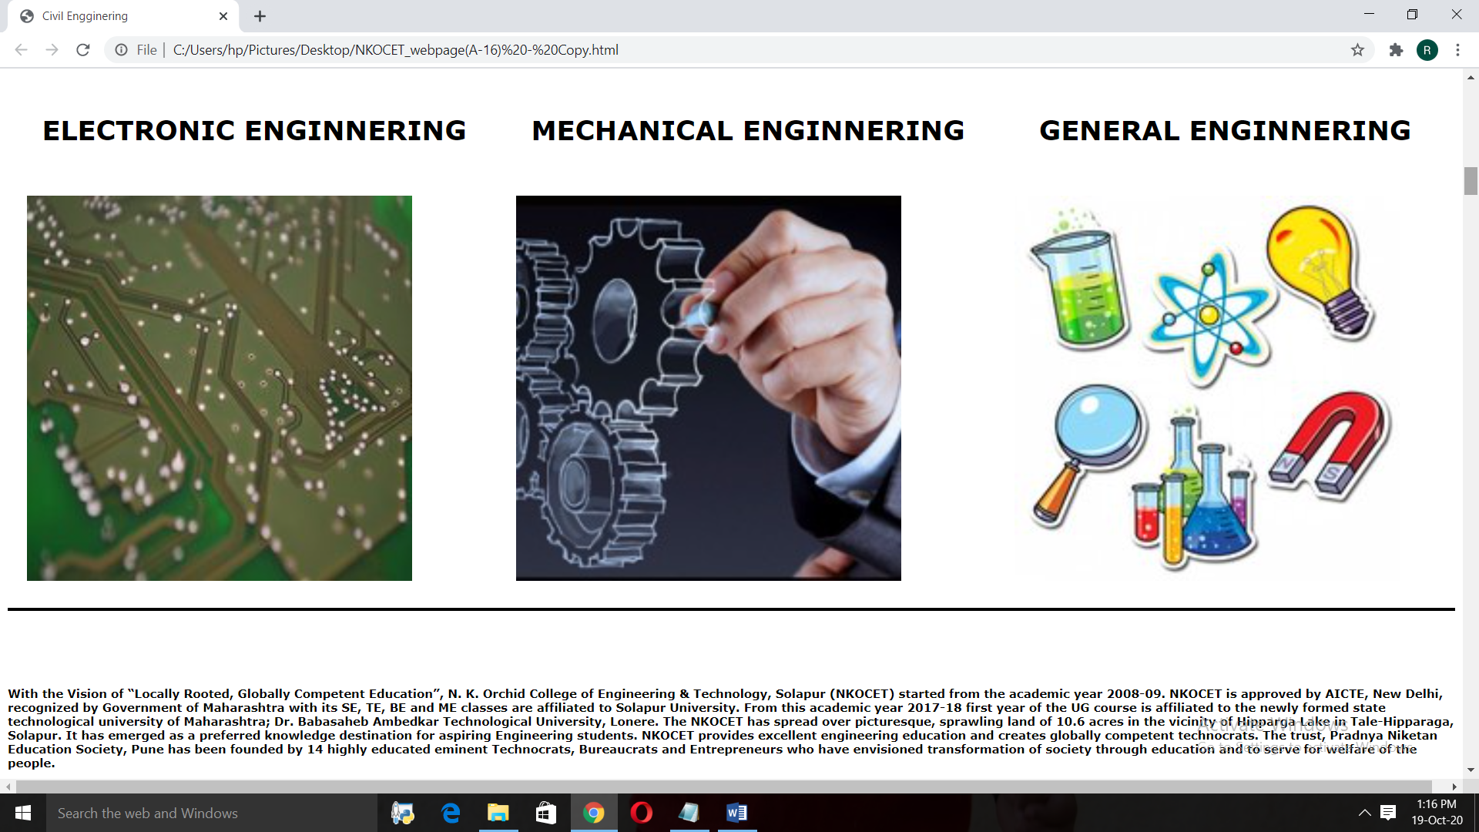

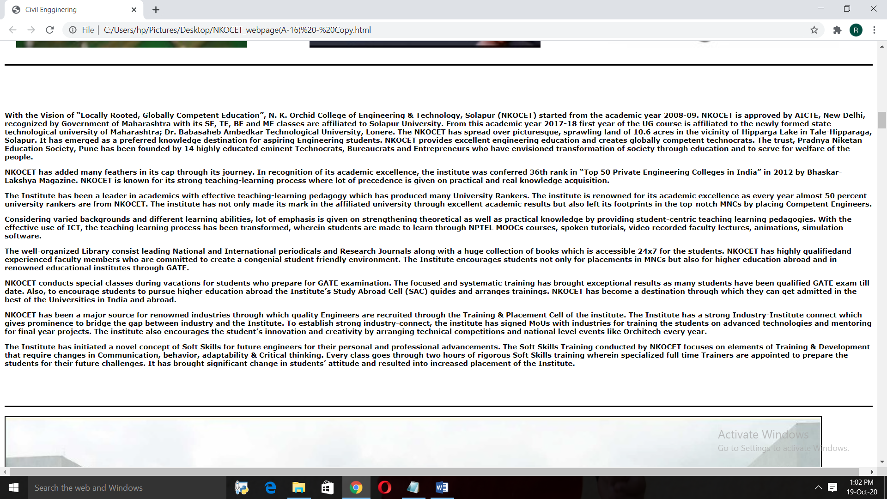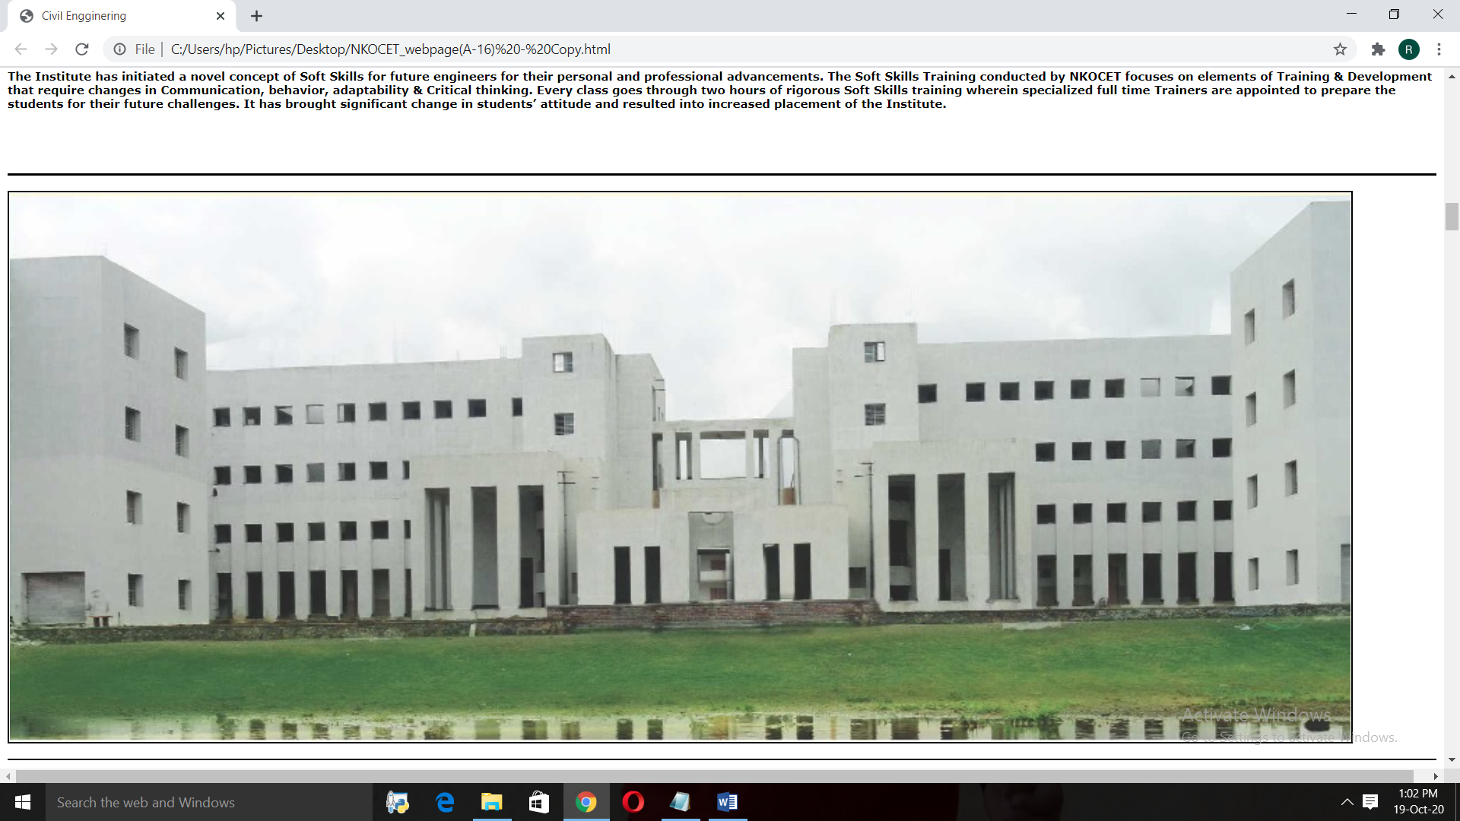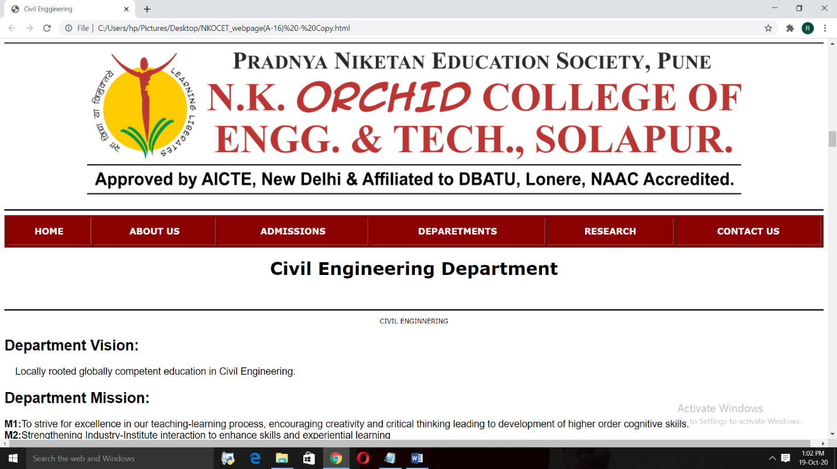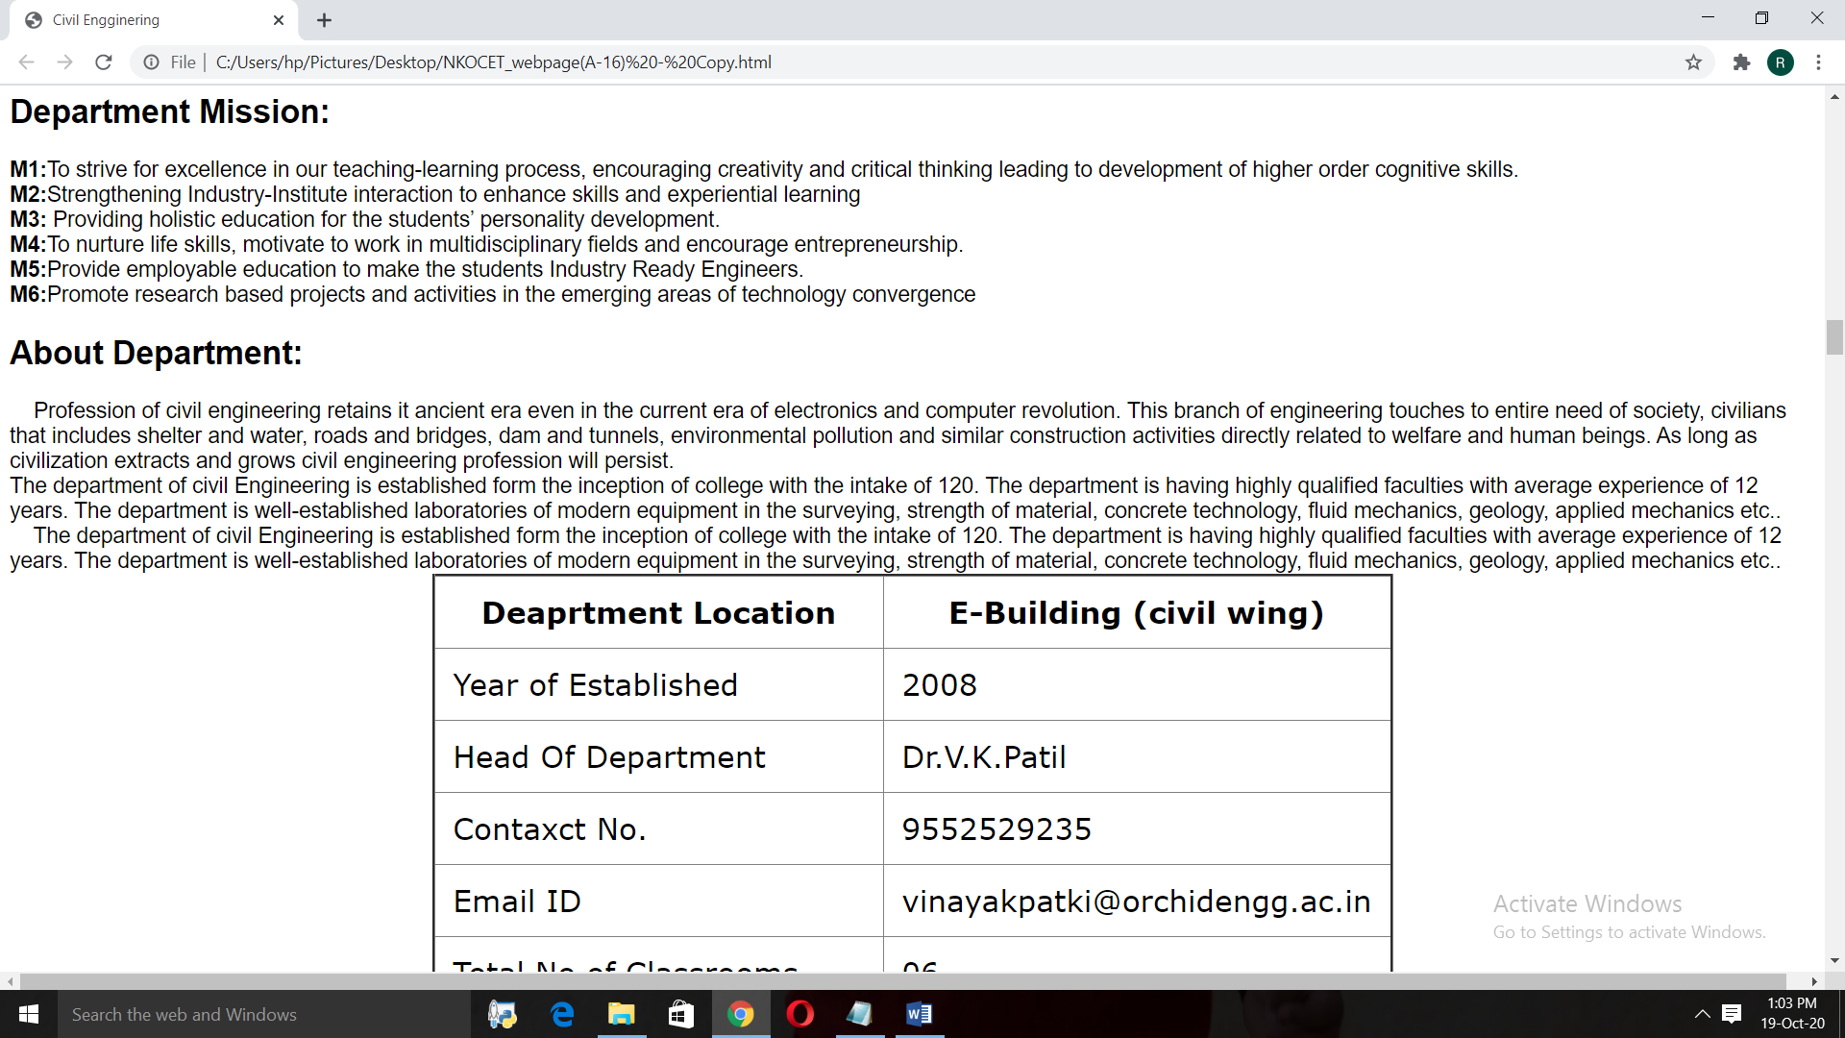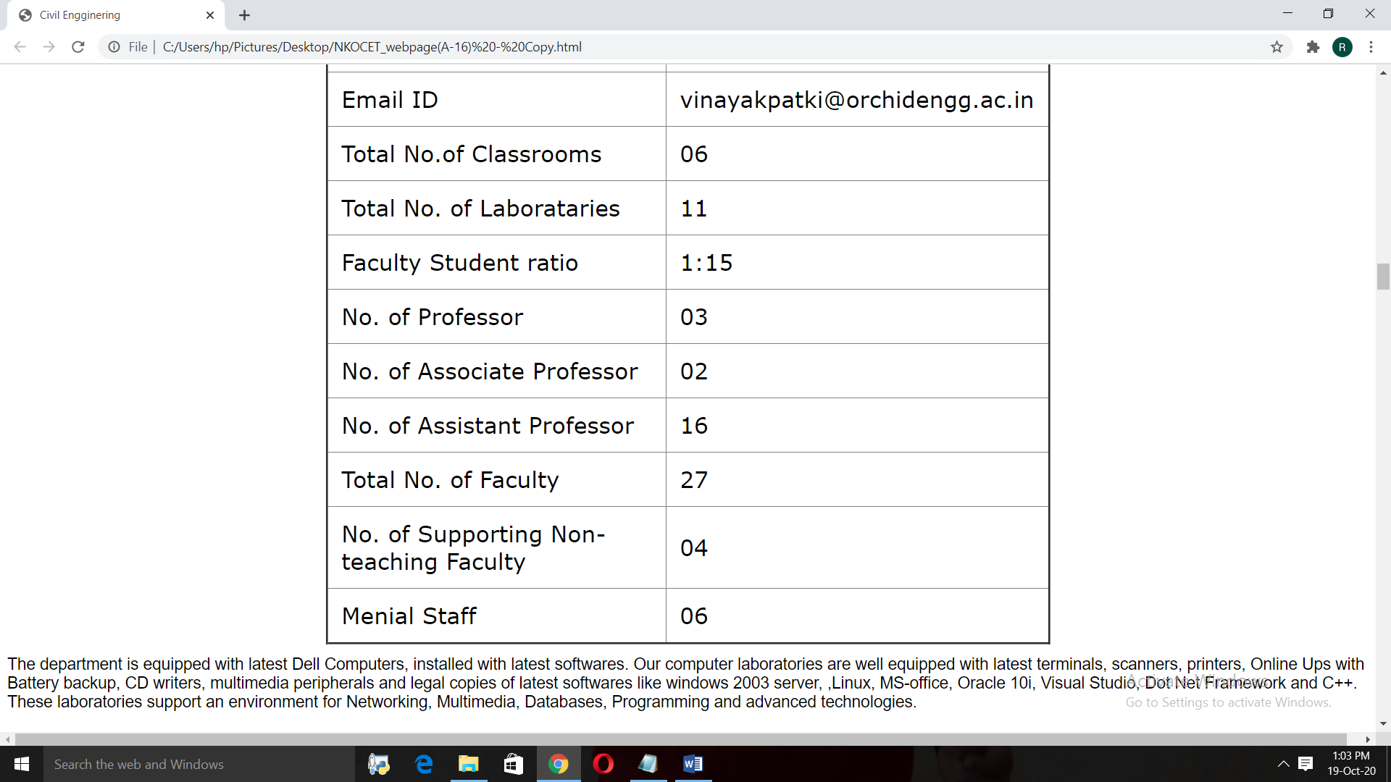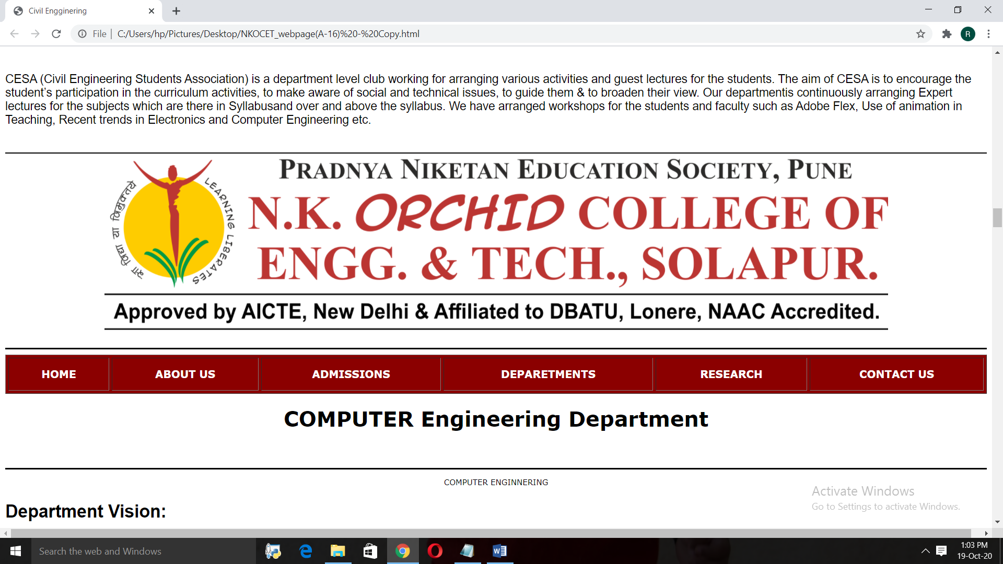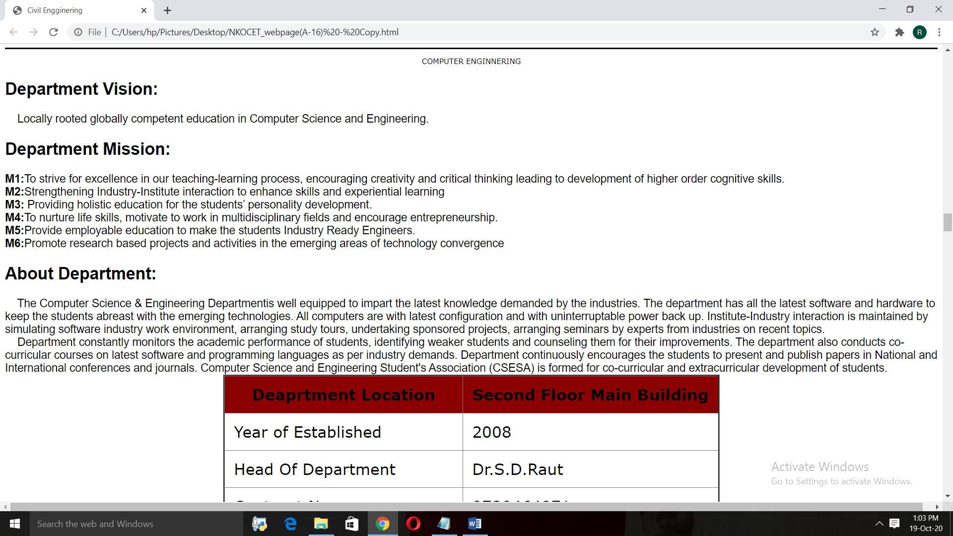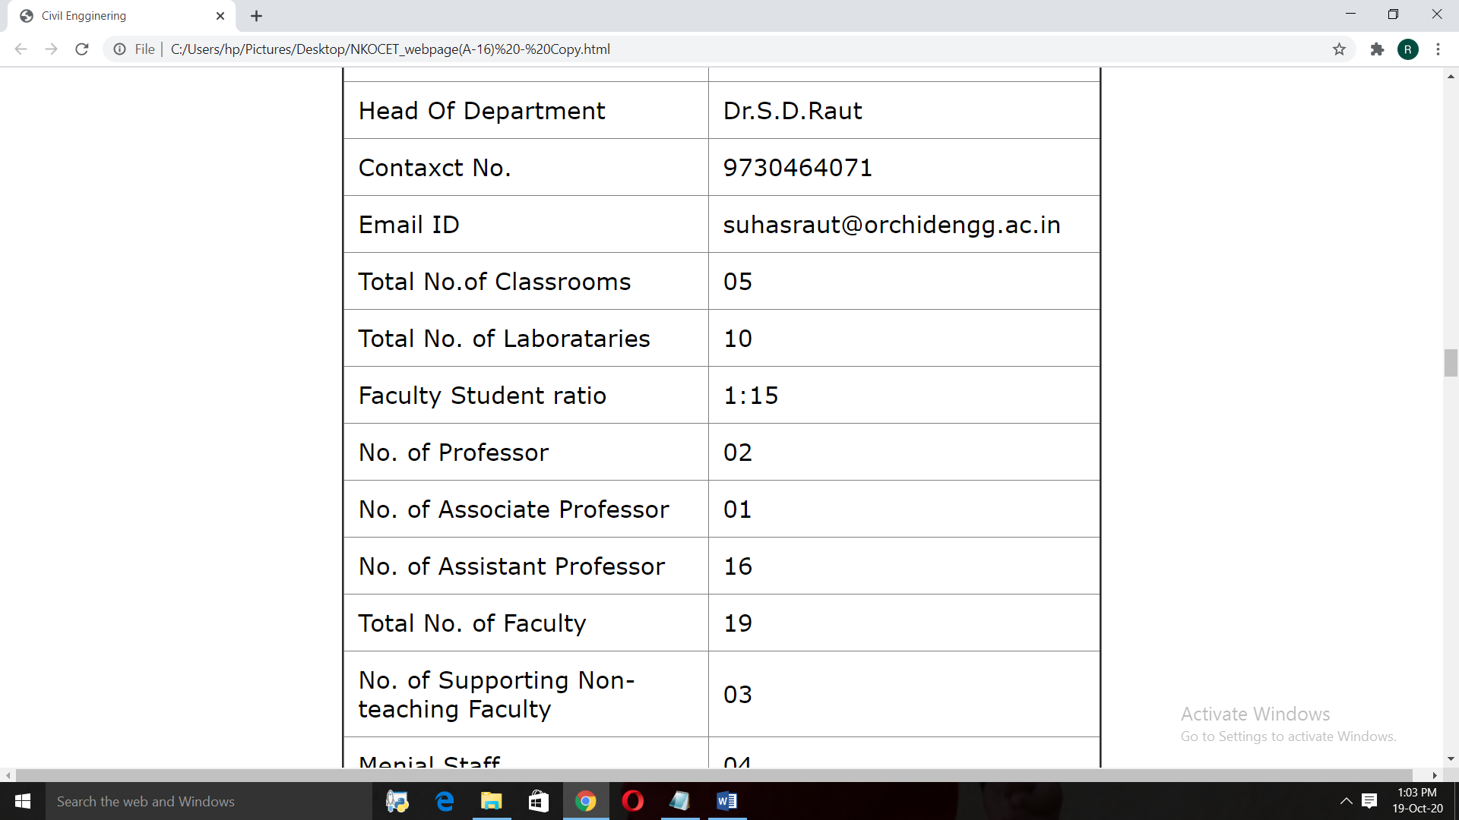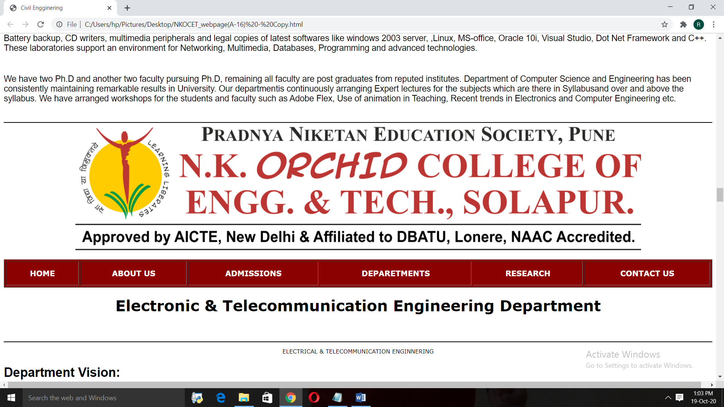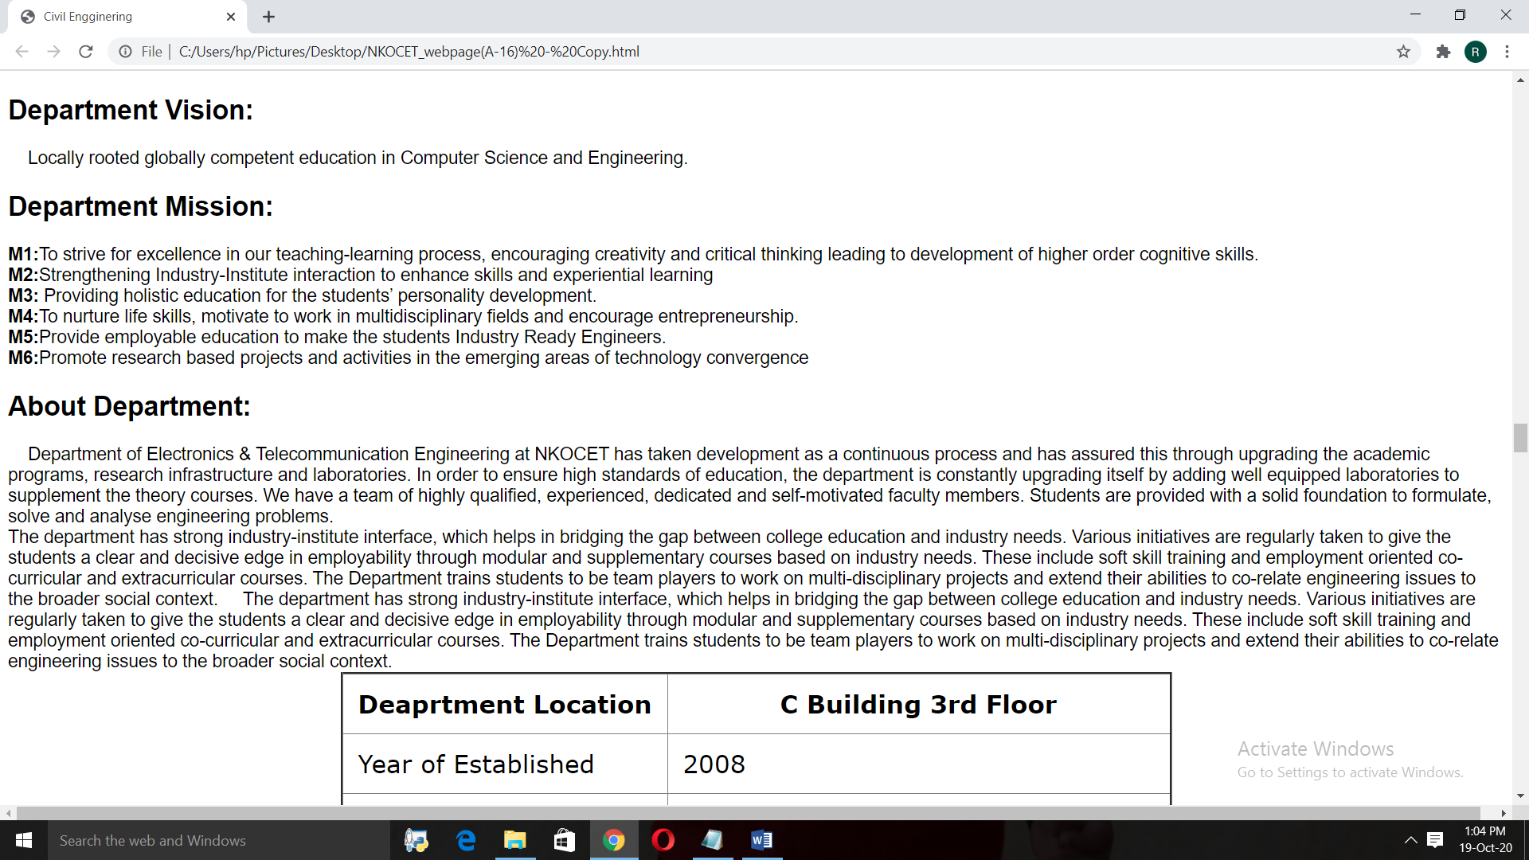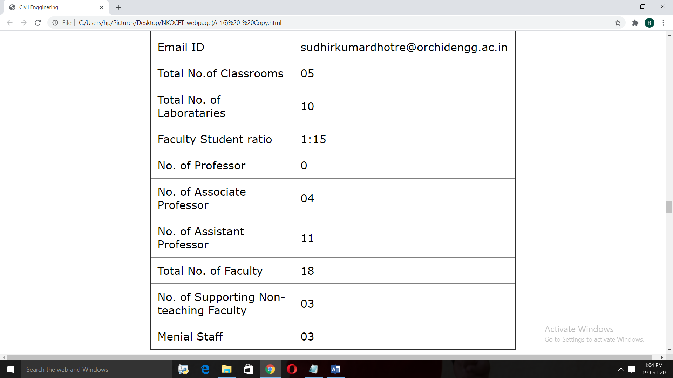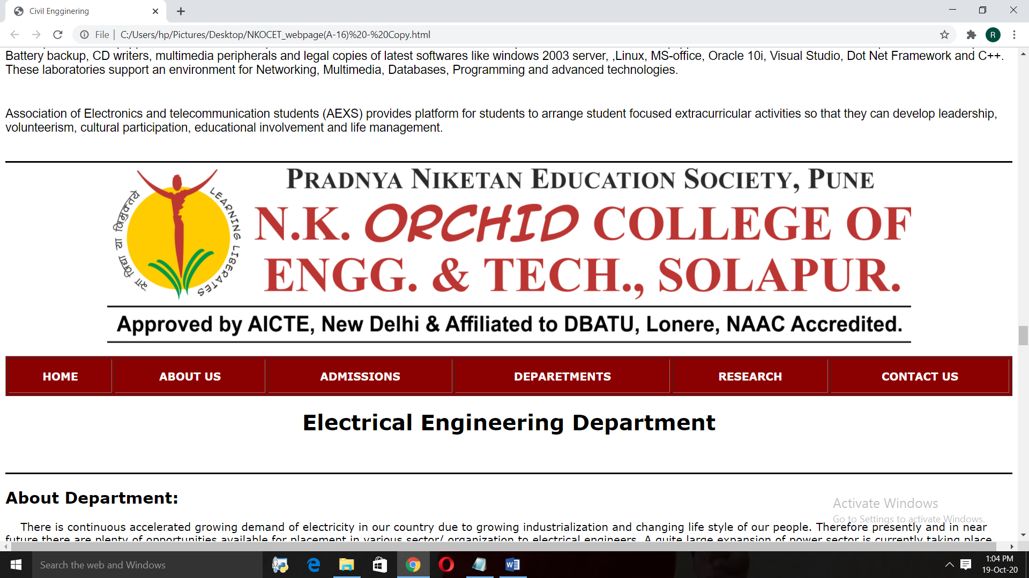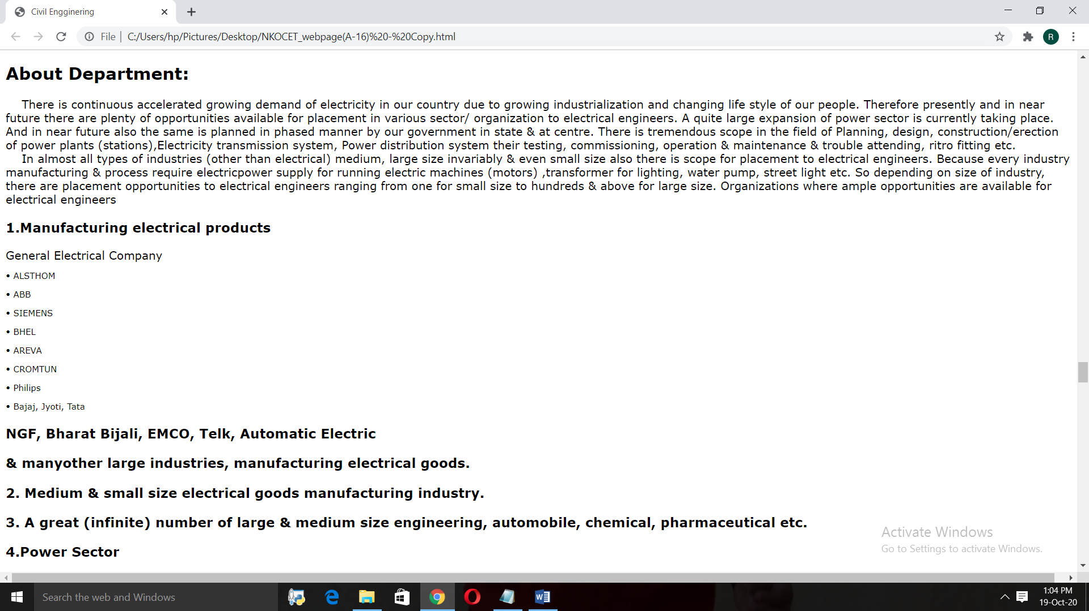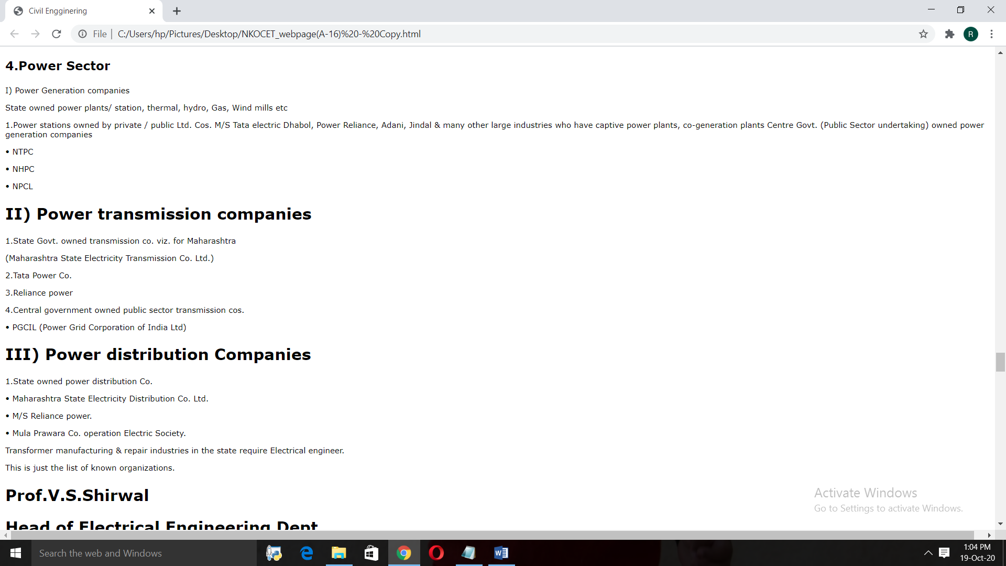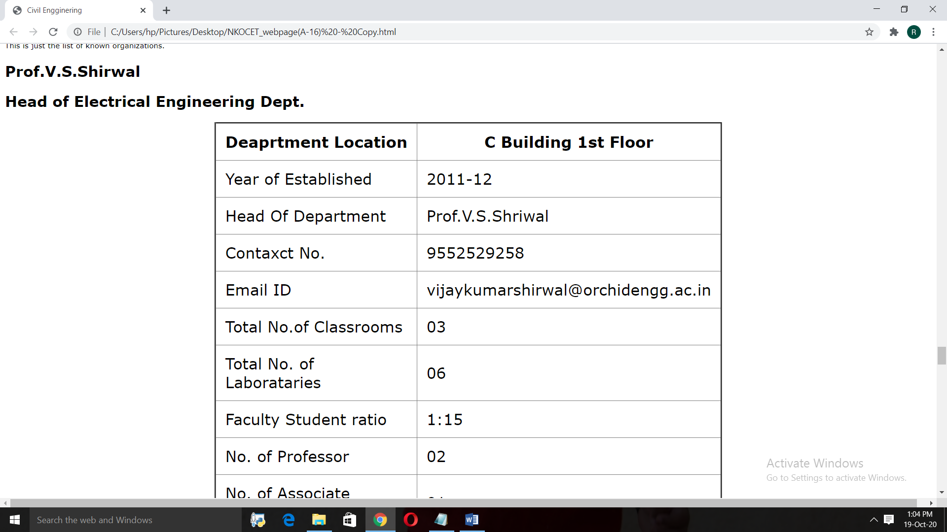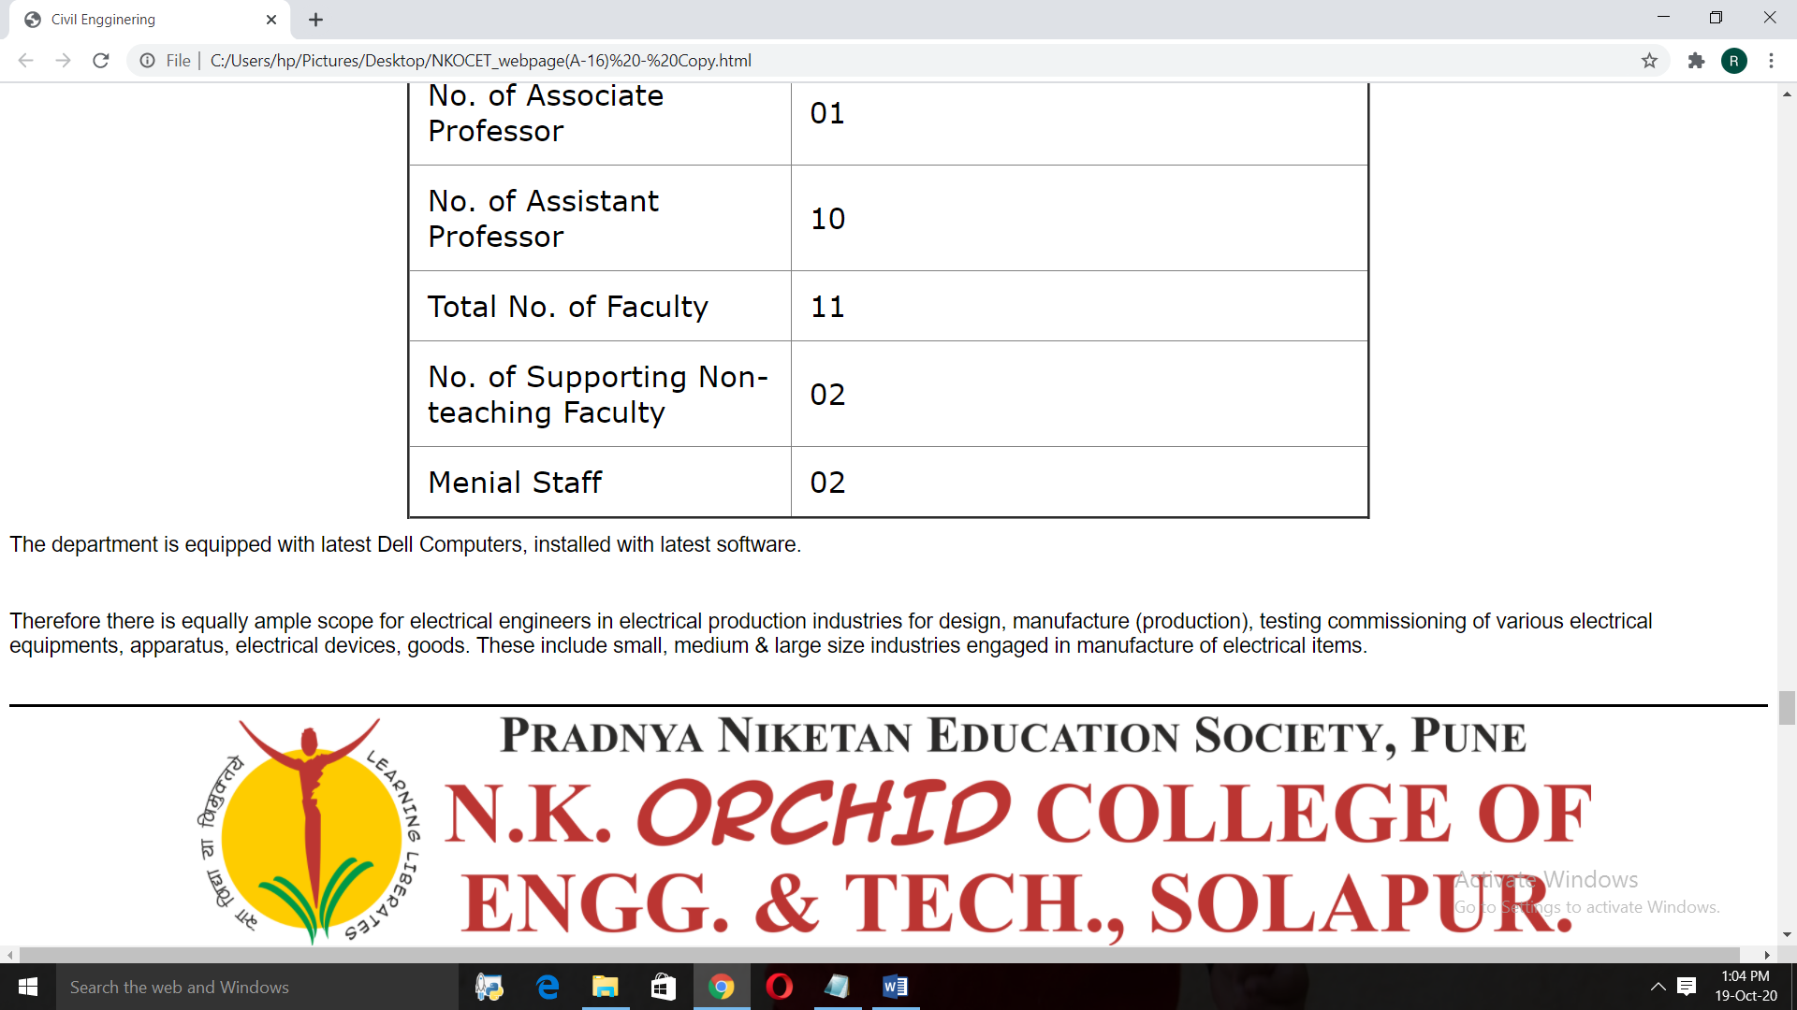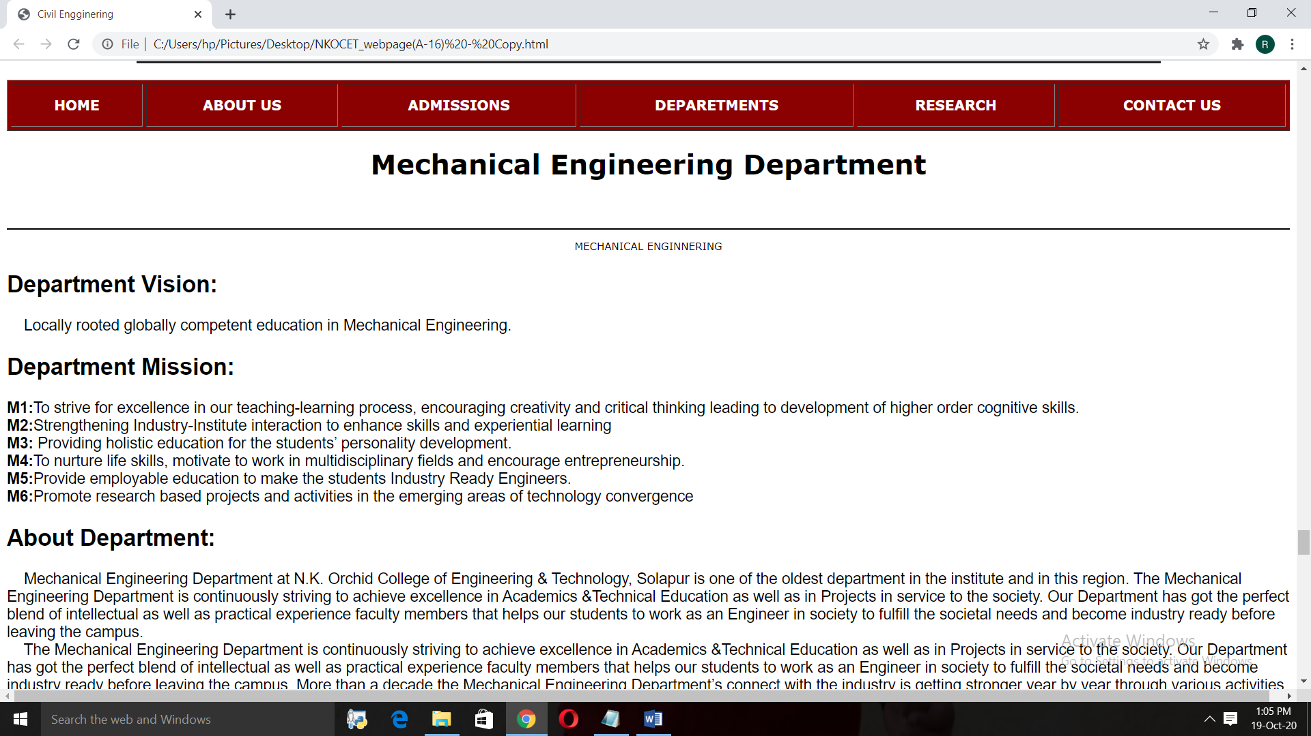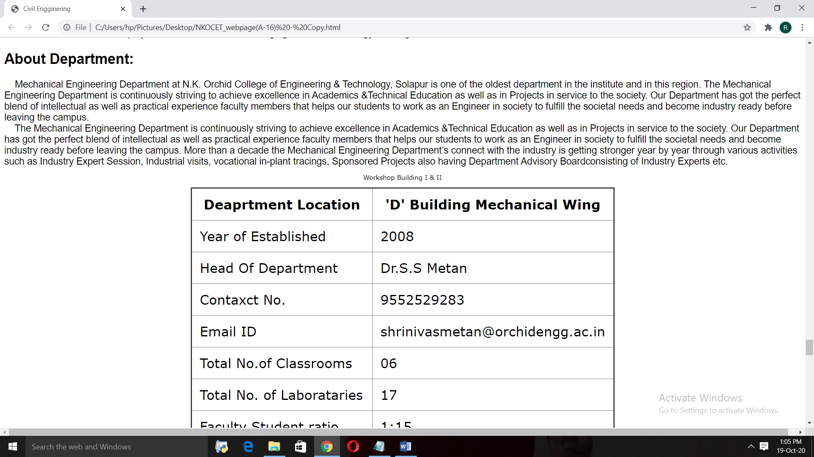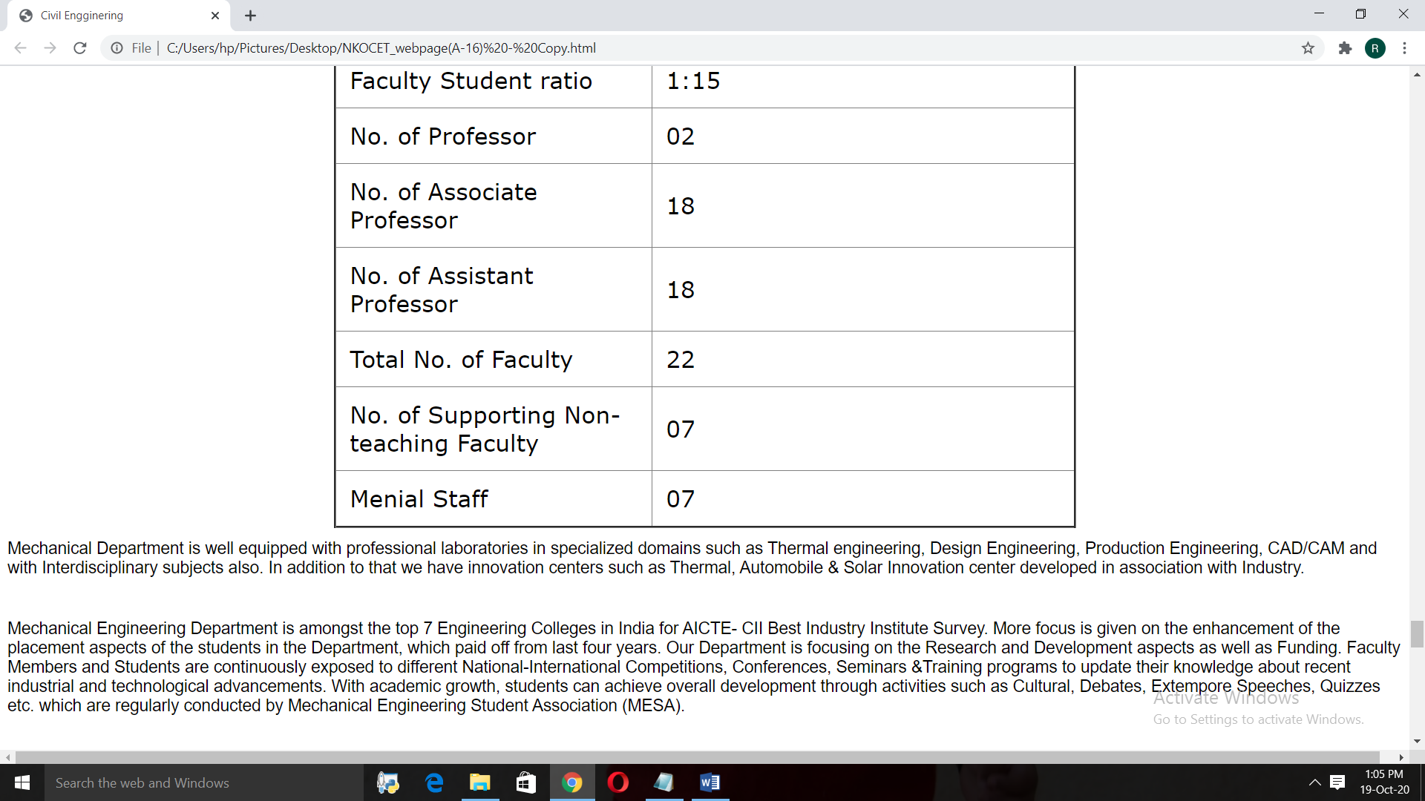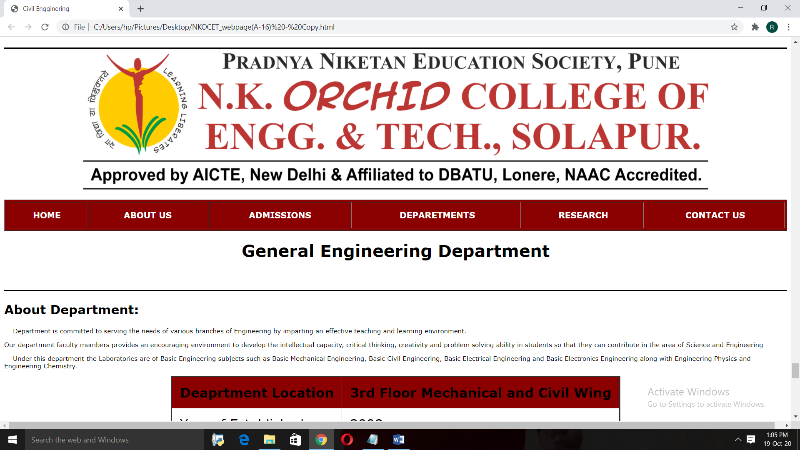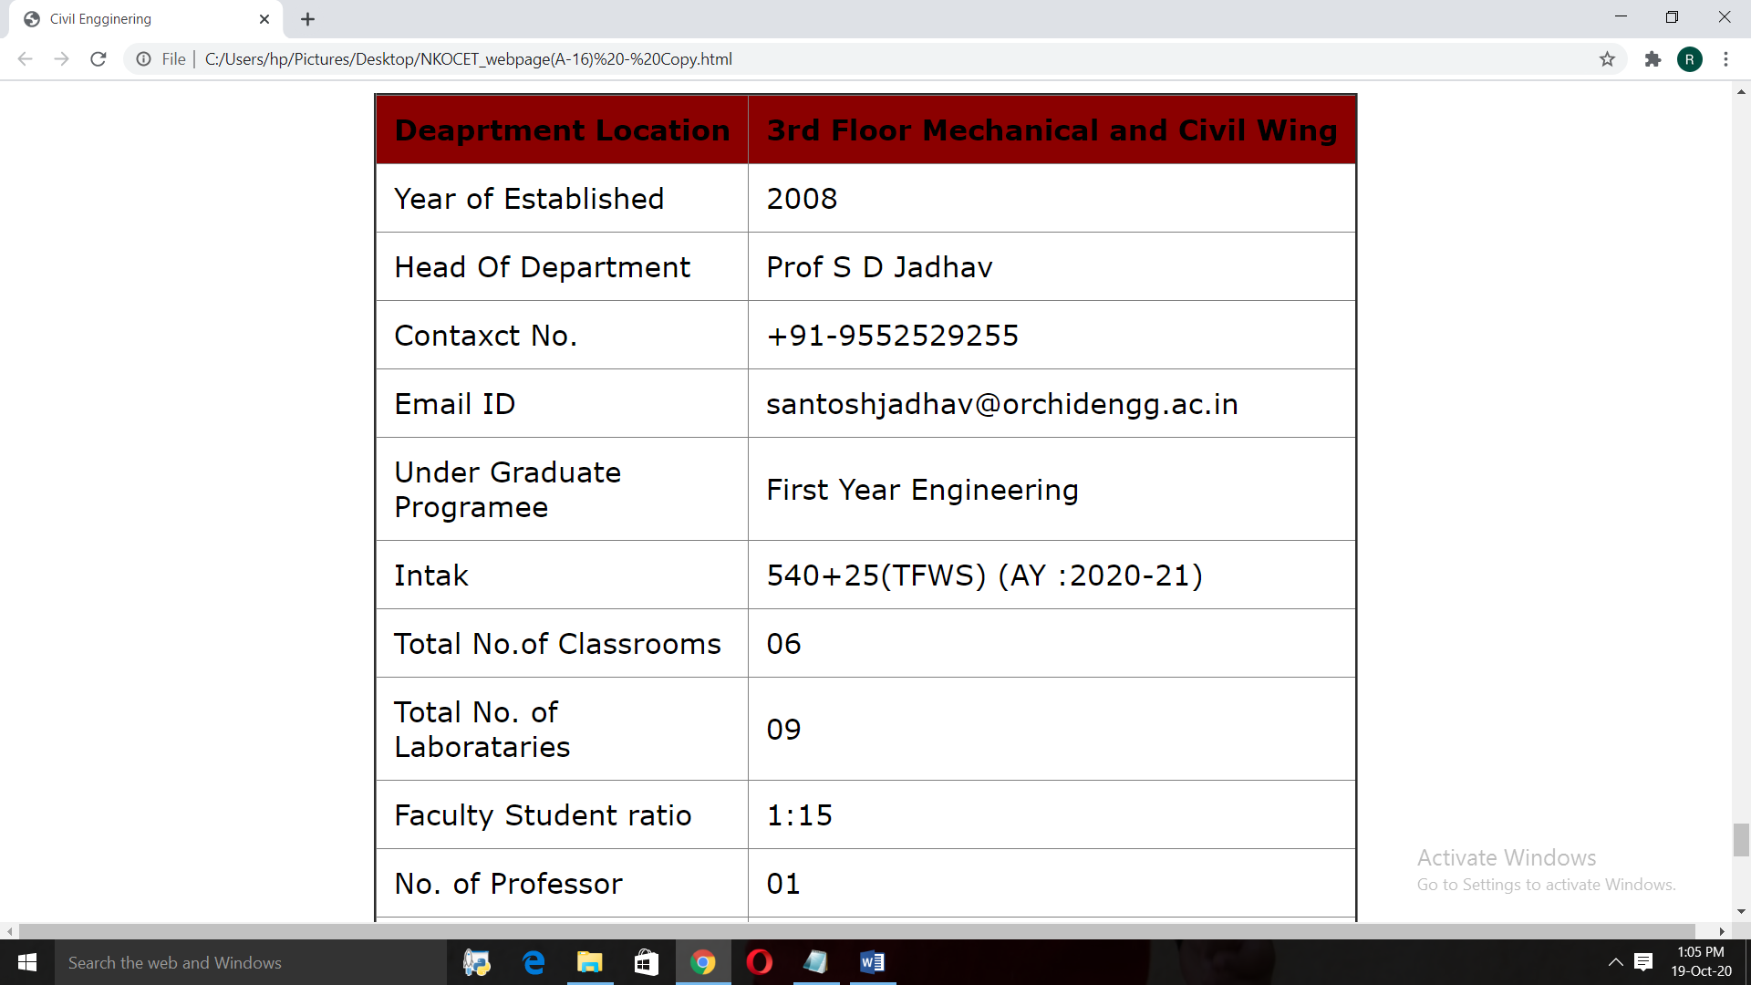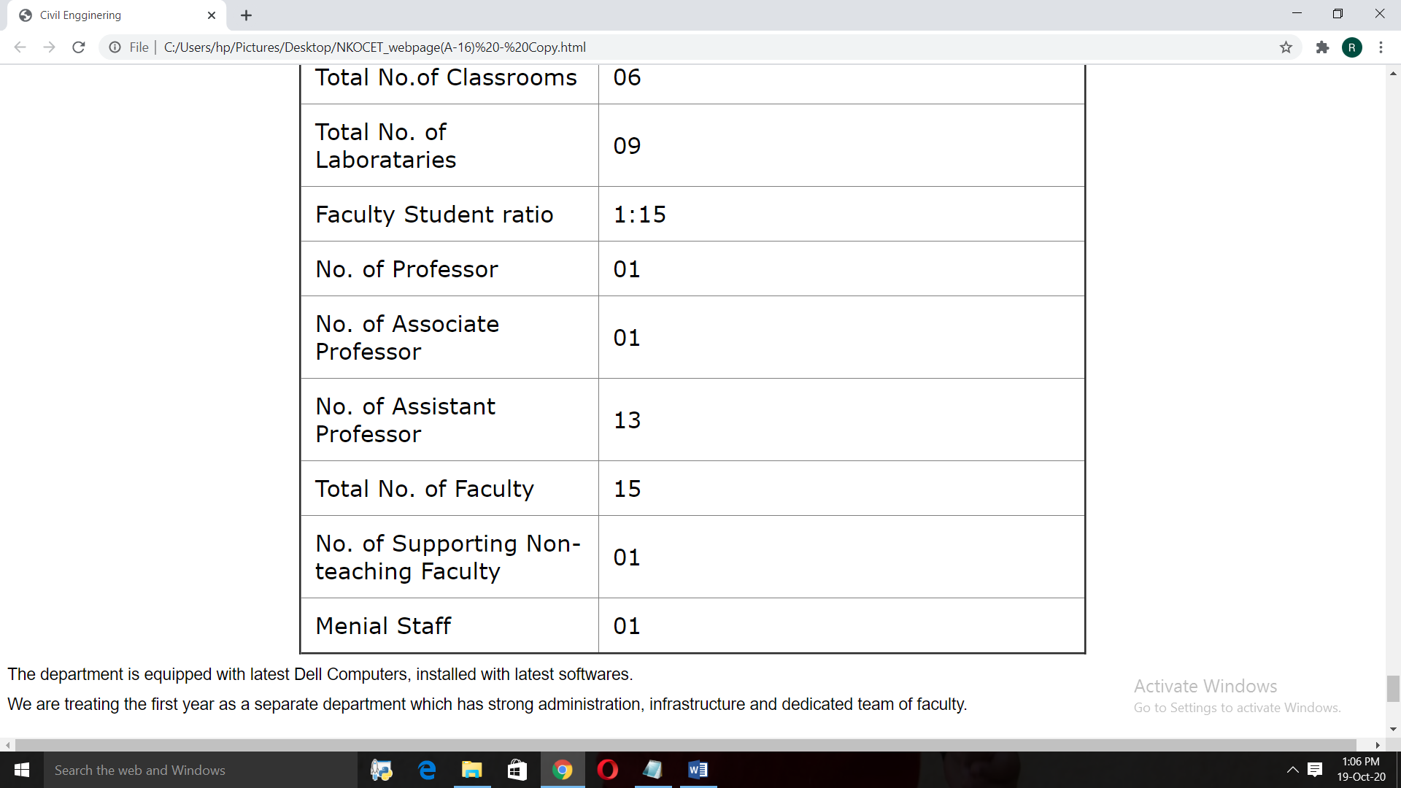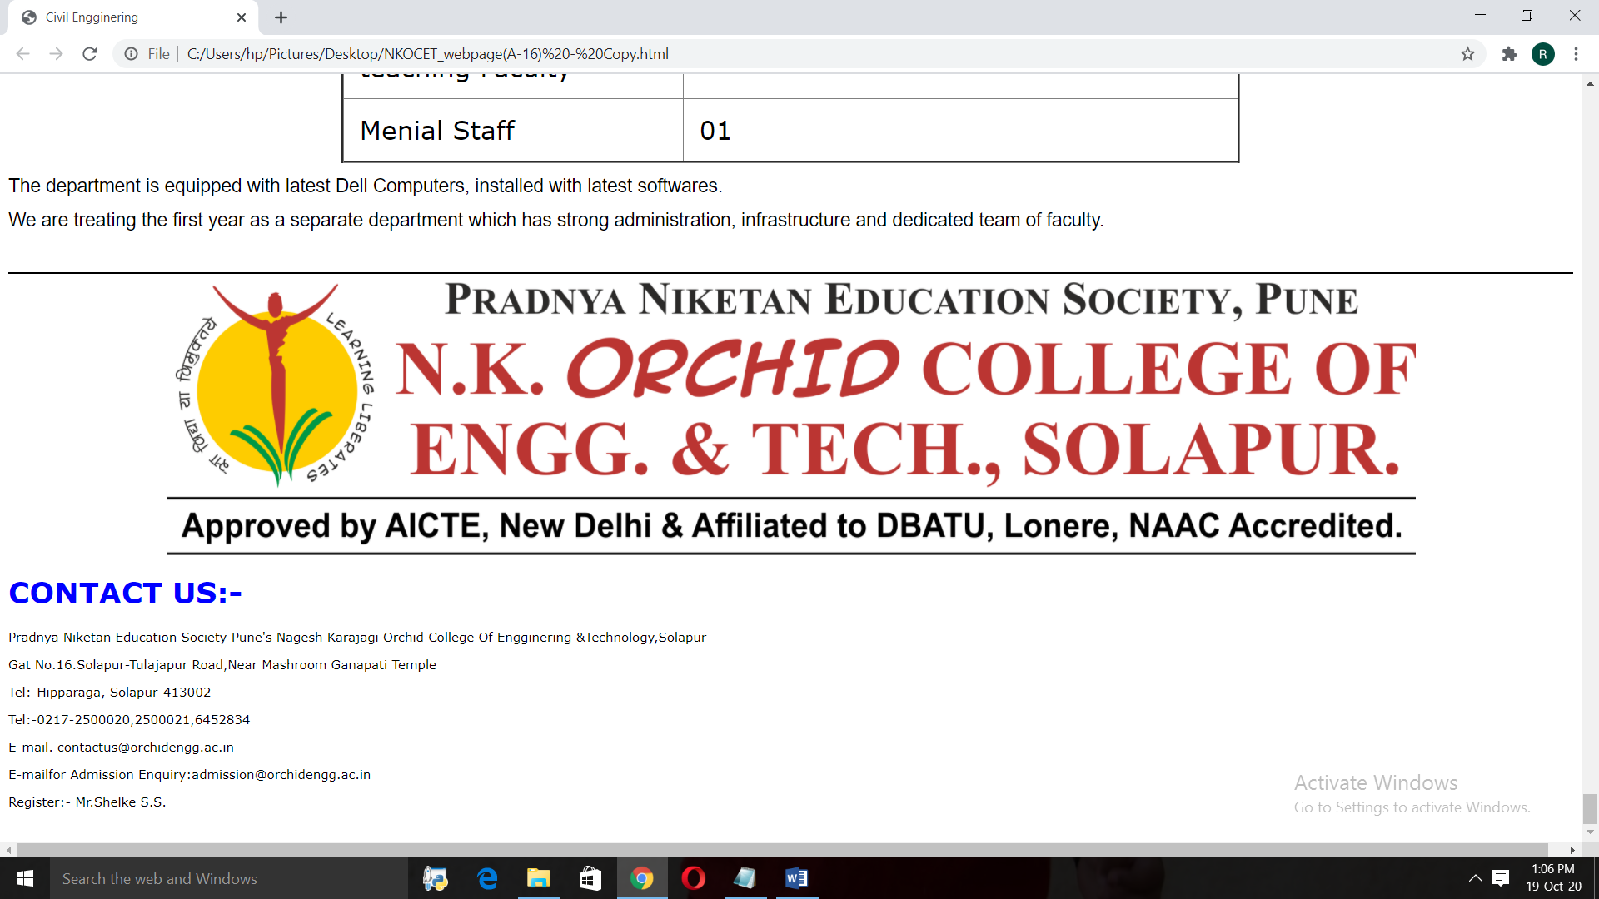

*CONCLUSION :-*

* By creating the college webpage using the CSS we can get the particular information about the college.
* By using the CSS the design of the page get the decorative, attaractive .
* With the help of the website the user can get the whole information about the college.